ATTACHMENT 2

TO REQUEST FOR PROPOSALS (RFP) FOR DESIGN BUILD ENTITY

|  |  |  |
| --- | --- | --- |
|  |  | TGMP/GMP PREPARATION FORM & INSTRUCTIONS |
|  |  | New Fort Ord Courthouse  Superior Court of California,  County of Monterey |
|  |  |  |

**TGMP/GMP PREPARATION FORM & INSTRUCTIONS**

1. INSTRUCTIONS TO COMPLETE TGMP/GMP PREPARATION FORM
   1. The below provides instructions for completing the TGMP/GMP Preparation Form that shall be used to evaluate the Target GMP, provide for any potential revisions to the TGMP and ultimately reflect the GMP agreed upon by the Design Build Entity and Judicial Council. These instructions should be read in conjunction with the Design Build General Conditions Matrix (**Exhibit E** to the Agreement). All Work referenced herein shall be priced in a manner that includes all Design Build Entity’s obligations during the performance of Construction Work as set forth in the Contract Documents.
   2. Uniformat Systems Costs.
      1. The Design Build Entity shall prepare a detailed, itemized breakdown of all Uniformat systems costs and shall provide Design Build Entity’s anticipated values for each system or component in the TGMP/GMP Preparation Form.
      2. Design Build Entity shall carry an errors and omissions contingency of two percent (2%) in all Uniformat systems costs. If the Design Build Entity considers it necessary to carry additional contingency for errors and omissions, it must be included in the Design Build Entity’s Construction Fee/(Overhead and Profit), Line C6 of the Design Build Entity’s Fee Proposal.
   3. Project Contingency. The Judicial Council has identified three percent (3%) for a Project Contingency for use by the Design Build Entity in accordance with the General Conditions. This Contingency appears in line 36 of the TGMP/GMP Preparation Form. If the Design Build Entity considers it necessary to carry additional contingency, it must be included in the Design Build Entity’s Construction Fee/(Overhead and Profit), Line C6 of the Design Build Entity’s Fee Proposal.
   4. Allowances. Judicial Council may have identified an Allowance(s) included in the Contract Documents. Line 39a of the TGMP/GMP Preparation Form includes the sum of all identified Allowance(s). If the Design Build Entity proposes allowances in addition to the amount identified in line 39a, they must be indicated on line 39b of the TGMP/GMP Preparation Form. Design Build Entity’s proposal of an additional Allowance(s) shall be accompanied by all substantiation required by the General Conditions to support the requested Allowance(s).

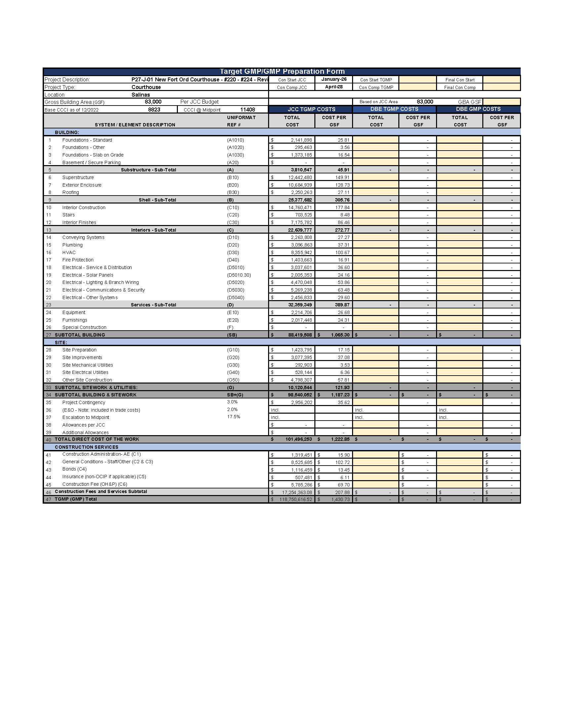

**END OF ATTACHMENT**