 |  | Attachment B  Project Summary
New Los Banos Courthouse

City of Los Banos

Superior Court of California
County of Merced

 |  | 

Project Description

The Project is the pre-construction planning, design, construction, and commissioning of a new building with site development for a new courthouse facility comprised of approximately 29,000 BGSF with 2 courtrooms, related superior court administrative offices & public service spaces, holding areas adjacent to courtrooms, in-custody secure central holding, and court support spaces. The court building will be approximately one story with a vehicle sallyport, security operations, building services and secure parking of approximately 7 stalls. The site for the courthouse consists of approximately 4.58 acres which will include a surface parking area for approximately 150 spaces. The Project includes, but is not limited to, all building structure, enclosure, interior improvements, mechanical, electrical, data, telecommunication, audio visual, security systems and landscaping for both sites. Furnishing and installation of interior furniture, furnishings, and fixtures may be performed under a separate, but concurrent contract by others.

The site development includes but is not limited to site preparation, underground utilities, landscape, hardscape, vehicular drives, surface parking, security barriers, fencing, and gates. The Project may include removal of underground utilities and the rerouting of underground utilities. Site work will include demolition of the existing concrete foundations on the courthouse site.

Goals and Standards

The New Los Banos Courthouse will welcome and inspire the public and engender respect for the judicial system in a safe, dignified, efficient, user-friendly environment in which to conduct the public business.

This project will be consistent with the California Trial Court Facilities Standards, adopted by Judicial Council of California effective April 21, 2006, as amended; and the revised California Trail Court Facilities Standards 2011 pending JCC approval/adoption. The purposes of these standards are to produce high-performing public buildings with a positive architectural legacy that reflects the Judicial Council’s commitment to providing equal access to justice.

The following goals have been established for the project:

- Architecture – The architecture shall be dignified, timeless and constructed with quality, durable materials and systems. The entire Project shall be recognized by the community as a prominent public building that enriches the City of Woodland.

Site Design – The site design shall be appropriate to the development of the surrounding community and in support of a prominent public building.

- Function – Space configurations shall promote efficient court and security operations and shall be effectively designed to maximize usable space while providing efficient circulation, waiting, and queuing areas for the public.

- Schedule and Cost - The project design and construction shall be completed within the approved schedule and within the authorized funds. Where possible, project tasks should at least be concurrent, with the overall goal of creating the new Woodland Courthouse building as quickly as prudent, and to avoid the effect of cost escalation.

- Life Span – This facility should function effectively for several generations. The design shall support a logical and cost-effective approach to accommodate change over time in court operations. Seismic design shall incorporate innovative and cost-effective measures to ensure building stability, limit damage to structure & contents and to enhance building longevity.

- Design Quality Assurance – The entire project team shall utilize quality assurance procedures to ensure that the contract documents result in change orders issued to the construction contractor of less than 2% of the original contract amount.

- Sustainable Design – The Project shall be designed for sustainability and to the standards of the United State Green Building Council’s (USGBC) LEEDTM “Silver” rating, including full participation in the LEED certification process from the design through construction phases. The CM at Risk is to provide required, full documentation for LEED certification during construction phase. Submittals to USGBC, required for certification, are included in the scope of work of the Architect. The project will participate in the “Savings by Design” incentives/rewards program sponsored by the local utility company. The building shall consume 15% less energy or better than a code minimum facility. The Project will promote access to sunlight, and optimize interior day lighting while addressing site influences.

- Accessibility – Design of building shall reflect Judicial Council’s mission to provide access to justice for all, including equal access and fairness with the highest quality of service to the public. The building shall incorporate Universal design concepts, to make the facility equally accessible to all users.

- Security – A secure environment shall be created by simple means and shall have clear divisions between private and public areas. The design will provide for efficient and safe court operations in a cost-effective manner. Security measures for the building and site shall meet the requirements of the AOC and other authorities having jurisdiction.

- Durability, Quality and Efficiency – Materials and systems for the building and site should be chosen with regard to the amount of traffic, use and visibility of each space. Materials should be durable, operationally and energy efficient, easily maintained and environmentally friendly. Easy maintenance of materials and systems shall have high importance. Landscaping materials shall be chosen for durability, climate compatibility, and attractive appearance.

- Commissioning – A building commissioning program shall be implemented to ensure that the building systems perform interactively in accord with the design intent.

Project goals and principles will be re-evaluated throughout the design and construction phases and at the completion of the Project to determine whether the Project goals have been achieved.

Funding Sources – The Project will be funded by Senate Bill (SB) 1407 (Chapter 311, Statutes of 2008) resources and other sources.

This project is ranked in the Immediate Need priority group in the Trial Court Five-Year Infrastructure Plan adopted by the Judicial Council in April 2008, and consequently is one of the highest priority trial court capital-outlay projects for the judicial branch.

The current project costs were approved by the State Public Works Board on August 16, 2011. The Acquisition and Preliminary Plans (Schematic Design and Design Development) Phases are funded from the Immediate and Critical Needs Account (Fund 3138). Future Working Drawing and Construction phases will be funded through subsequent state budget approvals.

Project Budget – The overall construction budget is approximately $25,077,411.00. The construction budget does not include fees for professional services or other owner “soft costs”. The budget amount must not be exceeded. OCCM is responsible for maintaining individual line items in the budget and for budget modification throughout the project. See Cost Responsibility Matrix (Attachment I) and Construction Phase Scope Detail (Attachment C) for the scope of work anticipated in the construction contract.

Project Summary Program
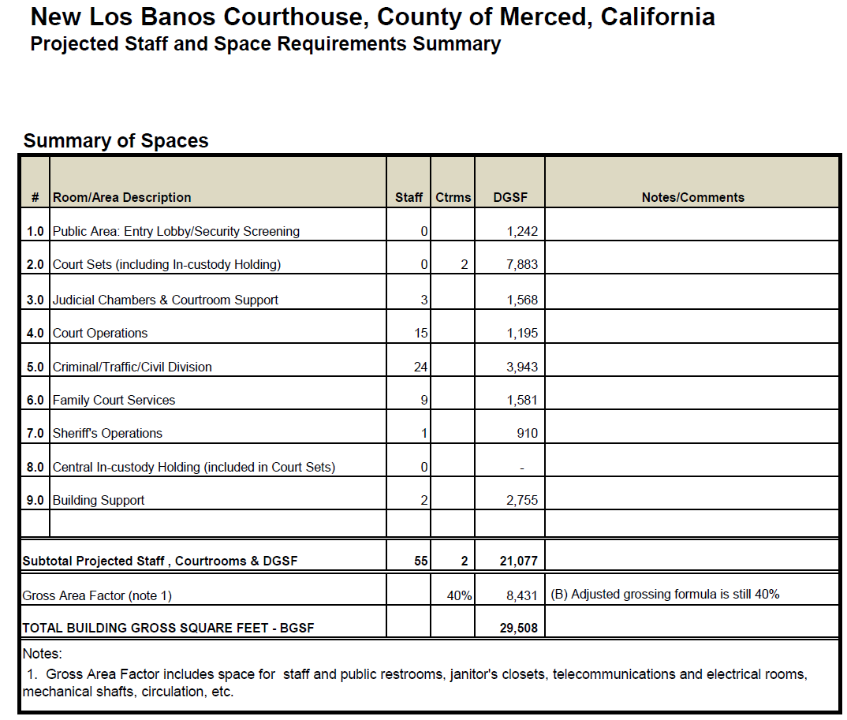

END OF EXHIBIT B

