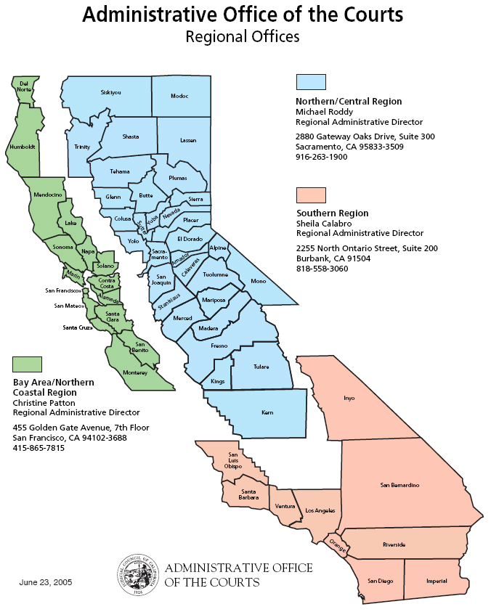
ATTACHMENT B
FACILITY LIST

Special Notice and Disclaimer of Information Provided

A. Special Notice. Currently, the Court Transfer Process is still in its transfer phase, although most transfer have already occurred. Therefore, dates of transfer, maintenance responsibilities, and other related agreements with various counties may still be under negotiation. It should be noted that maintenance for some court facilities will remain with their respective County. This is especially true if the court does not occupy the majority of the space in the facility. Moreover, there may be instances whereby the AOC will only provide maintenance services to portions of the facility and/or select systems within the facility. Further, there may be instances whereby the respective County provides routine maintenance and the AOC provides the Major Works (MW) for the court facility. In addition, some facilities are leased and, in some instances, the maintenance of the facility will be provided by the landlord. New court facilities may be added to this list and may require maintenance on behalf the Proposer. It is estimated that by the time of the contract award, approximately 500 facilities will be under AOC responsibility.

B. Disclaimer of Information. Due to the nature of the Court Transfer Process, the AOC is not able to provide definite information regarding court facilities. However, as part of a good faith effort to keep Proposers informed, the AOC has provided this Facility List with the intent to offer as much information as possible regarding the types, sizes, and location of the facilities which may be transferred to the AOC and subsequently maintained by the respective Proposer. This list is not a commitment on the part of the AOC to Proposers of an assignment of facility management and maintenance. Though the data reflected in this attachment is the most current data available, it should be noted that the data has not been completely verified by the AOC, and that all data in this Attachment B is subject to change at the sole discretion of the AOC. In the event that any amendments relating to this attachment are provided to Proposers, the amendments themselves are subject to this original Disclaimer of Information. The AOC will make a good faith effort to provide Proposers with updates to this information throughout the proposal process. It is not the intent of the AOC to provide information that intentionally misleads or misguides Proposers.

A Microsoft Excel version of this document is posted on the website along with this RFP.

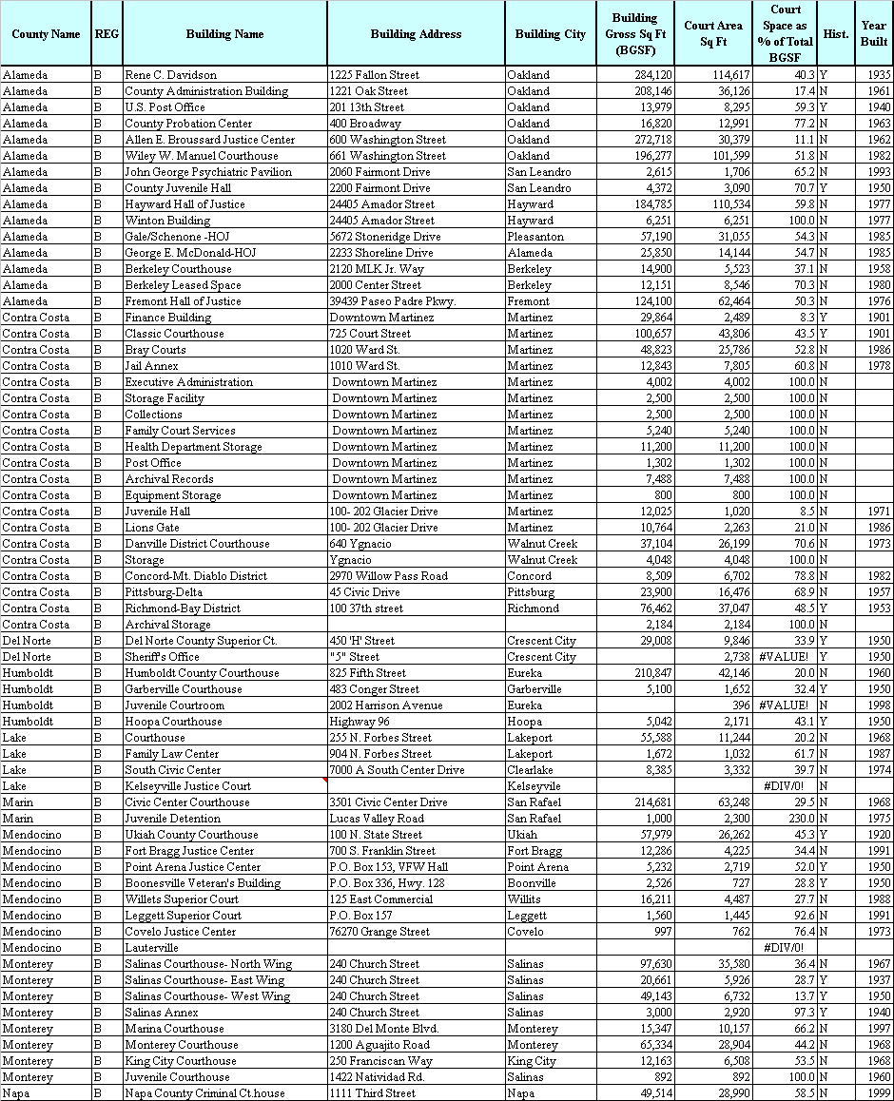
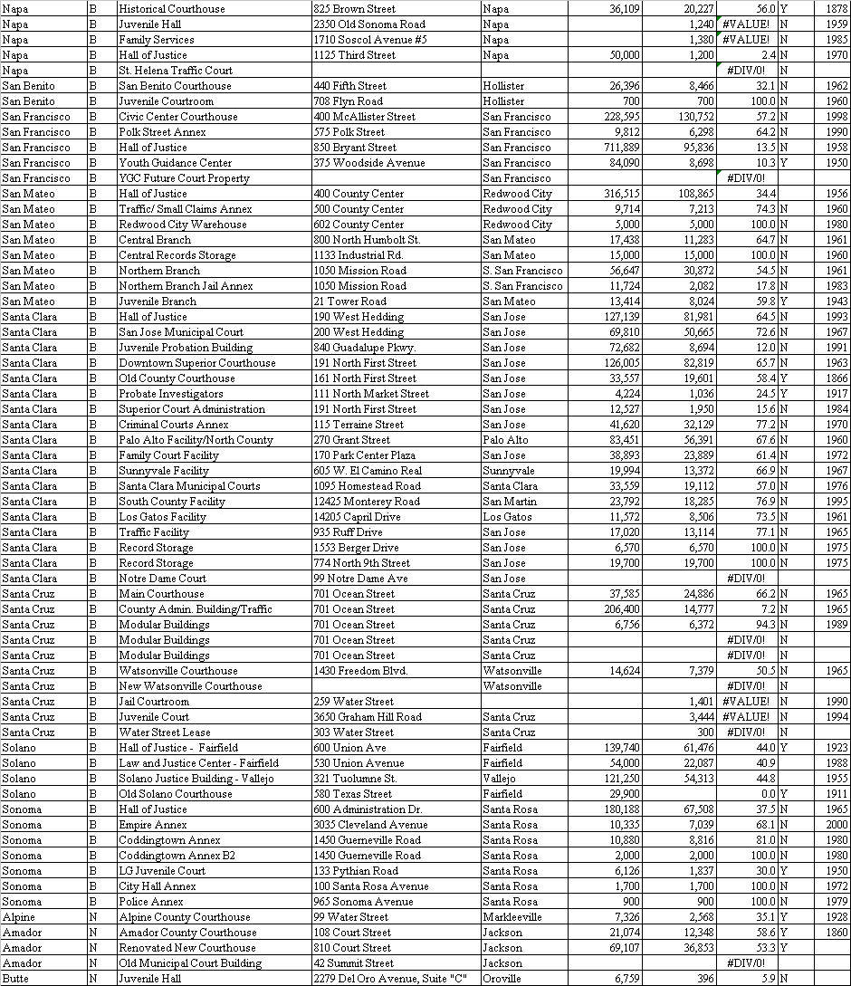

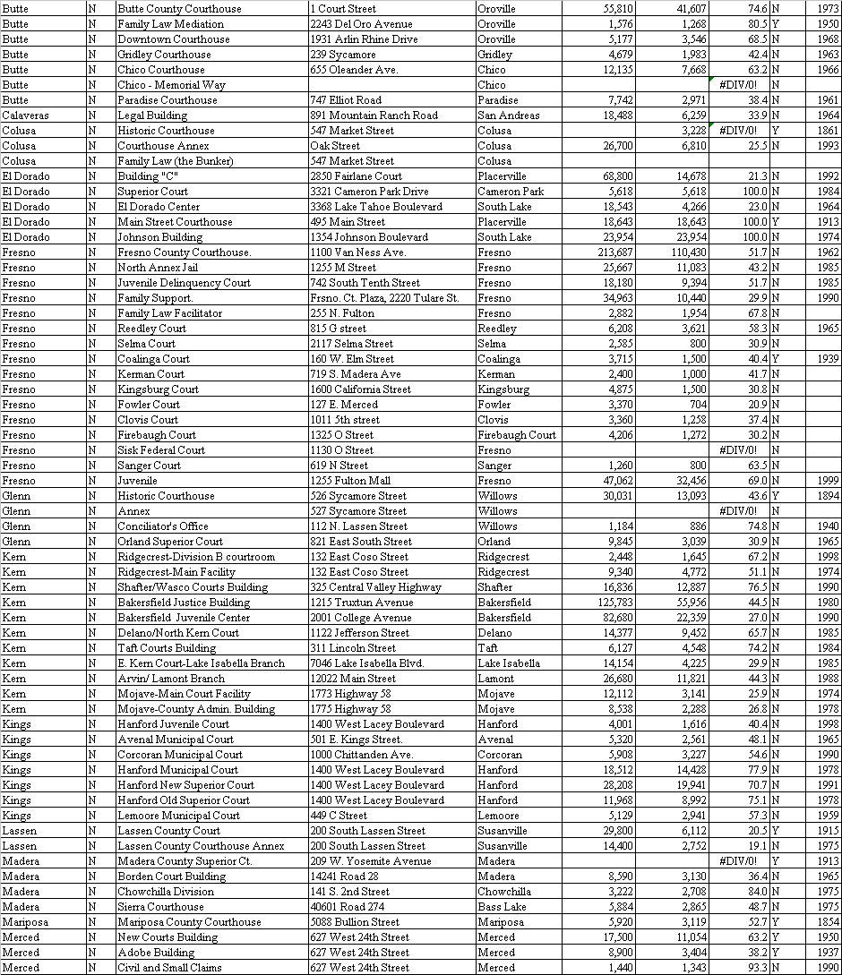

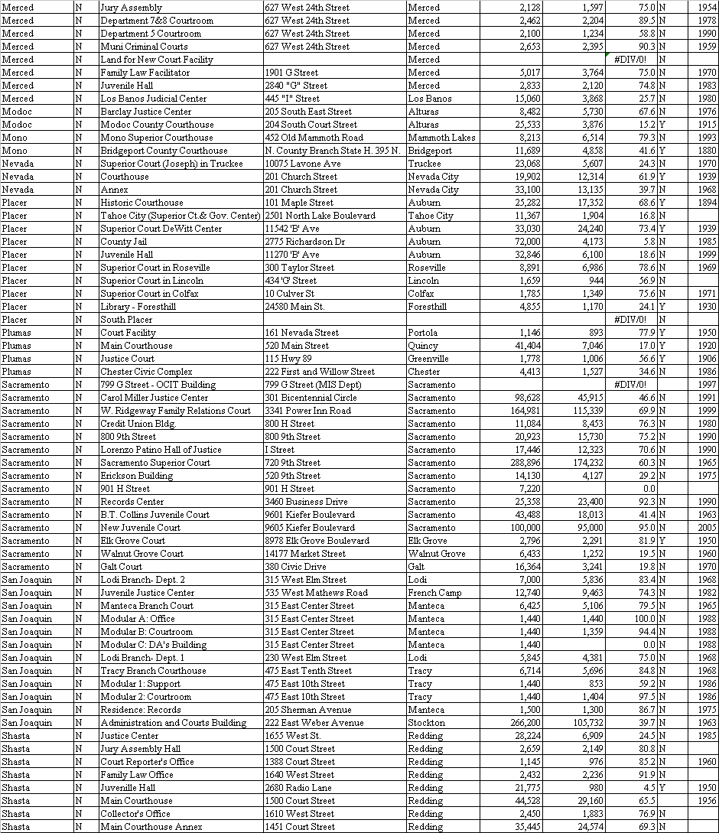

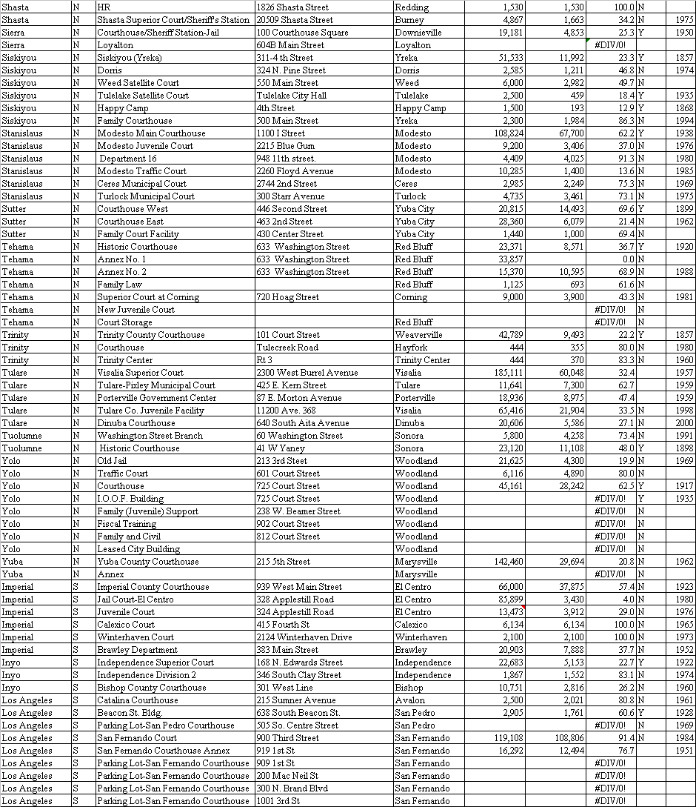

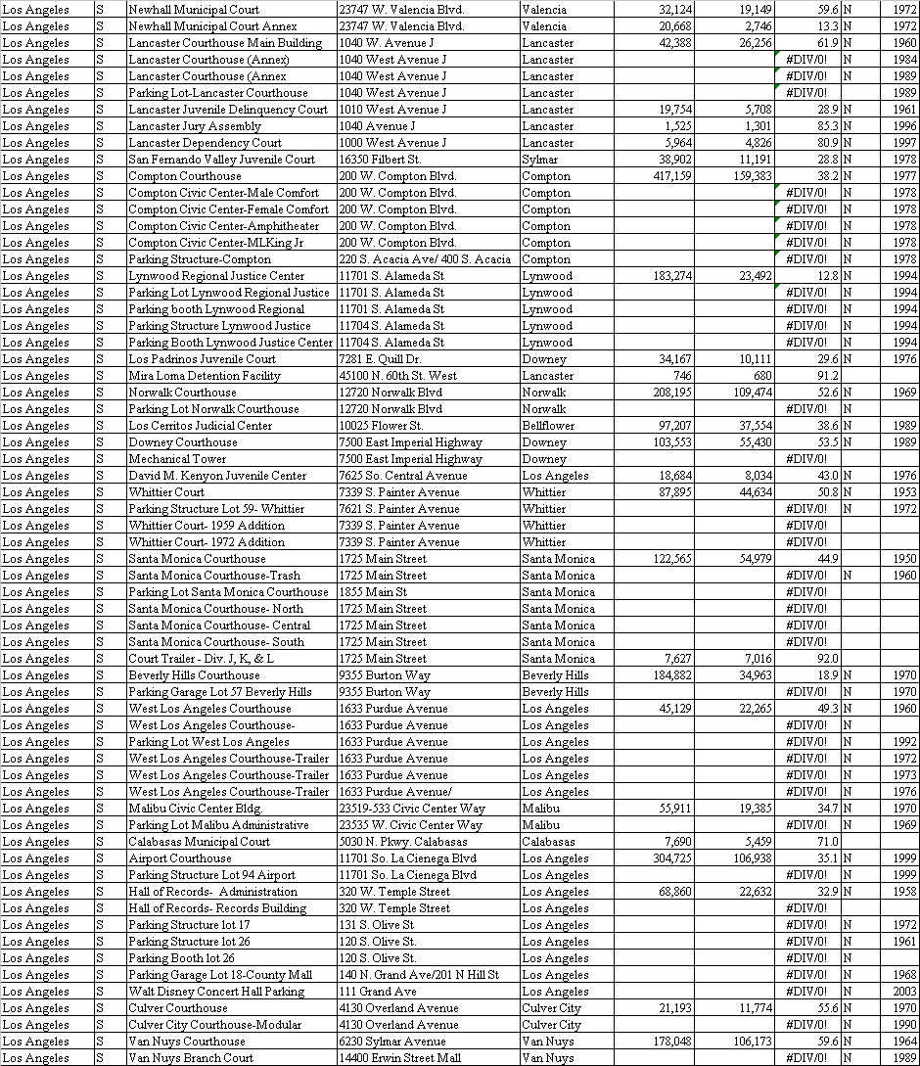

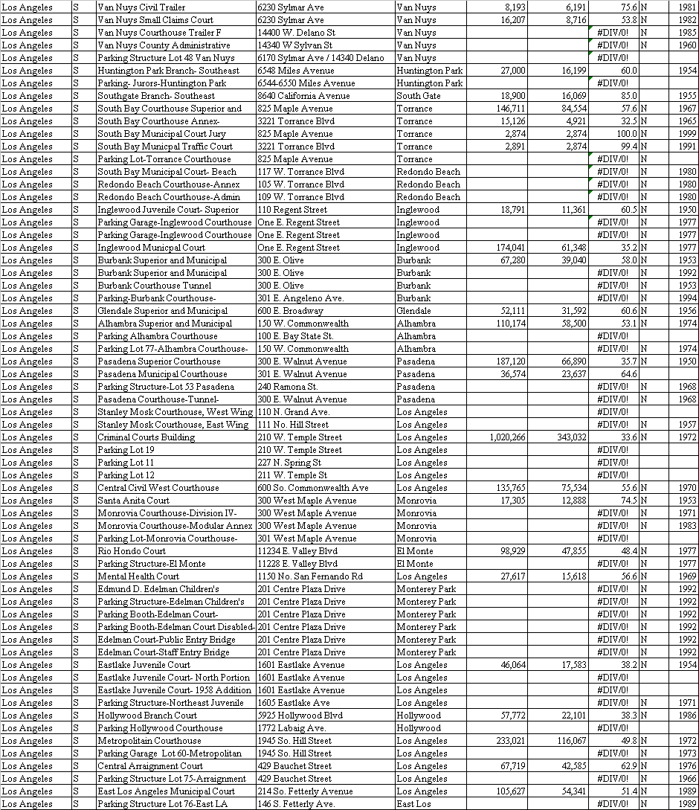

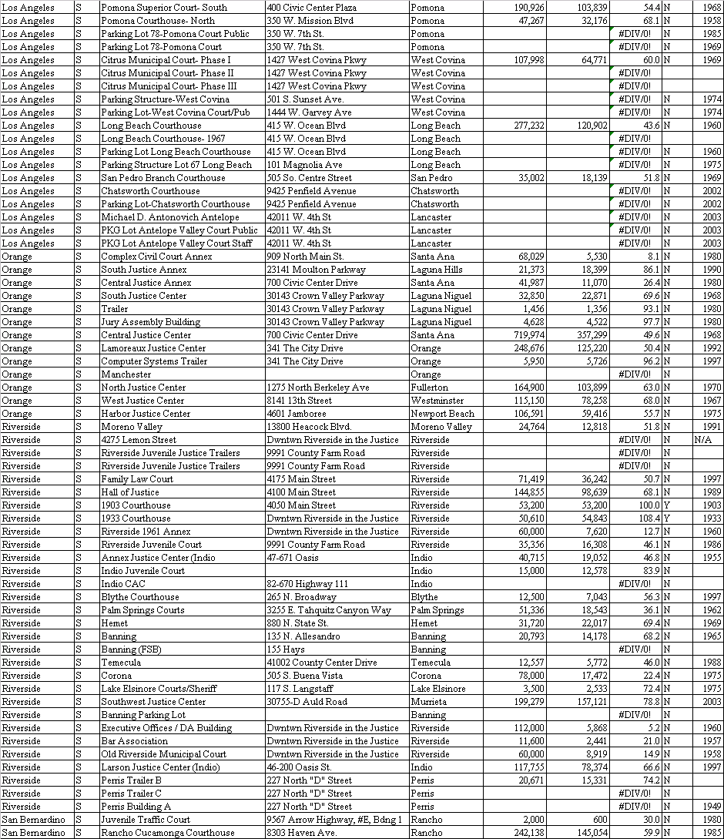

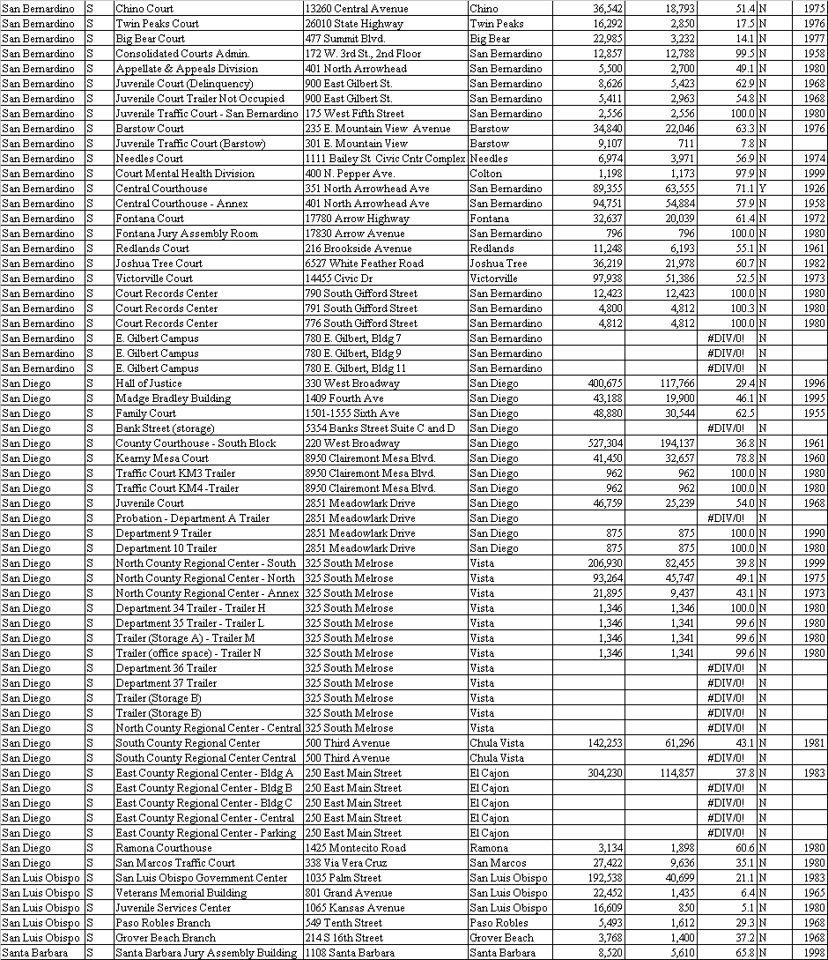

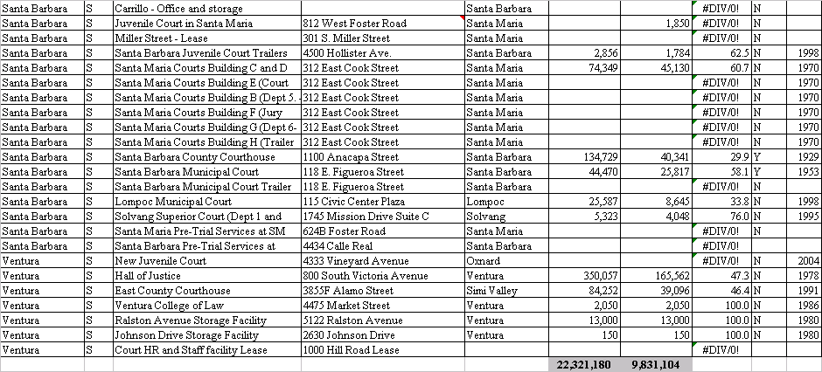

End of Attachment B

