CONSULTING MANAGED SERVICES RFP Number: IT-2025-203-RB

Exhibit D Region Map

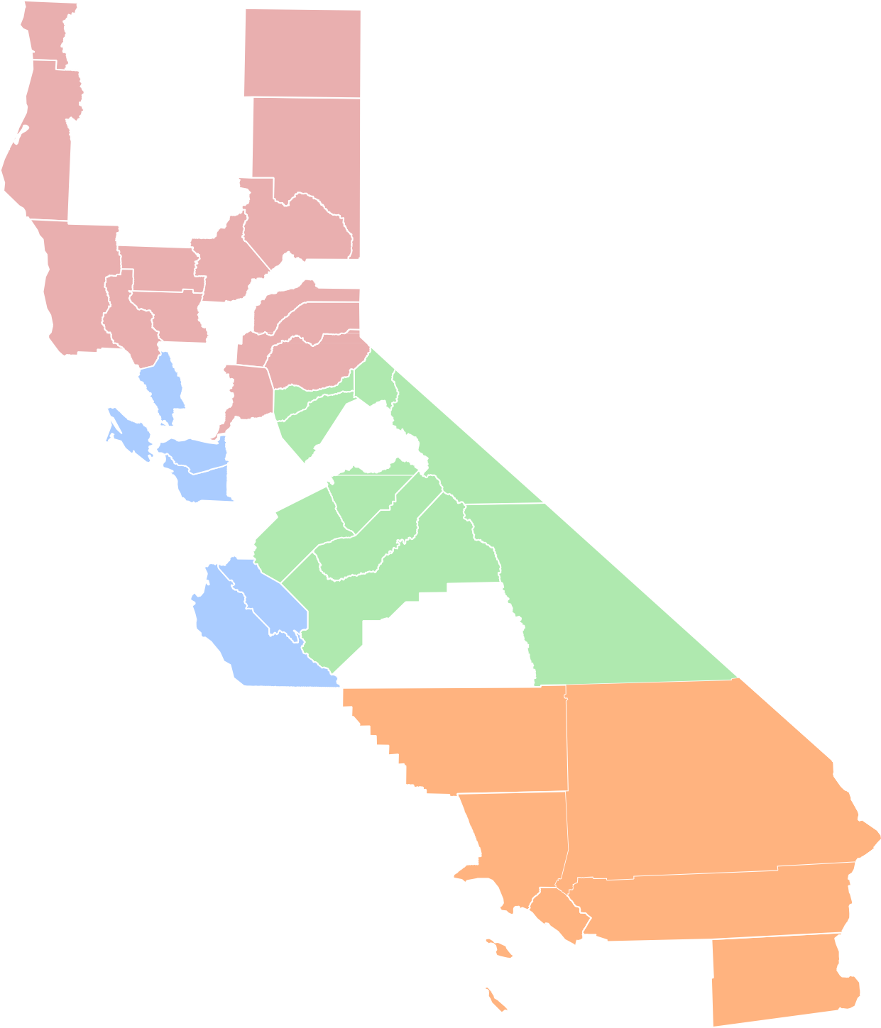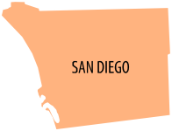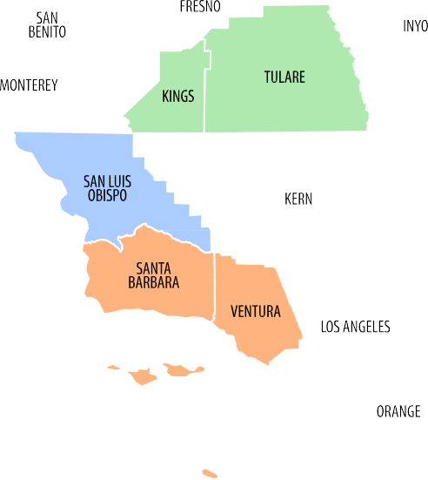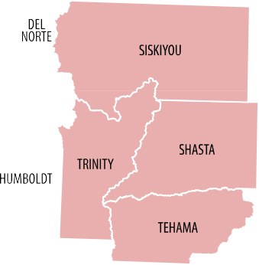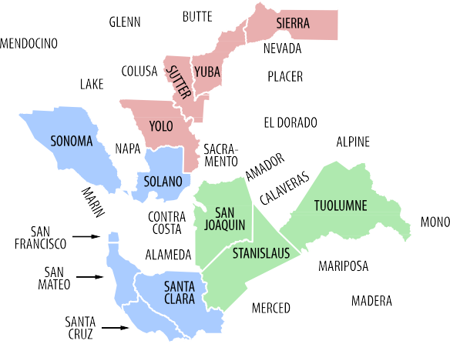

1

Court | Locations | Classification
Alameda | 10 | Large
Alpine | 1 | Small
Amador | 1 | Small
Butte | 2 | Small/Medium
Calaveras | 1 | Small
Colusa | 2 | Small
Contra Costa | 8 | Medium
Del Norte | 1 | Small
El Dorado | 5 | Small/Medium
Fresno | 5 | Medium
Glenn | 2 | Small
Humboldt | 1 | Small/Medium
Imperial | 3 | Small/Medium
Inyo | 2 | Small
Kern | 11 | Medium
Kings | 1 | Small/Medium
Lake | 2 | Small
Lassen | 1 | Small
Los Angeles | 40 | Large
Madera | 1 | Small/Medium
Marin | 1 | Small/Medium
Mariposa | 1 | Small
Mendocino | 2 | Small/Medium
Merced | 5 | Small/Medium
Modoc | 1 | Small
Mono | 2 | Small
Monterey | 3 | Medium
Napa | 3 | Small/Medium
Nevada | 2 | Small/Medium
Orange | 9 | Large
Placer | 4 | Small/Medium
Plumas | 3 | Small
Riverside | 16 | Large
Sacramento | 6 | Large
San Benito | 1 | Small
San Bernardino | 13 | Large
San Diego | 7 | Large
San Francisco | 4 | Large
San Joaquin | 5 | Medium
San Luis Obispo | 4 | Small/Medium
San Mateo | 5 | Medium
Santa Barbara | 8 | Medium
Santa Clara | 10 | Large
Santa Cruz | 2 | Small/Medium
Shasta | 2 | Small/Medium
Sierra | 1 | Small

Siskiyou | 2 | Small
Solano | 4 | Medium
Sonoma | 4 | Medium
Stanislaus | 7 | Medium
Sutter | 1 | Small
Tehama | 5 | Small
Trinity | 2 | Small
Tulare | 6 | Medium
Tuolumne | 2 | Small
Ventura | 3 | Medium
Yolo | 1 | Small/Medium
Yuba | 1 | Small

Court | Locations | Classification
Court of Appeal - 1st District | 1 | Medium
Court of Appeal - 2nd District | 2 | Medium
Court of Appeal - 3rd District | 1 | Small/Medium
Court of Appeal - 4th District | 3 | Medium
Court of Appeal - 5th District | 1 | Small/Medium
Court of Appeal - 6th District | 1 | Small/Medium
Supreme Court | 1 | Small/Medium

Judicial Branch Entities Listing
with addresses and county location

County | Court | Address | City | State | Zip Code
Alameda | Alameda | 1225 Fallon Street | Oakland | CA | 94612
Alameda | Alameda | 1221 Oak Street | Oakland | CA | 94612
Alameda | Alameda | 661 Washington Street | Oakland | CA | 94607
Alameda | Alameda | 2120 Martin Luther King Jr. Way | Berkeley | CA | 94704
Alameda | Alameda | 2233 Shoreline Drive | Alameda | CA | 94501
Alameda | Alameda | 2500 Fairmont Drive | San Leandro | CA | 94578
Alameda | Alameda | 2060 Fairmont Drive | San Leandro | CA | 94578
Alameda | Alameda | 24405 Amador Street | Hayward | CA | 94544
Alameda | Alameda | 39439 Paseo Padre Parkway | Fremont | CA | 94538
Alameda | Alameda | 5151 Gleason Dr. | Dublin | CA | 94568
Alpine | Alpine | 14777 State Route 89 | Markleeville | CA | 96120
Amador | Amador | 500 Argonaut Lane | Jackson | CA | 95642
Butte | Butte | One Court Street | Oroville | CA | 95965-3303
Butte | Butte | 1775 Concord Avenue | Chico | CA | 95928
Calaveras | Calaveras | 400 Government Center Dr. | San Andreas | CA | 95249
Colusa | Colusa | 547 Market Street | Colusa | CA | 95932
Colusa | Colusa | 532 Oak Street | Colusa | CA | 95932
Contra Costa | Contra Costa | 1020 Ward Street | Martinez | CA | 94553
Contra Costa | Contra Costa | 725 Court Street | Martinez | CA | 94553
Contra Costa | Contra Costa | 751 Pine Street | Martinez | CA | 94553
Contra Costa | Contra Costa | 202 Glacier Drive | Martinez | CA | 94553
Contra Costa | Contra Costa | 100 37th Street | Richmond | CA | 94805-2136
Contra Costa | Contra Costa | 640 Ygnacio Valley Road | Walnut Creek | CA | 94596
Contra Costa | Contra Costa | 1000 Center Drive | Pittsburg | CA | 94565
Contra Costa | Contra Costa | 1111 Ward Street | Martinez | CA | 94551-1328
Del Norte | Del Norte | 450 "H" Street | Crescent City | CA | 95531
El Dorado | El Dorado | 2850 Fairlane Court | Placerville | CA | 95667

County | Court | Address | City | State | Zip Code
El Dorado | El Dorado | 1354 Johnson Blvd, Suite 2 | South Lake Tahoe | CA | 96150
El Dorado | El Dorado | 495 Main Street | Placerville | CA | 95667
El Dorado | El Dorado | 295 Fair Lane | Placerville | CA | 95667
El Dorado | El Dorado | 3321 Cameron Park Drive | Cameron Park | CA | 95682
Fresno | Fresno | 1100 Van Ness Avenue | Fresno | CA | 93724-0002
Fresno | Fresno | 1225 M Street | Fresno | CA | 93721
Fresno | Fresno | 3333 E American Ave | Fresno | CA | 93725
Fresno | Fresno | 2317 Tuolumne Street | Fresno | CA | 93721
Fresno | Fresno | 1130 ‘O’ Street | Fresno | CA | 93721
Glenn | Glenn | 526 West Sycamore Street | Willows | CA | 95988
Glenn | Glenn | 821 E. South Street | Orland | CA | 95963
Humboldt | Humboldt | 825 5th Street | Eureka | CA | 95501
Imperial | Imperial | 939 West Main Street | El Centro | CA | 92243-2847
Imperial | Imperial | 220 E Main Street | Brawley | CA | 92227
Imperial | Imperial | 2124 Winterhaven Drive | Winterhaven | CA | 92283
Inyo | Inyo | 168 North Edwards Street | Independence | CA | 93526
Inyo | Inyo | 301 West Line Street | Bishop | CA | 93514
Kern | Kern | 1415 Truxtun Avenue | Bakersfield | CA | 93301
Kern | Kern | 2100 College Avenue | Bakersfield | CA | 93305
Kern | Kern | 1215 Truxtun Avenue | Bakersfield | CA | 93301
Kern | Kern | 3131 Arrow Street | Bakersfield | CA | 93308
Kern | Kern | 7046 Lake Isabella Boulevard | Lake Isabella | CA | 93240
Kern | Kern | 1773 Highway 58 | Mojave | CA | 93501
Kern | Kern | 132 East Coso Street | Ridgecrest | CA | 93555
Kern | Kern | 1122 Jefferson Street | Delano | CA | 93215
Kern | Kern | 325 Central Valley Highway | Shafter | CA | 93263
Kern | Kern | 12022 Main Street | Lamont | CA | 93241
Kern | Kern | 311 Lincoln Street | Taft | CA | 93268
Kings | Kings | 1640 Kings County Drive | Hanford | CA | 93230
Lake | Lake | 255 North Forbes Street | Lakeport | CA | 95453
Lake | Lake | 7000 - A South Center Drive | Clearlake | CA | 95422
Lassen | Lassen | 2610 Riverside Drive | Susanville | CA | 96130
Los Angeles | Los Angeles | 111 North Hill Street | Los Angeles | CA | 90012

County | Court | Address | City | State | Zip Code
Los Angeles | Los Angeles | 11701 South La Cienega Boulevard | Los Angeles | CA | 90045
Los Angeles | Los Angeles | 1040 West Avenue J | Lancaster | CA | 93534
Los Angeles | Los Angeles | 150 West Commonwealth Avenue | Alhambra | CA | 91801
Los Angeles | Los Angeles | 10025 East Flower Street | Bellflower | CA | 90706
Los Angeles | Los Angeles | 9355 Burton Way | Beverly Hills | CA | 90210-3669
Los Angeles | Los Angeles | 300 East Olive | Burbank | CA | 91502
Los Angeles | Los Angeles | 215 Sumner Avenue | Avalon | CA | 90704
Los Angeles | Los Angeles | 429 Bauchet Street | Los Angeles | CA | 90012-2995
Los Angeles | Los Angeles | 600 South Commonwealth Avenue | Los Angeles | CA | 90005
Los Angeles | Los Angeles | 9425 Penfield Avenue | Chatsworth | CA | 91311
Los Angeles | Los Angeles | 210 West Temple Street | Los Angeles | CA | 90012-3210
Los Angeles | Los Angeles | 200 West Compton Boulevard | Compton | CA | 90220
Los Angeles | Los Angeles | 7500 East Imperial Highway | Downey | CA | 90242
Los Angeles | Los Angeles | 4848 E. Civic Center Way | Los Angeles | CA | 90022
Los Angeles | Los Angeles | 1601 Eastlake Avenue | Los Angeles | CA | 90033
Los Angeles | Los Angeles | 201 Centre Plaza Drive | Monterey Park | CA | 91754-2158
Los Angeles | Los Angeles | 11234 East Valley Boulevard | El Monte | CA | 91731
Los Angeles | Los Angeles | 600 East Broadway | Glendale | CA | 91206
Los Angeles | Los Angeles | 5925 Hollywood Boulevard | Los Angeles | CA | 90028-5434
Los Angeles | Los Angeles | One Regent Street | Inglewood | CA | 90301
Los Angeles | Los Angeles | 110 Regent Street | Inglewood | CA | 90301
Los Angeles | Los Angeles | 275 Magnolia Ave. | Long Beach | CA | 90802
Los Angeles | Los Angeles | 7281 East Quill Drive | Downey | CA | 90242
Los Angeles | Los Angeles | 1945 South Hill Street | Los Angeles | CA | 90007
Los Angeles | Los Angeles | 42011 4th Street West | Lancaster | CA | 93534-7185
Los Angeles | Los Angeles | 12720 Norwalk Boulevard | Norwalk | CA | 90650
Los Angeles | Los Angeles | 300 East Walnut Street | Pasadena | CA | 91101
Los Angeles | Los Angeles | 400 Civic Center Plaza | Pomona | CA | 91766-3201
Los Angeles | Los Angeles | 900 Third Street | San Fernando | CA | 91340
Los Angeles | Los Angeles | 23747 West Valencia Boulevard | Santa Clarita | CA | 91355
Los Angeles | Los Angeles | 1725 Main Street | Santa Monica | CA | 90401
Los Angeles | Los Angeles | 16350 Filbert Street, Room 200 | Sylmar | CA | 91342
Los Angeles | Los Angeles | 312 North Spring Street | Los Angeles | CA | 90012

County | Court | Address | City | State | Zip Code
Los Angeles | Los Angeles | 825 Maple Avenue | Torrance | CA | 90503
Los Angeles | Los Angeles | 6230 Sylmar Avenue | Van Nuys | CA | 91401
Los Angeles | Los Angeles | 14400 Erwin Street Mall | Van Nuys | CA | 91401-2705
Los Angeles | Los Angeles | 1427 West Covina Parkway | West Covina | CA | 91790
Los Angeles | Los Angeles | 7339 South Painter Ave. | Whittier | CA | 90602
Madera | Madera | 200 South G Street | Madera | CA | 93637
Marin | Marin | 3501 Civic Center Drive | San Rafael | CA | 94903
Mariposa | Mariposa | 5088 Bullion Street | Mariposa | CA | 95338
Mendocino | Mendocino | 100 North State Street | Ukiah | CA | 95482
Mendocino | Mendocino | 700 South Franklin Street | Fort Bragg | CA | 95437
Merced | Merced | 2260 N Street | Merced | CA | 95340
Merced | Merced | 2840 W. Sandy Mush Road | Merced | CA | 95340
Merced | Merced | 627 West 21st Street | Merced | CA | 95340
Merced | Merced | 1159 G Street | Los Banos | CA | 93635
Merced | Merced | 720 W. 20th Street | Merced | CA | 95340
Modoc | Modoc | 205 South East Street | Alturas | CA | 96101
Mono | Mono | 100 Thompsons Way | Mammoth Lakes | CA | 93546
Mono | Mono | 278 Main Street | Bridgeport | CA | 93517
Monterey | Monterey | 240 Church Street | Salinas | CA | 93901
Monterey | Monterey | 1200 Aguajito Road | Monterey | CA | 93940
Monterey | Monterey | 3180 Del Monte Boulevard | Marina | CA | 93933
Napa | Napa | 825 Brown Street | Napa | CA | 94559
Napa | Napa | 1111 Third Street | Napa | CA | 94559
Napa | Napa | 2350 Old Sonoma Road | Napa | CA | 94559
Nevada | Nevada | 201 Church Street | Nevada City | CA | 95959
Nevada | Nevada | 10075 Levon Avenue, Ste. 301 | Truckee | CA | 96161
Orange | Orange | 700 W Civic Center Drive West | Santa Ana | CA | 92701
Orange | Orange | 751 West Santa Ana Boulevard | Santa Ana | CA | 92701
Orange | Orange | 909 North Main Street | Santa Ana | CA | 92701
Orange | Orange | 341 The City Drive S | Orange | CA | 92868
Orange | Orange | 23141 Moulton Parkway | Laguna Hills | CA | 92653-1251
Orange | Orange | 4601 Jamboree Road | Newport Beach | CA | 92660-2595
Orange | Orange | 1275 North Berkeley Avenue | Fullerton | CA | 92832-0500

County | Court | Address | City | State | Zip Code
Orange | Orange | 550 N. Flower St. | Santa Ana | CA | 92103
Orange | Orange | 8141-8144 13th Street | Westminster | CA | 92683
Placer | Placer | 101 Maple Street | Auburn | CA | 95603
Placer | Placer | 11270 B Avenue | Auburn | CA | 95603
Placer | Placer | 10820 Justice Center Drive | Roseville | CA | 95678
Placer | Placer | 2501 North Lake Blvd. | Tahoe City | CA | 96145
Plumas | Plumas | 520 Main Street | Quincy | CA | 95971
Riverside | Riverside | 4050 Main Street | Riverside | CA | 92501
Riverside | Riverside | 4100 Main Street | Riverside | CA | 92501
Riverside | Riverside | 4175 Main Street | Riverside | CA | 92501
Riverside | Riverside | 9991 County Farm Road | Riverside | CA | 92501
Riverside | Riverside | 30755-D Auld Road | Murrieta | CA | 92563
Riverside | Riverside | 13800 Heacock Street, Bldg. D #201 | Moreno Valley | CA | 92553
Riverside | Riverside | 3255 E. Tahquitz Canyon Way | Palm Springs | CA | 92262
Riverside | Riverside | 311 E. Ramsey Street | Banning | CA | 92220
Riverside | Riverside | 880 North State Street | Hemet | CA | 92543
Riverside | Riverside | 41002 County Center Drive | Temecula | CA | 92590
Riverside | Riverside | 265 North Broadway Street | Blythe | CA | 92225
Riverside | Riverside | 47-671 Oasis Street | Indio | CA | 92201
Riverside | Riverside | 46-200 Oasis Street | Indio | CA | 92201
Sacramento | Sacramento | 720 Ninth Street | Sacramento | CA | 95814
Sacramento | Sacramento | 3341 Power Inn Road | Sacramento | CA | 95826
Sacramento | Sacramento | 301 Bicentennial Circle | Sacramento | CA | 95826
Sacramento | Sacramento | 9605 Kiefer Boulevard | Sacramento | CA | 95827
Sacramento | Sacramento | 651 I Street | Sacramento | CA | 95814
Sacramento | Sacramento | 813 6th Street | Sacramento | CA | 95814
San Benito | San Benito | 450 Fourth Street | Hollister | CA | 95023
San Bernardino | San Bernardino | 351 North Arrowhead Avenue | San Bernardino | CA | 92415
San Bernardino | San Bernardino | 655 West Second St 2nd Flr | San Bernardino | CA | 92415
San Bernardino | San Bernardino | 900 East Gilbert Street | San Bernardino | CA | 92415-0942
San Bernardino | San Bernardino | 860 East Gilbert Street | San Bernardino | CA | 92415
San Bernardino | San Bernardino | 401 N Arrowhead Avenue | San Bernardino | CA | 92415
San Bernardino | San Bernardino | 235 East Mountain View Avenue | Barstow | CA | 92311

County | Court | Address | City | State | Zip Code
San Bernardino | San Bernardino | 17780 Arrow Boulevard | Fontana | CA | 92335
San Bernardino | San Bernardino | 6527 White Feather Road | Joshua Tree | CA | 92252
San Bernardino | San Bernardino | 8303 North Haven Avenue | Rancho Cucamonga | CA | 91730
San Bernardino | San Bernardino | 14455 Civic Drive | Victorville | CA | 92392
San Bernardino | San Bernardino | 247 W 3rd Street | San Bernardino | CA | 92415
San Bernardino | San Bernardino | 477 Summit Blvd | Big Bear Lake | CA | 92315
San Bernardino | San Bernardino | 1111 Bailey Street | Needles | CA | 92363
San Diego | San Diego | 1100 Union Street | San Diego | CA | 92101
San Diego | San Diego | 330 West Broadway | San Diego | CA | 92101
San Diego | San Diego | 330 West Broadway | San Diego | CA | 92101
San Diego | San Diego | 8950 Clairemont Mesa Boulevard | San Diego | CA | 92123
San Diego | San Diego | 2851 Meadowlark Drive | San Diego | CA | 92123
San Diego | San Diego | 250 East Main Street | El Cajon | CA | 92020
San Diego | San Diego | 325 South Melrose Drive | Vista | CA | 92081
San Diego | San Diego | 500 Third Avenue | Chula Vista | CA | 91910
San Francisco | San Francisco | 400 McAllister Street | San Francisco | CA | 94102
San Francisco | San Francisco | 375 Woodside Avenue | San Francisco | CA | 94127
San Francisco | San Francisco | 850 Bryant Street | San Francisco | CA | 94103
San Francisco | San Francisco | 575 Polk Street | San Francisco | CA | 94102
San Joaquin | San Joaquin | 180 E Weber | Stockton | CA | 95202
San Joaquin | San Joaquin | 535 West Mathews Road | French Camp | CA | 95231
San Joaquin | San Joaquin | 217 West Elm Street | Lodi | CA | 95240
San Joaquin | San Joaquin | 315 West Elm Street | Lodi | CA | 95240
San Joaquin | San Joaquin | 315 East Center Street | Manteca | CA | 95336
San Luis Obispo | San Luis Obispo | 1035 Palm Street | San Luis Obispo | CA | 93408-2500
San Luis Obispo | San Luis Obispo | 801 Grand Avenue | San Luis Obispo | CA | 93408
San Luis Obispo | San Luis Obispo | 1050 Monterey St | San Luis Obispo | CA | 93408
San Luis Obispo | San Luis Obispo | 901 Park Street | Paso Robles | CA | 93446
San Mateo | San Mateo | 400 County Center | Redwood City | CA | 94063

County | Court | Address | City | State | Zip Code
San Mateo | San Mateo | 500 County Center | Redwood City | CA | 94063
San Mateo | San Mateo | 1050 Mission Road | South San Francisco | CA | 94080
San Mateo | San Mateo | 800 North Humboldt Street | San Mateo | CA | 94401
San Mateo | San Mateo | 222 Paul Scannell Drive | San Mateo | CA | 94402
Santa Barbara | Santa Barbara | 1100 Anacapa Street | Santa Barbara | CA | 93101
Santa Barbara | Santa Barbara | 118 East Figueroa Street | Santa Barbara | CA | 93101
Santa Barbara | Santa Barbara | 312-C East Cook Street | Santa Maria | CA | 93456
Santa Barbara | Santa Barbara | 312-M East Cook Street, Bldg E | Santa Maria | CA | 93454
Santa Barbara | Santa Barbara | 4285 California | Santa Maria | CA | 93454
Santa Barbara | Santa Barbara | 115 Civic Center Plaza | Lompoc | CA | 93436-6967
Santa Barbara | Santa Barbara | 1745 Mission Drive | Solvang | CA | 93463
Santa Clara | Santa Clara | 270 Grant Avenue | Palo Alto | CA | 94306
Santa Clara | Santa Clara | 191 North First Street | San Jose | CA | 95113
Santa Clara | Santa Clara | 190 West Hedding Street | San Jose | CA | 95110
Santa Clara | Santa Clara | 840 Guadalupe Parkway | San Jose | CA | 95110
Santa Clara | Santa Clara | 1095 Homestead Road | Santa Clara | CA | 95050
Santa Clara | Santa Clara | 161 North First Street | San Jose | CA | 95113
Santa Clara | Santa Clara | 301 Diana Avenue | Morgan Hill | CA | 95037
Santa Cruz | Santa Cruz | 701 Ocean Street | Santa Cruz | CA | 95060
Santa Cruz | Santa Cruz | 1 Second Street | Watsonville | CA | 95076
Shasta | Shasta | 1500 Court Street | Redding | CA | 96001
Shasta | Shasta | 20509 Shasta Street | Burney |  | 96013
Sierra | Sierra | 100 Courthouse Square | Downieville | CA | 95936
Siskiyou | Siskiyou | 311 Fourth Street | Yreka | CA | 96097
Siskiyou | Siskiyou | 324 North Pine Street | Dorris | CA | 96023
Solano | Solano | 600 Union Avenue | Fairfield | CA | 94533-5000
Solano | Solano | 321 Tuolumne Street | Vallejo | CA | 94590
Solano | Solano | 530 Union Avenue | Fairfield | CA | 94533
Solano | Solano | 580 Texas Street | Fairfield | CA | 94533
Sonoma | Sonoma | 600 Administration Drive | Santa Rosa | CA | 94503
Sonoma | Sonoma | 3035 Cleveland Avenue | Santa Rosa | CA | 95403
Sonoma | Sonoma | 3055 Cleveland Avenue | Santa Rosa | CA | 95403
Sonoma | Sonoma | 7425 Rancho Los Guilicos Road | Santa Rosa | CA | 95409

County | Court | Address | City | State | Zip Code
Stanislaus | Stanislaus | 800 11th Street | Modesto | CA | 95353
Stanislaus | Stanislaus | 801 10th Street | Modesto | CA | 95354
Stanislaus | Stanislaus | 2260 Floyd Avenue | Modesto | CA | 95355
Stanislaus | Stanislaus | 2215 Blue Gum Avenue | Modesto | CA | 95356
Stanislaus | Stanislaus | 300 Starr Avenue | Turlock | CA | 95380
Stanislaus | Stanislaus | 1100 I Street | Modesto | CA | 95354
Sutter | Sutter | 1175 Civic Center Blvd | Yuba City | CA | 95993
Tehama | Tehama | 633 Washington St. | Red Bluff | CA | 96080
Tehama | Tehama | 445 Pine Street, 2nd Floor | Red Bluff | CA | 96080
Tehama | Tehama | 445 Pine Street, 1st Floor | Red Bluff | CA | 96080
Tehama | Tehama | 1740 Walnut Street | Red Bluff | CA | 96080
Trinity | Trinity | 11 Court Street | Weaverville | CA | 96093
Trinity | Trinity | 6641 B State Hwy 3 | Hayfork | CA | 96041
Tulare | Tulare | 221 Mooney Blvd. | Visalia | CA | 93291-4593
Tulare | Tulare | 11200 Avenue 368 | Visalia | CA | 93291
Tulare | Tulare | 640 South Alta Avenue | Dinuba | CA | 93618
Tulare | Tulare | 36650 Road 112 | Visalia | CA | 93291
Tulare | Tulare | 3400 W. Mineral King Ave | Visalia | CA | 93291
Tulare | Tulare | 300 E Olive | Porterville | CA | 93257
Tuolumne | Tuolumne | 41 West Yaney Avenue | Sonora | CA | 95370
Tuolumne | Tuolumne | 60 North Washington Street | Sonora | CA | 95370
Ventura | Ventura | 800 South Victoria Avenue | Ventura | CA | 93006-0001
Ventura | Ventura | 3855-F Alamo Street | Simi Valley | CA | 93063
Ventura | Ventura | 4353 Vineyard Avenue | Oxnard | CA | 93036
Yolo | Yolo | 1000 Main Street | Woodland | CA | 95695
Yuba | Yuba | 215 Fifth Street | Marysville | CA | 95901
San Francisco | Supreme Court | 350 McAllister Street | San Francisco | CA | 94102-4797
San Francisco | 1st District Appellate | 350 McAllister Street | San Francisco | CA | 94102-3600
Los Angeles | 2nd District Appellate (Division One, Two, Three, Four, Five,  Seven, Eight) | 300 South Spring Street | Los Angeles | CA | 90013

County | Court | Address | City | State | Zip Code
Ventura | 2nd District Appellate (Division Six) | 200 East Santa Clara Street | Ventura | CA | 93001
Sacramento | 3rd District Appellate | 914 Capitol Mall, 4th Floor | Sacramento | CA | 95814
San Diego | 4th District Appellate (Division One) | 750 B Street, Suite 300 | San Diego | CA | 92101
Riverside | 4th District Appellate (Division Two) | 3389 Twelfth Street | Riverside | CA | 92501
Orange | 4th District Appellate (Division Three) | 601 W. Santa Ana Blvd | Santa Ana | CA | 92701
Fresno | 5th District Appellate | 2424 Ventura Street | Fresno | CA | 93721
Santa Clara | 6th District Appellate | 333 West Santa Clara Street | San Jose | CA | 95113
San Francisco | JUDICIAL COUNCIL (SF) | 455 Golden Gate Avenue | San Francisco | CA | 94102-3688
Sacramento | JUDICIAL COUNCIL (OGA) | 770 L Street | Sacramento | CA | 95814
Sacramento | JUDICIAL COUNCIL | 2860 Gateway Oaks Drive, Suite 400 | Sacramento | CA | 95833-3509

