EXHIBIT A
STANDARD PROVISIONS

- Indemnification

The Contractor shall indemnify, defend (with counsel satisfactory to the State), and save harmless the State and its officers, agents, and employees from any and all claims and losses accruing or resulting to any and all other contractors, Subcontractors, suppliers, and laborers, and any other person, firm, or corporation furnishing or supplying Work, Materials, Data, or services in connection with the performance of this Agreement, and from any and all claims and losses accruing or resulting to any person, firm, or corporation who may be injured or damaged by the Contractor or its agents or employees in the performance of this Agreement.

- Relationship of Parties

The Contractor and the agents and employees of the Contractor, in the performance of this Agreement, shall act in an independent capacity and not as officers or employees or agents of the State of California.

- Termination for Cause

The State may terminate this Agreement and be relieved of the payment of any consideration to the Contractor if the Contractor fails to perform the provisions of this Agreement at the time and in the manner provided. If the Agreement is terminated, the State may proceed with the Work in any manner it deems proper. The cost to the State to perform this Agreement shall be deducted from any sum due the Contractor under this Agreement or any other agreement, and the balance, if any, shall be paid to the Contractor upon demand.

- No Assignment

Without the written consent of the State, the Contractor shall not assign this Agreement in whole or in part.

- Time of Essence

Time is of the essence in this Agreement.

- Validity of Alterations

Alteration or variation of the terms of this Agreement shall not be valid unless made in writing and signed by the parties, and an oral understanding or agreement that is not incorporated shall not be binding on any of the parties.

- Consideration

The consideration to be paid to the Contractor under this Agreement shall be compensation for all the Contractor's expenses incurred in the performance of this Agreement, including travel and per diem, unless otherwise expressly provided.

END OF EXHIBIT
EXHIBIT B
SPECIAL PROVISIONS

- Definitions

Terms defined below and elsewhere throughout the Contract Documents shall apply to the Agreement as defined.

  - “Acceptance” means the written acceptance issued to the Contractor by the State after the Contractor has completed a Deliverable, Submittal, or other Contract requirement, in compliance with the Contract Documents and the authorized Work Authorization Form, including without limitation, Exhibit D, Work Authorization Administration, and the Acceptance of the Work provision set forth in this Exhibit.

  - “Administrative Director” refers to that individual or authorized designee, empowered by the State to make final and binding executive decisions on behalf of the State.

  - “Amendment” means a written document issued by the State and signed by the Contractor which alters the Contract Documents and identifies the following: (i) a change in the Work; (ii) a change in Contract Amount; (iii) a change in time allotted for performance; and/or (iv) an adjustment to the Agreement terms.

  - “Confidential Information” means trade secrets, financial, statistical, personnel, technical, and other Data and information relating to the State’s business or the business of its constituents. Confidential Information does not include (i) information that is already known by the receiving party, free of obligation of confidentiality to the disclosing party; (ii) information that becomes generally available to the public, other than as a result of disclosure by the receiving party in breach of this Agreement; (iii) information that is independently developed by the receiving party without reference to the Confidential Information; and (iv) information that the receiving party rightfully obtains from a Third Party free of the obligation of confidentiality to the disclosing party.

  - The “Contract” or “Contract Documents” constitute the entire integrated agreement between the State and the Contractor, as attached to and incorporated by a fully executed State Standard Agreement form. The terms “Contract” or “Contract Documents” may be used interchangeably with the term “Agreement.”

  - “Contract Amount” means the total amount encumbered under this Agreement for any payment by the State to the Contractor for performance of the Work, in accordance with the Contract Documents.

  - “Contract Counterpart” means the several originally signed, fully executed versions of the State Standard Agreement, together with the integrated Contract Documents, each representing this Agreement.

  - The “Contractor” means the individual, association, partnership, firm, company, consultant, corporation, affiliates, or combination thereof, including joint ventures, contracting with the State to do the Contract Work. The Contractor is one of the parties to this Agreement.

  - The “Contractor’s Technology” refers to various concepts, ideas, methods, methodologies, procedures, processes, know-how, and techniques including, without limitation, function, process, system and data models; templates; generalized features of the structure, sequence and organization software, user interfaces and screen designs; general purpose consulting and software tools, utilities and routines; and, logic, coherence and methods of operation of systems which the Contractor has created, acquired or otherwise has rights in and may, in connection with the performance of services hereunder, create, acquire or otherwise obtain rights in.

  - “Data” means all types of raw data, articles, papers, charts, records, reports, studies, research, memoranda, computation sheets, questionnaires, surveys, and other documentation.

  - “Day” means calendar day, unless otherwise specified.

  - “Deliverable(s)” or “Submittal(s)” means one or more items, if specified in the Contract Documents, that the Contractor shall complete and deliver or submit to the State for acceptance.

  - “Force Majeure” means a delay which impacts the timely performance of Work which neither the Contractor nor the State are liable for because such delay or failure to perform was unforeseeable and beyond the control of the party. Acts of Force Majeure include, but are not limited to:

    - Acts of God or the public enemy;
    - Acts or omissions of any government entity;
    - Fire or other casualty for which a party is not responsible;
    - Quarantine or epidemic;
    - Strike or defensive lockout; and,
    - Unusually severe weather conditions.

  - “Foreign Language Translation” means the process of translating English language text into foreign language text, such as Spanish, Chinese, Korean, Vietnamese, Cambodian and Russian.

  - “Master Agreement” means this Master Agreement Number To Be Determined that sets forth the terms and conditions under which the State retains the Contractor and the Contractor provides Work detailed in individual Work Authorizations.

  - “Material” means all types of tangible personal property, including but not limited to goods, supplies, equipment, commodities, and information and telecommunication technology.

  - “Milestone(s)” means one or more events or dates, if specified in the Contract Documents, by which Work, as identified, must be provided by the Contractor.

  - “Notice” means a written document initiated by the authorized representative of either party to this Agreement and given by:

    - Depositing in the U. S. Mail (or approved commercial express carrier) prepaid to the address of the appropriate authorized representative of the other party, which shall be effective upon date of receipt; or
    - Hand-delivered to the other party’s authorized representative, which shall be effective on the date of service.

  - “Plain Language” shall mean employing a “plain English” vocabulary and sentences that are easy to understand. Meeting “Plain Language” criteria means maximizing “readability.” The average native English speaking American reads comfortably at the 5th grade level. To ensure that the translated documents reach the greatest number of readers, text must be appropriate for a 4th – 7th grade level range.

  - “Project” refers to all activity relative to this Agreement including activity of the Contractor, its Subcontractors, the State and the State’s representatives.

  - The “State” refers to the Judicial Council of California / Administrative Office of the Courts (“AOC”). The State is one of the parties to this Agreement.

  - “State Standard Agreement” means the form used by the State to enter into agreements with other parties.

  - “Stop Work Order” means the written Notice, delivered in accordance with this Agreement, by which the State may require the Contractor to stop all, or any part, of the Work of this Agreement, for the period set forth in the Stop Work Order. The Stop Work Order shall be specifically identified as such and shall indicate that it is issued pursuant to the Stop Work provision in this Exhibit.

  - “Subcontractor” shall mean an individual, firm, partnership, or corporation having a contract, purchase order, or agreement with the Contractor, or with any Subcontractor of any tier for the performance of any part of the Agreement. When the State refers to Subcontractor(s) in this document, for purposes of this Agreement and unless otherwise expressly stated, the term Subcontractor includes, at every level and/or tier, all subcontractors, sub-consultants, suppliers, and materialmen.

  - “Task(s)” means one or more functions, if specified in the Contract Documents, to be performed by the Contractor for the State.

  - “Third Party” refers to any individual, association, partnership, firm, company, corporation, consultant, Subcontractor, or combination thereof, including joint ventures, other than the State or the Contractor, which is not a party to this Agreement.

  - “Work” or “Work to be Performed” or “Contract Work” may be used interchangeably to refer to the service, labor, Materials, Data, and other items necessary for the execution, completion and fulfillment of the Agreement by the Contractor to the satisfaction of the State. Work may be defined to include Tasks, Deliverables, and/or Submittals, as required by the Contract.

  - “Work Authorization” refers to a document, substantially in the form of Exhibit E, Attachment 1, Sample Work Authorization Form, that is used by the State’s Project Manager or his/her designee to authorize Work pursuant to this Agreement and provides details about the nature of the Work the Contractor will perform, the timeline for completion of the Work, not-to-exceed Work Authorization Amount, additional reporting guidelines, and other practical details.

  - “Work Authorization Amount” means the not to exceed amount specified in a Work Authorization.

- Manner of Performance of Work

The Contractor shall complete all Work specified in these Contract Documents to the State's satisfaction and in compliance with the Nondiscrimination/No Harassment Clause, as set forth in this Exhibit B.

- Termination Other Than for Cause

  - In addition to termination for cause under Exhibit A, Standard Provisions paragraph 3, the State may terminate this Agreement at any time upon providing the Contractor written Notice at least ten (10) Days before the effective date of termination. Upon receipt of the termination Notice, the Contractor shall promptly discontinue all services affected unless the Notice specifies otherwise.

  - If the State terminates all or a portion of this Agreement other than for cause, the State shall pay the Contractor for the fair value of satisfactory services rendered before the termination, not to exceed the amount specified in any uncompleted Work Authorization or the Contract Amount.

- Agreement Term(s) and Options to Renew

  - The Master Agreement shall remain in effect from To Be Determined, 2007 through To Be Determined, 2008 (“Initial Term”), unless otherwise set forth in writing, in accordance with the terms and conditions of the Master Agreement.

  - The parties agree that the State may elect to extend the Master Agreement up to two (2) consecutive optional one-year Terms, identified as follows, if authorized in writing in accordance with the terms and conditions of the Master Agreement:

    - To Be Determined, 2008 through To Be Determined, 2009 (“First Option Term”).
    - To Be Determined, 2009 through To Be Determined, 20010 (“Second Option Term”).

  - In the event the State elects to exercise an option to extend the Master Agreement, as set forth in this provision, the parties will modify the Agreement via bilateral execution of the State’s Standard Agreement form.

  - In the event any option Term is exercised under this Agreement, the rates applicable for each option Term, as set forth in Exhibit C, Payment Provisions, shall apply.

- State's Obligation Subject to Availability of Funds

  - The State's obligation under this Agreement is subject to the availability of authorized funds. The State may terminate the Agreement or any part of the Contract Work, without prejudice to any right or remedy of the State, for lack of appropriation of funds. If expected or actual funding is withdrawn, reduced or limited in any way prior to the expiration date set forth in this Agreement, or in any Amendment hereto, the State may terminate this Agreement in whole or in part, upon written Notice to the Contractor. Such termination shall be in addition to the State's rights to terminate for convenience or default.

  - Payment shall not exceed the amount allowable for appropriation by Legislature. If the Agreement is terminated for non-appropriation:

    - The State will be liable only for payment in accordance with the terms of this Agreement for services rendered prior to the effective date of termination; and
    - The Contractor shall be released from any obligation to provide further services pursuant to the Agreement as are affected by the termination.

  - Funding for this Agreement beyond the current appropriation year is conditional upon appropriation by the Legislature of sufficient funds to support the activities described in this Agreement. Should such an appropriation not be approved, the Agreement may terminate at the close of the current appropriation year. The appropriation year ends on June 30 of each year.

- Stop Work

  - The State may, at any time by written Notice to the Contractor, require the Contractor to stop all, or any part, of the Work of this Agreement, for a period up to ninety (90) Days after the Notice is delivered to the Contractor, and for any further period to which the parties may agree. The Stop Work Order shall be specifically identified as such and shall indicate it is issued under this provision. Upon receipt of the Stop Work Order, the Contractor shall immediately comply with its terms and take all reasonable steps to minimize the incurrence of costs allocable to the Work covered by the Stop Work Order during the period of Work stoppage. Within a period of ninety (90) Days after a Stop Work Order is delivered to the Contractor, or within any extension of that period to which the parties shall have agreed, the State shall either:

    - Cancel the Stop Work Order; or
    - Terminate the Work covered by the Stop Work Order as provided for in either of the termination provisions of this Agreement.

  - If a Stop Work Order issued under this provision is canceled or the period of the Stop Work Order or any extension thereof expires, the Contractor shall resume Work. The State shall make an equitable adjustment in the delivery schedule and/or the Work Order Amount, and the Agreement shall be modified, in writing, accordingly, if:

    - The Stop Work Order results in an increase in the time required for, or in the Contractor’s cost properly allocable to the performance of any part of this Agreement; and
    - The Contractor asserts its right to an equitable adjustment within thirty (30) Days after the end of the period of Work stoppage; however, if the State decides the facts justify the action, the State may receive and act upon a proposal submitted at any time before final payment under this Agreement.

  - If a Stop Work Order is not canceled and the Work covered by the Stop Work Order is terminated in accordance with the Termination Other Than For Cause provision or the State’s Obligation Subject to Availability of Funds provision, as set forth under Exhibit B, the State shall allow reasonable costs resulting from the Stop Work Order in arriving at the termination settlement.

  - The State shall not be liable to the Contractor for loss of profits because of the Stop Work Order issued under this provision.

- Agreement Administration/Communication

  - State Project Management

    - The State’s Project Manager assigned to this Agreement shall be To Be Determined, who will be responsible for issuing Work Authorizations, monitoring and evaluating the Contractor's performance as a representative of the State and will grant Acceptance of the Work. All requests and communications about the services to be performed under this Agreement shall be made through the State’s Project Manager, unless otherwise designated.

    - For a particular Work Authorization, the State’s Project Manager may authorize another individual, to serve as the designated State’s Project Manager, to be responsible for day-to-day management of that Work Authorization. The State’s Project Manager will consult with any designee(s) to determine if the Contractor has satisfactorily performed the Work in accordance with the terms and conditions of the Agreement.

  - Communications with the AOC

    - Any Notice from the Contractor to the State shall be in writing and shall be delivered the Project Manager, as follows:

To Be Determined
Administrative Office of the Courts
455 Golden Gate Avenue, 6th Floor
San Francisco, CA 94102

  - Additionally, for other than Notices, Bonnie Hough can be contacted as follows:

Telephone: To Be Determined
FAX: To Be Determined
e-Mail: To Be Determined

  - Notice to the Contractor shall be directed in writing as follows:

To Be Determined

  - Additionally, for other than Notices, Contractor can be contacted as follows:

Telephone: To Be Determined
FAX: To Be Determined
e-Mail: To Be Determined

- Authorization of Any Work

The State does not guarantee that the Contractor will receive a specific volume of Work, a specific total Contract or Work Authorization Amount, or a specific order value under this Agreement. Additionally, subject to available funds available under this Agreement, there will be no limit on the number of Work Authorizations the State may issue under this Agreement, nor will there be any specific limitation on the quantity, minimum and/or maximum value of individual Work Authorization.

- Acceptance of the Work

  - The State’s Project Manager shall be responsible for the sign-off acceptance of all the Work required and submitted pursuant to this Agreement. Prior to approval of the Work and prior to approval for payment, the State’s Project Manager will apply the acceptance criteria set forth in subparagraph B of this provision, as appropriate, to determine the acceptability of the Work provided by the Contractor. Unsatisfactory ratings will be resolved as set forth in this provision.

  - Acceptance Criteria for Work (“Criteria”) provided by the Contractor pursuant to this Agreement:

    - Timeliness: The Work was delivered on time;
    - Completeness: The Work contained the Data, Materials, and features required in the Contract and all revisions requested by the State have been made;
    - Technical accuracy: The Work is accurate as measured against commonly accepted standard (for instance, a statistical formula, an industry standard, or de facto marketplace standard); and
    - Statutory compliance: The Work complies with legal / statutory standards and requirements regarding specific language and criteria that must be included in the form.

  - The Contractor shall provide the Work to the State, in accordance with direction from the Project Manager. The State shall accept or reject the Work, within ten (10) business days, provided the Contractor has delivered the Work in accordance with the Criteria. The State’s Project Manager shall use the Acceptance and Signoff Form, provided as Attachment 2 to Exhibit E, to notify the Contractor of the Work’s acceptability.

  - If the State rejects the Work provided, the State’s Project Manager shall submit to the Contractor a written rejection using Attachment 2, the Acceptance and Signoff Form, describing in detail the failure of the Work as measured against the Criteria. If the State rejects the Work, then the Contractor shall have a period of ten (10) business days from receipt of the Notice of rejection to correct the stated failure(s) to conform to the Criteria.

  - If the Project Manager requests further change, the Contractor shall confer with the Project Manager, within three (3) business days of such request, to discuss changes for the final submission of the Work. The Contractor shall provide the Work within three (3) business days per form after this meeting, at which time the Work will be accepted or the question of its acceptability referred to the Administrative Director of the AOC and a principal of the Contractor, as set forth in subparagraph F below.

  - If agreement cannot be reached between the State’s Project Manager and the Contractor on the Work’s acceptability, a principal of the Contractor and the Administrative Director of the AOC, or its designee, shall confer to discuss the problem. If agreement cannot be reached, in the reasonable judgment of the Administrative Director of the AOC, or its designee, and/or the Contractor fails to cure such deficiencies that are perceived in the Work to the reasonable satisfaction of the Administrative Director, or its designee, in the reasonable time established by the Administrative Director, the State may reject the Work and will notify the Contractor in writing of such action and the reason(s) for so doing. Upon rejection of the Work, the State may terminate this Agreement pursuant to the terms of Standard Provisions paragraph 3, as set forth in Exhibit A.

- Evaluation of Contractor

The State shall evaluate the Contractor's performance under the Agreement.

- Confidentiality

  - Both the State and the Contractor acknowledge and agree that in the course of performing the Work under this Agreement, the State may disclose Confidential Information to the Contractor.

  - The Contractor agrees not to disclose the Confidential Information to any Third Party and to treat it with the same degree of care as it would its own confidential information. It is understood, however, that the Contractor may disclose the State’s Confidential Information on a “need to know” basis to employees and Subcontractors of the Contractor performing services for the State, which shall have executed a confidentiality agreement with the Contractor requiring a promise of confidentiality concerning the Contractor’s clients and business.

  - The Contractor shall acquire no right or title to the Confidential Information. The Contractor agrees not to use the Confidential Information for any purpose except as contemplated pursuant to this Agreement. Notwithstanding the foregoing, the Contractor may disclose the Confidential Information (i) to the extent necessary to comply with any law, rule, regulation or ruling applicable to it; (ii) as appropriate to respond to any summons or subpoena applicable to it; or (iii) to the extent necessary to enforce its rights under this Agreement.

- Services Warranty

The Contractor warrants and represents that each of its employees, independent contractors or agents assigned to perform any services or provide any technical assistance in planning, development, training, consulting or related services under the terms of this Agreement shall have the skills, training, and background reasonably commensurate with his or her level of performance or responsibility, so as to be able to perform in a competent and professional manner. The Contractor further warrants that the services provided hereunder will conform to the requirements of this Agreement. All warranties, including any special warranties specified elsewhere herein, shall inure to the State, its successors, assigns, customer agencies, and any other recipients of the services provided hereunder.

- Contractor's Personnel--Replacement

  - The Contractor shall provide for the staffing requirements as set forth in Exhibit D, Work Authorization Administration, and each Work Authorization, if any, prior to commencing any Work pertaining to the staffing requirements.

  - The State reserves the right to disapprove the continuing assignment of any of the Contractor's personnel provided to the State under this Agreement if in the State's opinion, the performance of the Contractor’s personnel is unsatisfactory. The State agrees to provide Notice to the Contractor in the event it makes such a determination. If the State exercises this right, the Contractor shall immediately assign replacement personnel, possessing equivalent or greater experience and skills.

  - The Contractor shall endeavor to retain the same individuals on the Project during the performance of the Work of this Agreement. However, the Contractor may, with approval of the State’s Program Manager, introduce personnel to the Project with specific skill sets or release personnel from the Project whose skill set is not needed at the time.

  - If any of the Contractor's personnel become unavailable or are disapproved and the Contractor cannot furnish a replacement acceptable to the State, the State may terminate this Agreement for cause pursuant to Standard Provisions paragraph 3, as set forth in Exhibit A.

- Subcontracting

The Contractor shall not subcontract this Agreement or services provided under this Agreement, unless the State agrees to the subcontracting in writing. Any authorized subcontract(s) shall be executed in the same manner as this Agreement. No party to this Agreement shall in any way contract on behalf of or in the name of another party to this Agreement.

- Permits and Licenses

The Contractor shall observe and comply with all federal, state, city, and county laws, rules, and regulations affecting services under this Agreement. The Contractor shall procure and keep in full force and effect during the term of this Agreement all permits and licenses necessary to accomplish the Work contemplated in this Agreement.

- Copyrights and Rights

  - For all products, including those other than publications, the State reserves the exclusive right to use and copyright, in whole or in part, the products produced with funding from the Agreement.

  - The Contractor agrees not to copyright any material produced with funding from the Agreement, unless the State gives the Contractor express permission to do so. If such permission is obtained and the material is copyrighted, the State will be given an exemption that reserves for it the right to use, duplicate, and disseminate the products without fee.

- Ownership of Data & Materials

  - Any interest of the Contractor in the Data and Materials prepared or collected by the Contractor in the performance of the Work of this Contract, in any form, whether in hard copy or stored computer files shall become the property of the State. Upon the State's written request, the Contractor shall provide the State with all these Data and Materials within thirty (30) Days of the request.

  - The Contractor agrees not to assert any rights at common law, or in equity, or establish any claim to statutory copyright in such Data and Materials. The Contractor shall not publish or reproduce such Materials in any form, in whole or in part, or any manner or form, or authorize others to do so without the written consent of the State.

  - Notwithstanding the foregoing, the parties acknowledge that the Contractor may, employ, disclose, provide or modify the Contractor’s Technology in connection with the performance of the Work hereunder. The parties acknowledge and agree that the Contractor shall own all right, title, and interest, including without limitation, all rights under all copyright, patent, and other intellectual property laws, in and to the Contractor’s Technology and the Contractor may employ, modify, disclose, and otherwise exploit the Contractor’s Technology (including, without limitation, providing services or creating programming for other clients). Except as otherwise provided, upon full and final payment hereunder, the Data and Materials prepared or collected by the Contractor in the performance of the Work of this Contract, in any form, whether in hard copy or stored computer files related to this Project shall become the State’s property. To the extent that any of the Contractor’s Technology is contained in any of the Data and Materials resulting from the Work, the Contractor hereby grants the State, a royalty-free, fully paid, worldwide, non-exclusive license to use the Contractor’s Technology in connection with the Data and Materials resulting from the Work hereunder. To the extent that the Contractor uses any of its property, including the Contractor’s Technology or any hardware or software of the Contractor’s in connection with the performance of the Work hereunder, such property shall remain the property of the Contractor and, except for the license expressly granted herein, the State shall acquire no right or interest in such property.

  - The State shall have the right to use the Material and Data that result from the Work of this Agreement, as it deems appropriate, however the parties acknowledge that the Work is intended for internal use of the State and its contingents. The State may use the Materials or Data in conjunction with other works or works at its sole discretion.

- Protection of Proprietary Software and Other Proprietary Data

  - The State agrees that all Data and Materials appropriately marked or identified by Contractor in writing as proprietary, and furnished hereunder, are provided for the State’s exclusive use by the Contractor, or any Subcontractor or agent for the purposes of this Agreement only. All such proprietary Data shall remain the property of the Contractor. The State agrees to take all reasonable steps to insure that such proprietary Data are not disclosed to others, without prior written consent of the Contractor.

  - The State will use reasonable efforts to insure, prior to disposing of any media, that any licensed Data and Materials contained thereon have been erased or otherwise destroyed.

  - The State agrees that it will take appropriate action by instruction, agreement, or otherwise, with its employees or other persons permitted access to licensed software and other proprietary Data, to satisfy its obligations under this Agreement with respect to use, copying, modification, protection, and security of proprietary software and other proprietary Data.

- Trade Secret, Patent and Copyright Indemnification

  - The Contractor shall hold the Court and the State, its officers, agents, and employees, harmless from liability of any nature or kind, including costs and expenses, for infringement or use by the State or the Court of any copyrighted or un-copyrighted composition, secret process, patented or un-patented invention, article, or appliance furnished or used in connection with the Agreement.

  - Should the Data, Materials, or the operation thereof, become, or in the Contractor’s opinion are likely to become, the subject of a claim of infringement of a United States patent or copyright or a trade secret, the State shall permit the Contractor at its option and expense either to procure for the State the right to continue using the Data or Materials, or to replace or modify the same so that they become non-infringing. If none of these options can reasonably be taken, or if the use of such Data or Materials by the State shall be prevented by injunction, the Contractor agrees to take back such Data or Materials and make every reasonable effort to assist the State in procuring substitute Data or Materials. If, in the sole option of the State, the return of such infringing Data or Materials makes the retention of other Data or Materials acquired from the Contractor under this Agreement impractical, the State shall then have the option of terminating this Agreement, or applicable portions thereof, without penalty or termination charge. The Contractor agrees to take back such Data or Materials and refund any sums that the State has paid the Contractor less any reasonable amount for use or damage.

  - The Contractor shall have no liability to the Court or the State under any provision of this clause with respect to any claim of patent, copyright, or trade secret infringement which is based upon the following:

    - The combination or utilization of Data and/or Materials furnished hereunder with equipment or devices not made or furnished by the Contractor; or,
    - The operation of equipment furnished by the Contractor under the control of any operating software other than, or in addition to, the current version of Contractor-supplied operating software; or,
    - The modification by the State of the equipment furnished hereunder or of the software; or,
    - The combination or utilization of software furnished hereunder with non-Contractor supplied software.

  - The Contractor certifies that it has appropriate systems and controls in place to ensure that State funds will not be used in the performance of this Agreement for the acquisition, operation, or maintenance of computer software in violation of copyright laws.

  - The foregoing states the entire liability of the Contractor to the Court and the State with respect to infringement of patents, copyrights, or trade secrets.

- Accounting System Requirement

The Contractor shall maintain an adequate system of accounting and internal controls that meets Generally Accepted Accounting Principles or GAAP.

- Non-duplication of Agreement Fund Expenditures

The Contractor agrees that no ongoing or completed projects with the State, or other funding sources, duplicate or overlap any work contemplated or described in this Agreement. Any pending or proposed request for other funds that would duplicate or overlap work under this Agreement will be revised to exclude any such duplication of Agreement fund expenditures. Any such duplication of expenditures subsequently determined by audit will be subject to recovery by the State.

- Federal and State Record Requirements

All records and documentation shall be maintained in accordance with federal and state requirements and shall be made available to state or federal personnel for the purpose of conducting audits of the Program. All information shall be safeguarded in accordance with federal law.

- Retention of Records

The Contractor shall maintain all financial records, supporting documents, and all other records relating to performance and billing under this Agreement for a period in accordance with state and federal law, a minimum retention period being no less than four (4) years. The retention period shall start from the date of the submission of the final payment request. The Contractor is also obligated to protect records adequately against fire and other damage.

- Audit

The Contractor shall permit the authorized representative of the State or its designee or both at any reasonable time to inspect or audit all Data relating to performance and billing to the State under this Agreement. The Contractor further agrees to maintain such Data for a period of four (4) years after final payment under this Agreement.

- Right to Audit

  - The Contractor shall permit all work product and records relating to performance, procedures, and billing to the State under this Agreement to be inspected and/or audited, at any reasonable time, by the authorized representative of any of the following or its designee:

    - The State,
    - The Bureau of State Audits, and
    - Any other federal government auditing agency.

  - The right of each agency to inspect and/or audit the Agreement records is independent of whether or not any other independent audit or inspection has been performed.

- Audit Compliance

The Contractor shall accept responsibility for receiving, replying to, and/or complying with any audit exceptions by appropriate state and federal audit agencies that directly relate to the services to be performed under this Agreement. A draft of any reply shall be reviewed and approved for release by AOC Internal Audit prior to release to the cognizant entity. A copy of the final reply shall be submitted to AOC Internal Audit.

- Limitation on Publication

The Contractor shall not publish or submit for publication any article, press release, or other writing relating to the Contractor's services for the State without prior review and written permission by the State. The State review shall be completed within thirty (30) Days of submission to the Project Manager and, if permission is denied, the State shall provide its reasons for denial in writing.

- Changes and Amendments

Changes or Amendments to any component of the Contract Documents can be made only with prior written approval from the Project Manager. Requests for changes or Amendments must be submitted in writing and must be accompanied by a narrative description of the proposed change and the reasons for the change. Additional funds may not be encumbered under the Agreement due to an act of Force Majeure, although the performance period of the Agreement may be amended due to an act of Force Majeure. After the Project Manager reviews the request, a written decision shall be provided to the Contractor. Amendments to the Agreement shall be authorized via bilateral execution of a State Standard Agreement.

- Insurance Requirements

  - The Contractor shall maintain in full force during the full term of the Agreement, insurance in the following amounts and coverage:

    - Workers' Compensation/Employers' Liability that meet the statutory requirements of the state of residency.

    - Comprehensive General Liability (GL) insurance coverage for Projects covered by this Agreement with limits of liability not less than $500,000.00 for each occurrence.

    - Comprehensive Automobile Liability Insurance with limits not less than $1,000,000.00 for each occurrence, Combined Single Limit Bodily Injury and Property Damage, including owned and non-owned and hired automobile coverage, as applicable.

    - Professional Liability: Errors and Omissions; $1,000,000.00 single occurrence and $1,000,000.00 aggregate limit.

  - The Contractor's Comprehensive General Liability and Comprehensive Automobile Liability Insurance policies shall be endorsed to provide the following:

    - The State of California and its Officers, Agents, and Employees shall be named as additional insured.

    - The policies shall be primary insurance to any other insurance available to the Additional Insureds with respect to any claims arising out of this Agreement, and the insurance shall apply separately to each insured against whom a claim is made or a suit is brought.

  - All of the Contractor's policies shall be endorsed to provide advanced written Notice to the State of cancellation, nonrenewal, and reduction in coverage, within fifteen (15) Days, mailed to the following address: Judicial Council, Administrative Office of the Courts, Contracting Officer, Finance Division 455 Golden Gate Ave., San Francisco, CA 94102.

  - Upon request, the Contractor shall provide the State certificates of insurance satisfactory to the State evidencing all required insurance coverage and complete copies of each policy.

  - Approval of the insurance by the State shall not relieve or decrease the Contractor's liability under this Agreement.

- Conflict of Interest

  - The Contractor and employees of the Contractor shall not participate in proceedings that involve the use of State funds or that are sponsored by the State if the person's partner, family, or organization has a financial interest in the outcome of the proceedings. The Contractor and employees of the Contractor shall also avoid actions resulting in or creating the appearance of (1) use of an official position with the government for private gain; (2) preferential treatment to any particular person associated with this Agreement or the Work of this Agreement; (3) loss of independence or impartiality; (4) a decision made outside official channels; or (5) adverse effects on the confidence of the public in the integrity of the government or this Agreement.

  - The Contractor certifies and shall require any Subcontractor to certify to the following:

Former State employees will not be awarded a contract for two (2) years from the date of separation if that employee had any part of the decision making process relevant to the contract, or for one (1) year from the date of separation if that employee was in a policy making position in the same general subject area as the proposed contract within the twelve (12) month period of his or her separation from state service.

- Covenant Against Gratuities

The Contractor warrants by signing this Agreement that no gratuities, in the form of entertainment, gifts, or otherwise, were offered by the Contractor or any agent, director, or representative of the Contractor, to any officer, official, agent, or employee of the State with a view toward securing the Contract or securing favorable treatment with respect to any determinations concerning the performance of the Contract. For breach or violation of this warranty, the State will have the right to terminate the Contract, either in whole or in part, and any loss or damage sustained by the State in procuring, on the open market, any items which the Contractor agreed to supply, shall be borne and paid for by the Contractor. The rights and remedies of the State provided in this provision shall not be exclusive and are in addition to any other rights and remedies provided by law or under the Contract.

- National Labor Relations Board

By executing this Agreement, the Contractor certifies under penalty of perjury under the laws of the State of California that no more than one (1) final, unappealable finding of contempt of court by a federal court has been issued against the Contractor within the immediately preceding two (2) year period because of the Contractor's failure to comply with an order of the National Labor Relations Board.

- Drug-Free Workplace

The Contractor certifies that it will provide a drug-free workplace as required by California Government Code, Section 8355 through Section 8357.

- Nondiscrimination/Non Harassment Clause

  - During the performance of this Agreement, the Contractor and its Subcontractors shall not unlawfully discriminate against any employee or applicant for employment because of race, religion, color, national origin, ancestry, physical or mental disability, medical condition, marital status, age (over 40), sex, or sexual orientation. The Contractor shall ensure that the evaluation and treatment of employees and applicants for employment are free of such discrimination.

  - During the performance of this Agreement, the Contractor and its Subcontractors shall not engage in unlawful harassment, including sexual harassment, with respect to any persons with whom the Contractor or its Subcontractors interact in the performance of this Agreement. The Contractor and its Subcontractors shall take all reasonable steps to prevent harassment from occurring.

  - The Contractor shall comply with applicable provisions of the Fair Employment and Housing Act, California Government Code, section 12990 et seq., and the applicable regulations promulgated under California Code of Regulations, title 2, section 7285 et seq. The applicable regulations of the Fair Employment and Housing Commission implementing California Government Code, section 12990, set forth in chapter 5 of division 4 of title 2 of the California Code of Regulations, are incorporated into this Agreement by reference and made a part of it as if set forth in full.

  - The Contractor and any of its Subcontractors shall give written Notice of their obligations under this clause to labor organizations with which they have a collective bargaining or other agreement.

  - The Contractor shall include the nondiscrimination/no harassment and compliance provisions of this clause in any and all subcontracts issued to perform Work under the Agreement.

- Americans with Disabilities Act

By signing this Agreement, Contractor assures the State that it complies with applicable provisions of the Americans with Disabilities Act (“ADA”) of 1990 (42 U.S.C. Sections 012101 et seq.), which prohibits discrimination on the basis of disability, as well as with all applicable regulations and guidelines issued pursuant to the ADA.

- California Law

This Agreement shall be subject to and construed in accordance with the laws of the State of California.

- Public Contract Code References

References to the Public Contract Code are provided for Contract’s convenience only and shall not imply that the Public Contract Code applies to the AOC, but rather shall be used to define the Contractor’s obligations under the particular contract provision in which such code section is referenced.

- Limitation on State's Liability

The State shall not be responsible for loss of or damage to any non-State equipment arising from causes beyond the State's control.

- Severability

If any term or provision of this Agreement is found to be illegal or unenforceable, this Agreement shall remain in full force and effect and that term or provision shall be deemed stricken.

- Waiver

The omission by either party at any time to enforce any default or right, or to require performance of any of this Agreement's terms, covenants, or provisions by the other party at the time designated, shall not be a waiver of the default or right, nor shall it affect the right of the party to enforce those provisions later.

- Signature Authority

The parties signing this Agreement certify that they have proper authorization to do so.

- Survival

The termination or expiration of the Agreement shall not relieve either party of any obligation or liability accrued hereunder prior to or subsequent to such termination or expiration, nor affect or impair the rights of either party arising under the Agreement prior to or subsequent to such termination or expiration, except as expressly provided herein.

- Entire Agreement

This Agreement, consisting of all documents as defined herein, constitutes the entire agreement between the parties with respect to the subject matter hereof and shall supersede all previous proposals, both oral and written, negotiations, representations, commitments, writing and all other communications between the parties. No waiver, alteration, modification of, or addition to the terms and conditions contained herein shall be binding unless expressly agreed in writing by a duly authorized officer of the State.

END OF EXHIBIT

EXHIBIT C
PAYMENT PROVISIONS

- Compensation for Contract Work

  - The total amount the State may pay to the Contractor under this Agreement for performing the Work set forth in Exhibit D, Work to be Performed, and allowable travel expenses, shall be the actual costs not to exceed the Contract Amount of To Be Determined, as set forth in this Exhibit.

  - For performing the Work set forth in any valid Work Authorization, the State shall compensate the Contractor an amount not to exceed the Work Authorization Amount.

  - At no time shall the sum of all valid Work Authorization Amounts authorized under this Agreement exceed the Contract Amount. Therefore, notwithstanding the preceding paragrah B, any Work Authorization(s) issued that shall cause the sum of all Work Authorization Amounts from all Work Authorizations to exceed the Contract Amount shall be considered null and void and shall be promptly rejected by the Contractor.

- Compensation for Contract Work

  - For performing the Work of this Agreement, the State shall compensate the Contractor for the actual cost, at the rates set forth in Tables 1a, 1b, 1c, 2a, 2b, 2c, 3a, 3b and 3c below.

Table 1a: Contract rates for Translation Services – Initial Term
Language | Rate Per English Word | Hourly Rate for Modifications | Minimum Fee For Translation and/or Modifications
Cambodian | To Be Determined | To Be Determined | To Be Determined
Chinese | To Be Determined | To Be Determined | To Be Determined
Korean | To Be Determined | To Be Determined | To Be Determined
Russian | To Be Determined | To Be Determined | To Be Determined
Spanish | To Be Determined | To Be Determined | To Be Determined
Tagalog | To Be Determined | To Be Determined | To Be Determined
Vietnamese | To Be Determined | To Be Determined | To Be Determined

Table 1b: Contract rates for Translation Services – 1st Renewal Option Term
Language | Rate Per English Word | Hourly Rate for Modifications | Minimum Fee For Translation and/or Modifications
Cambodian | To Be Determined | To Be Determined | To Be Determined
Chinese | To Be Determined | To Be Determined | To Be Determined
Korean | To Be Determined | To Be Determined | To Be Determined
Russian | To Be Determined | To Be Determined | To Be Determined
Spanish | To Be Determined | To Be Determined | To Be Determined
Tagalog | To Be Determined | To Be Determined | To Be Determined
Vietnamese | To Be Determined | To Be Determined | To Be Determined

Table 1c: Contract rates for Translation Services – 2nd Renewal Option Term
Language | Rate Per English Word | Hourly Rate for Modifications | Minimum Fee For Translation and/or Modifications
Cambodian | To Be Determined | To Be Determined | To Be Determined
Chinese | To Be Determined | To Be Determined | To Be Determined
Korean | To Be Determined | To Be Determined | To Be Determined
Russian | To Be Determined | To Be Determined | To Be Determined
Spanish | To Be Determined | To Be Determined | To Be Determined
Tagalog | To Be Determined | To Be Determined | To Be Determined
Vietnamese | To Be Determined | To Be Determined | To Be Determined

Table 2a: Contract rates for Other Services – Initial Term
Description | Hourly Rate
Formatting | To Be Determined
Plain Language Translation | To Be Determined
To Be Determined | To Be Determined

Table 2b: Contract rates for Other Services – 1st Renewal Option Term
Description | Hourly Rate
Formatting | To Be Determined
Plain Language Translation | To Be Determined
To Be Determined | To Be Determined

Table 2c: Contract rates for Other Services – 2nd Renewal Option Term
Description | Hourly Rate
Formatting | To Be Determined
Plain Language Translation | To Be Determined
To Be Determined | To Be Determined

Table 3a: Rush Fees – Initial Term

To Be Determined

Table 3b: Rush Fees – 1st Renewal Option Term

To Be Determined

Table 3c: Rush Fees – 2nd Renewal Option Term

To Be Determined

  - The rates set forth in Tables 1a, 1b, 1c, 2a, 2b, 2c, 3a, 3b and 3c, above, shall be used in a Work Authorization as the basis for compensation, which the State shall pay the Contractor for actual costs expended to provide the Work and are inclusive of all costs, benefits, expenses, fees, overhead, and profits payable to the Contractor for services rendered to the State. Any Subcontractor rates must be set forth as fully burdened, inclusive of any mark-ups, as well.

  - The Contractor shall not charge nor shall the State pay any overtime rate.

  - The Contractor shall not request nor shall the State consider any reimbursement for non-production work including but not limited to time spent traveling to and from the a job site or any living expenses.

  - The total actual cost which the State may reimburse the Contractor, pursuant to this provision, shall not exceed To Be Determined.

- Compensation for Allowable Expenses

When specified in a Work Authorization, the State shall reimburse the Contractor as follows:

  - Administrative and Operating Expenses

    - The State shall reimburse the Contractor for itemized administrative and operating expenses that are reasonably incurred in performing this Agreement, provided that such expenses are specifically referenced in the applicable Work Authorization.

    - The total actual cost which the State may reimburse the Contractor, pursuant to this provision, shall not exceed the amount specified in each applicable Work Authorization.

  - Transportation, Meals, and Lodging Expenses

    - The State shall reimburse the Contractor for reasonable and necessary transportation, meals, lodging, and other travel-related expenses associated with the Work of this Contract.
    - The Contractor shall keep and maintain original invoices and receipts for these expenses, and provide copies of them for review if requested by the State’s Project Manager.
    - The Contractor shall submit a written travel plan to the Project Manager prior to incurring any travel expenses, including the reason for the trip, number of persons traveling, types of expenses the Contractor expects to incur and the estimated costs. Prior approval of the travel plan is required.
    - For necessary air transportation, the State will reimburse the Contractor for the actual cost incurred for coach class on a standard carrier.
    - For overnight travel, in accordance with State-approved rate guidelines, the State will reimburse the Contractor for reasonable actual meal and lodging expenses. Meals shall be reimbursed at the actual cost, not to exceed the following maximum amounts per person per day: breakfast $6.00; lunch $10.00; dinner $18.00; and/or incidentals $6.00. Incidentals may only be claimed after 24 hours of travel. Hotel room rental shall be reimbursed for the actual cost not to exceed $110.00 per day, plus tax and energy surcharge when applicable, or $140.00 per day, plus tax and energy surcharge when applicable, in the counties of Alameda, San Francisco, San Mateo, and Santa Clara.
    - For actual and necessary private vehicle ground transportation usage, the State will reimburse the Contractor up to $.485 per mile.
    - The total amount the State may pay the Contractor for allowable expenses under any Work Authorization shall be included in the Work Authorization Amount that is set forth in the Work Authorization.

- Direct Expenses

All fees and charges noted in this Agreement are inclusive of any and all anticipated travel, lodging, transportation, clerical support, Materials, fees, overhead, profits, and other costs and/or expenses incidental to the performance of the specified requirements under this Agreement.

- Other Expenses

The State shall not consider reimbursement for costs not defined as allowable in this Agreement, including but not limited to any administrative and operating expenses incurred during the performance of this Agreement.

- Taxes

The State is exempt from federal excise taxes and no payment will be made for any taxes levied on the Contractor’s or any Subcontractor’s employees’ wages. The State will pay for any applicable State of California or local sales or use taxes on the services rendered or equipment or parts supplied pursuant to this Agreement.

- Method of Payment

  - Upon providing the Work, Task(s), Milestone(s) and/or Deliverable(s), as set forth in a Work Authorization, the Contractor shall submit an invoice for Work completed, but no more often than once per month. In the event of multiple Work Authorizations, the Contractor shall provide a separate invoice for each Work Authorization. Within 10 business days after receipt of invoice, the State will either approve the invoice for payment or give the Contractor specific written reasons why part or all of the payment is being withheld and what remedial actions the Contractor must take to receive the withheld amount.

  - The State will make payment in arrears after receipt of the Contractor’s properly completed invoice. The Contractor shall submit detailed and precise billings. Invoices shall clearly the following:

    - The Contract number;
    - The Work Authorization number;
    - Contractor’s unique invoice number;
    - The Contractor’s name and address;
    - Taxpayer identification (the Contractor’s federal employer identification number);
    - Description of the completed Work, Task(s), Milestone(s) performed, and/or Deliverable(s) provided, as appropriate;
    - The dates Work was actually provided;
    - The applicable contractual charges;
    - The appropriate receipts for reimbursement of allowable expenses, if the Work Authorization provides for reimbursement of allowable expenses; and,
    - Preferred remittance address, if different from the mailing address.

  - The Contractor shall submit one (1) original and two (2) copies of invoices to:

Judicial Council of California

Administrative Office of the Courts

c/o Finance Division, Accounts Payable

455 Golden Gate Avenue

San Francisco, CA 94102-3688

  - Please note that invoices or vouchers not on printed bill heads shall be signed by the Contractor or the person furnishing the supplies or services.

- Payment Does Not Imply Acceptance of Work

The granting of any payment by the State as provided in this Exhibit shall in no way lessen the liability of the Contractor to replace unsatisfactory Work or Material, even if the unsatisfactory character of such Work or Material may not have been apparent or detected at the time such payment was made. Materials, Data, components, or workmanship that do not conform to this Agreement and any subsequent Work Authorization, shall be rejected and shall be replaced by the Contractor without delay.

- Disallowance

If the Contractor claims or receives payment from the State for a service or reimbursement that is later disallowed by the State, the Contractor shall promptly refund the disallowed amount to the State upon the State's request. At its option, the State may offset the amount disallowed from any payment due or that may become due to the Contractor under this Agreement or any other agreement.

END OF EXHIBIT

EXHIBIT D
WORK AUTHORIZATION ADMINISTRATION

- General Contract Work

  - Under direction of the Project Manager, the Contractor’s services shall include, but not be limited to the following services when specified in a Work Authorization:

    - Consulting expertise,

    - Translation of English legal text into simple, easy to read, Plain Language text.

    - Translation of English language text, forms, legal documents, online text into Chinese, Korean, Spanish, Tagalog, Vietnamese, and other languages on an as-needed basis.

    - Drafting and/or layout/formatting of Plain Language forms and/or foreign language forms.

    - The Contractor shall provide field testing services using procedures acceptable to the AOC. Field Testing, may include:

      - Development of a survey instrument
      - Analysis of survey responses
      - Creation of a Plain Language report to summarize comments and recommendations
      - Development of a field test instrument
      - Facilitator
      - Note taker
      - Observer
      - Focus group report to summarize participant comments and recommendations
      - Video taping of focus group
      - Stipend for each participant
      - Recruiting and selecting participants
      - Providing a private setting to conduct the testing
      - Field test design
      - Pre-testing
      - Evaluation

  - The Contractor shall provide the Plain Language translation, as specified in the Work Authorization. For every 6 forms, the Contractor shall complete them within either (i) fifteen (15) business days of receipt of a Work Authorization, or (ii) four (4) business days of a Work Authorization specifying “Rush”.

  - The Contractor shall provide the Foreign Language translations as specified in the Work Authorization. For every 6 forms translated, the Contractor shall complete them within either (i) fifteen (15) business days of receipt of a Work Authorization, or (ii) for nine (9) business days or less of a Work Authorization specifying “Rush” (see Exhibit C, Item 2A, Table 3). Rush projects are subject to availability.

  - All Work shall conform the to specifications of the AOC Style Guide in Exhibit E, Attachment 3.

  - For Spanish translations, the Contractor must use the glossary/style guide that that can be referenced at the following web site:
http://www.courtinfo.ca.gov/selfhelp/espanol/glosario.htm

  - For Spanish translations, the Contractor shall use only translators certified by the American Translator Association with a current “Active” or “Corresponding” certification.

  - Foreign Language translations must follow the language and dialect style of translation currently used in the AOC’s current Domestic Violence and Juvenile Dependency forms which can be referenced at http://www.courtinfo.ca.gov/forms/. Deviation from the glossary or proposed changes to language and dialect must be approved by the Project Manager.

  - For Foreign Language translations, the Contractor shall use two separate translators: one to perform the initial translation, and the second to perform a review and final revision.

  - To ensure consistency in style and form, the consultant shall endeavor to use the same translator for each language.

  - All completed formatted forms must resemble the original English version in appearance if an English version is provided.

  - All Work shall be performed by persons within North America. At no time shall any part of the Work be performed by persons outside of North America.

  - The consultant shall provide its completed translated documents/forms in Omniform, Adobe® Portable Document Format (PDF), and the native format used to create the Omniform and PDF document. Note that Omniform is not compatible with non-Roman fonts.

  - The Contractor will receive and transmit drafts and completed work from and to the Project Manager by secure electronic file attachments to e-mail in Microsoft® Word® and/or Adobe Acrobat® ”pdf” file formats or facsimile as specified in the Work Authorization.

  - The Contractor will participate in revision processes. The Contractor shall prepare some revisions and AOC staff shall also prepare some revisions, using AOC software. Revisions prepared by the Contractor shall be due within three (3) business days of the request to revise. AOC revisions will be inserted in the WORD file using Track Changes. AOC will provide Contractor with revisions within three (3) weeks of AOC’s receipt of documents from Contractor.

  - The State makes no representations about the amount of Work that may be given to the Contractor hereunder.

- Work Authorization Process

  - From time to time, the State may request a proposal from the Contractor for Work on a forthcoming project using the Work Authorization Request Form in Exhibit E, Attachment 1. Such a request will describe the nature and extent of the proposed project, its scope, preliminary schedule, and rough order of magnitude of individual components, and submittal information necessary for the State to issue a Work Authorization for the project.

  - Using the same Work Authorization Request Form, the Contractor will then respond by preparing a proposal and completing Part 2 of the of the Work Authorization Request Form which shall include an applicable scope of Work, and a schedule for completion of the Work, including due dates for applicable Deliverables, and Tasks. The proposal shall include an estimate of billable hours, applicable billing rates specified in Exhibit C, and an estimated extended amount. The Contractor shall submit the proposal to the State’s Project Manager within ten (10) business days of receiving the Work Authorization Request Form.

  - The State will evaluate the proposal and make a determination whether to accept or reject the proposal by completing Part 3 of the same Work Authorization Request Form and returning it to the Contractor.

- Work Authorization Amount

  - The Contractor shall use the appropriate rates for services as specified in Exhibit C, Payment Provisions, and/or other items and associated rates and/or other costs proposed to determine the Work Authorization Amount.

  - In no event shall the State be obligated to pay more than the Work Authorization Amount set forth in the authorized Work Authorization.

- Work Authorization

  - The Work Authorization will reference the appropriate staff, Subcontractors, and/or other items. The Contractor and the State are not precluded from incorporating other agreed upon rates for different services in a specific Work Authorization.

  - The Contractor shall not commence performing any Work unless it is in receipt of a valid Work Authorization issued by the State. Any commencement of performance of Work prior to the Contractor’s receipt of the authorized Work Authorization shall be done so at the Contractor’s own risk.

  - Once the Contractor receives a valid Work Authorization from the State, the Contractor may begin commencement of Work. If the Contractor receives a modified Work Authorization with changes proposed by the State, the Contractor’s commencement of Work shall deem the Contractor’s acceptance of such modified Work Authorization.

  - No Work Authorization shall cause to amend the terms and conditions of this Agreement.

  - All Work Authorizations are subject to the terms and conditions of the Work Authorization and the Agreement. In the event of a conflict between a Work Authorization and the Agreement, the Agreement shall prevail.

  - The State’s final approval of the completed Work will be in the form of an executed Acceptance and Signoff Form attached hereto as Attachment 2 to Exhibit E. Payment of invoices submitted in accordance with Exhibit C shall not be contingent upon completion of Attachment 2 to Exhibit E.

END OF EXHIBIT

exhibit e
attachment 1

WORK AUTHORIZATION REQUEST FORM

PART 1: REQUEST FOR QUOTATION

(To be completed by the AOC)

To request a quote for Work under Agreement # To Be Determined, complete Part 1 of this form, then mail, fax or e-mail a copy of the entire Work Authorization Request Form along with the applicable text files and forms to the Contractor named below.

1. Contractor:

To Be Determined

Date: | AOC Reference Number:

2. Translation/Formatting Services Requested:

For each language translation, enter:  T = Translation Only; F = Formatting Only;  X = Translation and Formatting | Translation from English to:
AOC FORM Number or Description | Chinese | Korean | Spanish | Tagalog | Vietnamese | Plain English | Other | Comments / Special Instructions
[Form 1, Description]
[Form 2, Description]
[Form 3, Description] |  |  |  |  |  |  |  | .

3. Other Services Requested:
4. Requested Delivery Date(s):
5. Deliverables: | a. Completed translations must be delivered in the following formats: Word, Omniform, PDF  b.

6. Requested by: [Enter persons name requesting services below as applicable]:

To Be Determined,

PART 2: CONTRACTOR’S PROPOSAL

(To be completed by the Contractor)

To a propose a quote for Work under Agreement # To Be Determined, complete this Part 2 and, then mail, fax or e-mail a copy of the entire Work Authorization Request Form to the AOC person named in Section 6 of Part 1.

Contractor’s Reference: [Enter the Contractor’s reference number/data for this Proposal]

Contractor proposes the following quote based on the specifications for the Work in Part 1 of this Work Authorization Request Form and in accordance with the rates and terms and conditions of Contract # To Be Determined, between the Contractor and the AOC:

7. Translation Charges: | [Specify Languages, Word Counts, Rate(s) per Word, and Extended Amounts]: Quote
8. Formatting Charges: | [Specify Languages, Number of Hours, HourlyRate(s), and Extended Amounts]: Quote
9. Modification Charges: | [Specify Languages, Number of Hours, HourlyRate(s), and Extended Amounts]: Quote
10. Minimum Charges: | [Specify Languages, Basis and Amounts] Quote
11. Other Service Charges: | [Specify Services, Number of Hours, Hourly Rate(s), and Extended Amounts]: Quote
12. Rush Charges: | [Specify Basis, Surcharge Percentage, and Extended Amounts]: Quote
13. Completion Date(s) | [Completion Dates by Form, Form Group, or Overall as applicable. ] Quote
14. Total Proposal Amount | [Add the quotes from Sections 6 – 11 and enter the Total Amount for this proposal] Total Quote
15. Authorized by: [Enter persons name approving this proposal below]:
To Be Determined

PART 3: AOC’s ACCEPTANCE OF CONTRACTORS PROPOSAL

(To be completed by the AOC)

Complete this Part 3 and return all 3 parts to the Contractor named in Section 1 of this Work Authorization AND e-mail a copy to the Business Services Contracts Mailbox at
To Be Determined
16. AOC’s Acceptance of Contractor’s Proposal: [Check only one appropriate box]

The AOC Accepts the Contractor’s Proposal As Is
The AOC Accepts the Contractor’s Proposal With The Following Modifications: [Enter Modifications]
Contractor’s commencement of Work shall deem Contractor’s acceptance of AOC’s modifications.
The AOC Rejects the Contractor’s Proposal in its entirety.

This Work Authorization is issued to the Contractor named below under the terms and conditions of Contract # To Be Determined and shall expire i) upon the expiration of Contract # To Be Determined between the Contractor and the AOC; or ii) upon the Delivery and Acceptance of the Work, whichever is earliest.

Contractor Name: To Be Determined

17. Not to exceed amount of this Work Authorization: [Enter Total Amount Authorized for this Work Authorization below]:
$ To Be Determined

18. Authorized by: [Enter applicable persons name approving this Work Authorization below]:
To Be Determined
Administrative Office of the Courts
455 Golden Gate Ave., To Be Determinedth Floor
San Francisco, CA 94102

END OF ATTACHMENT 1

EXHIBIT E
ATTACHMENT 2
Acceptance AND Signoff Form

Work Authorization Number:______

Description of Work provided by Contractor:

Date submitted:_____________

Work is:

1) Submitted on time: [ ] yes [ ] no. If no, please note length of delay and reasons.

2) Complete: [ ] yes [ ] no. If no, please identify incomplete aspects of the Work.

3) Technically accurate: [ ] yes [ ] no. If no, please note corrections required.

Please note level of satisfaction:
[ ] Poor [ ] Fair [ ] Good [ ] Very Good [ ] Excellent

Comments, if any:

[ ] Work is accepted.
[ ] Work is unacceptable as noted above.

Name:________________________________________

Title:_________________________________________

Date:____________

END OF ATTACHMENT 2

EXHIBIT E
ATTACHMENT 3
Plain Language Forms Style Guide
(February 7, 2005 version)

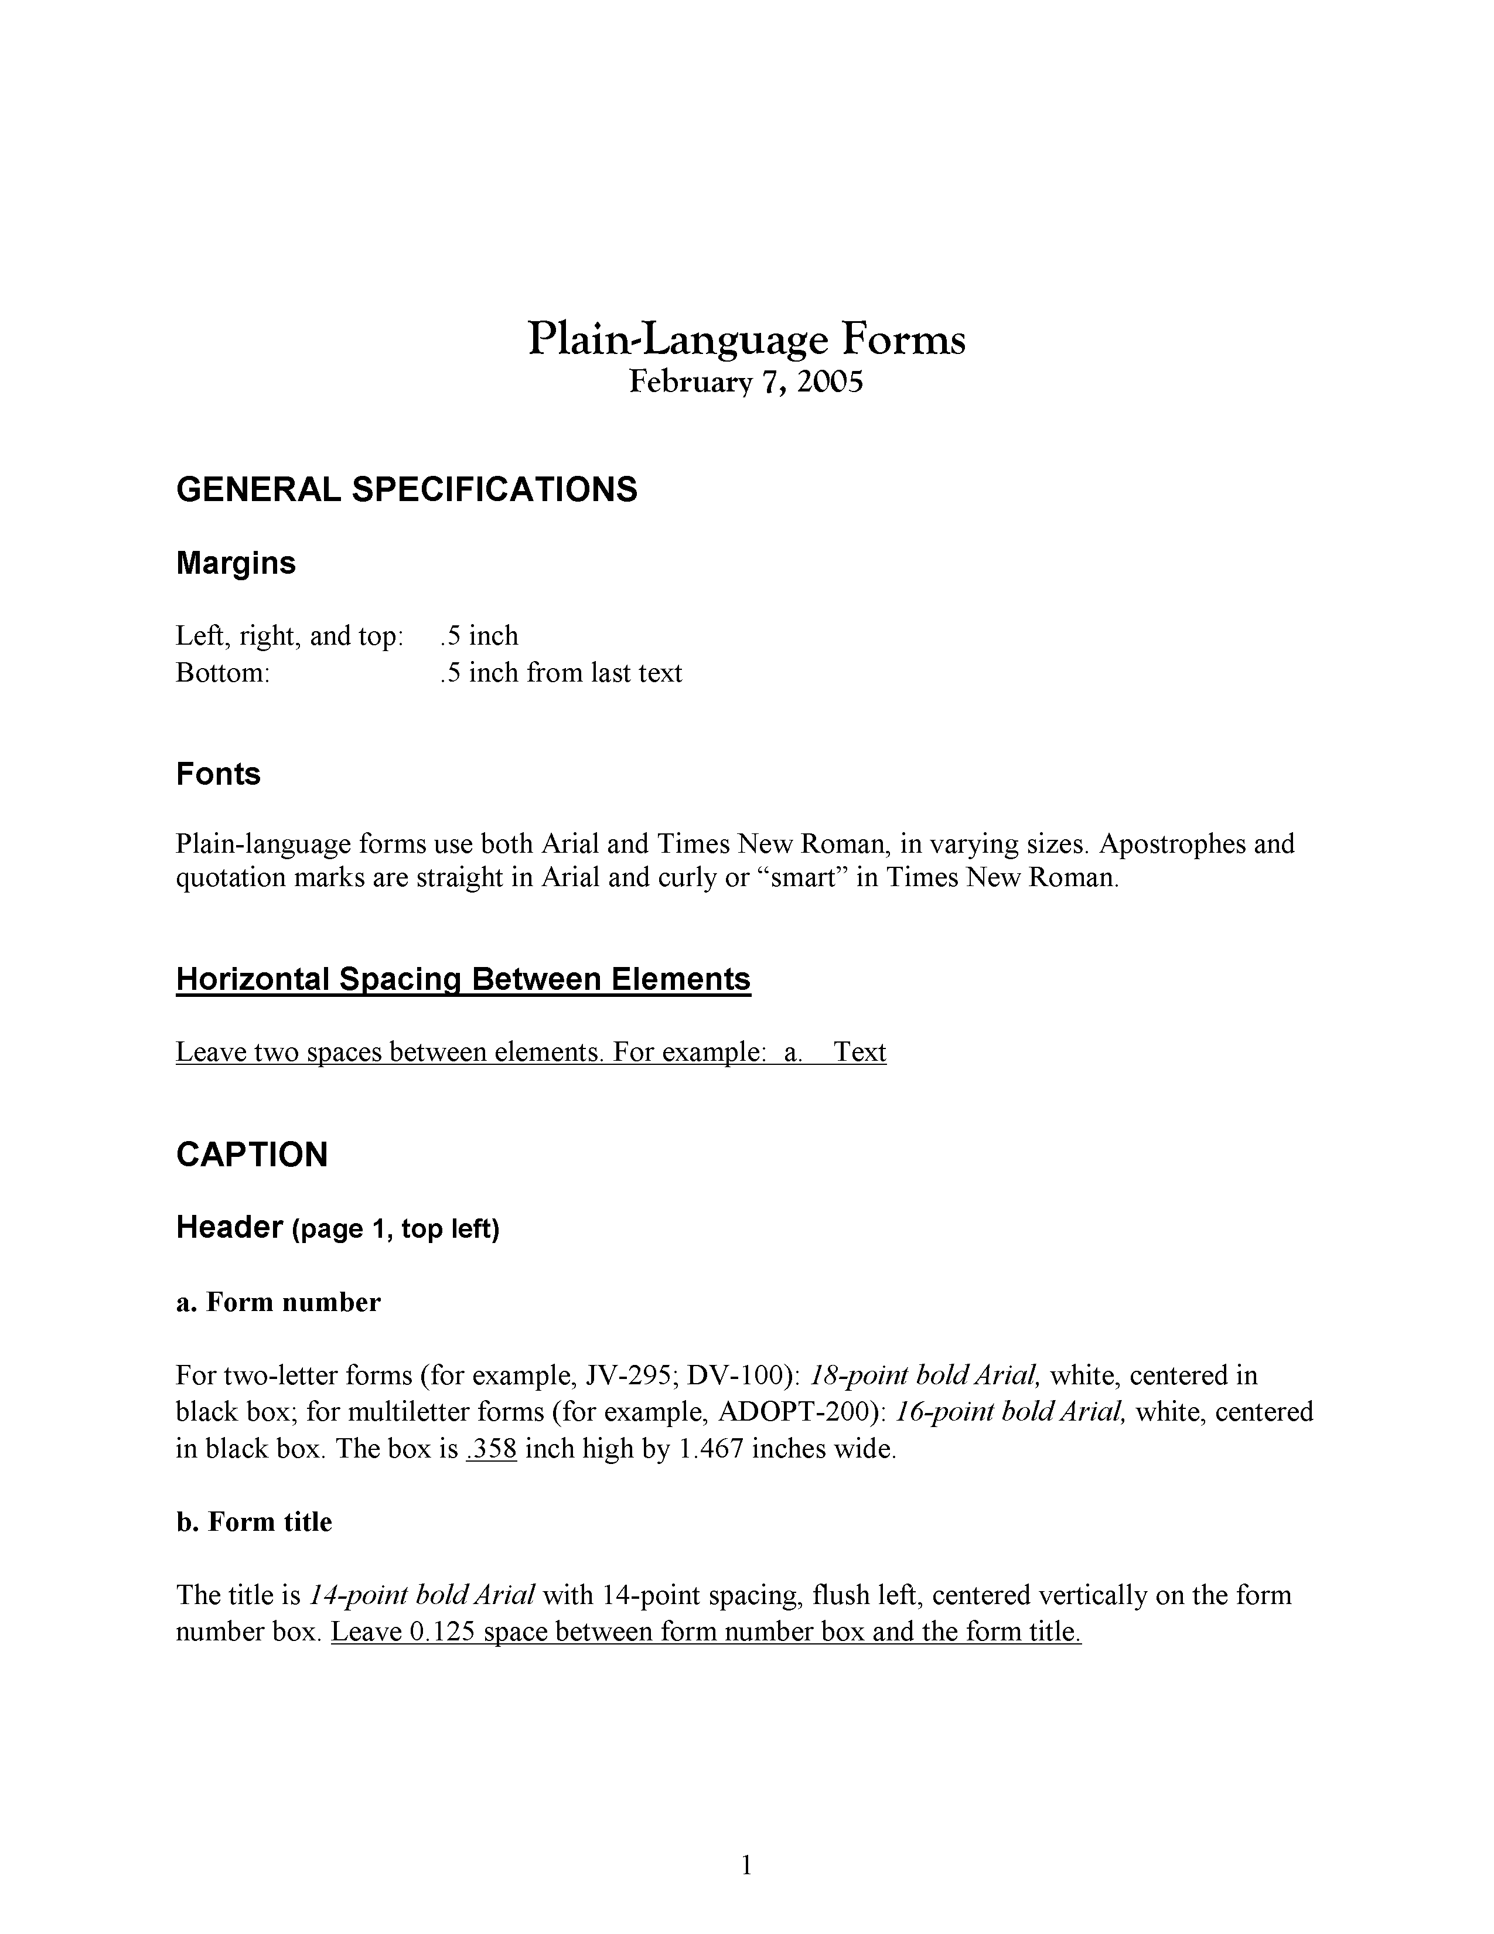

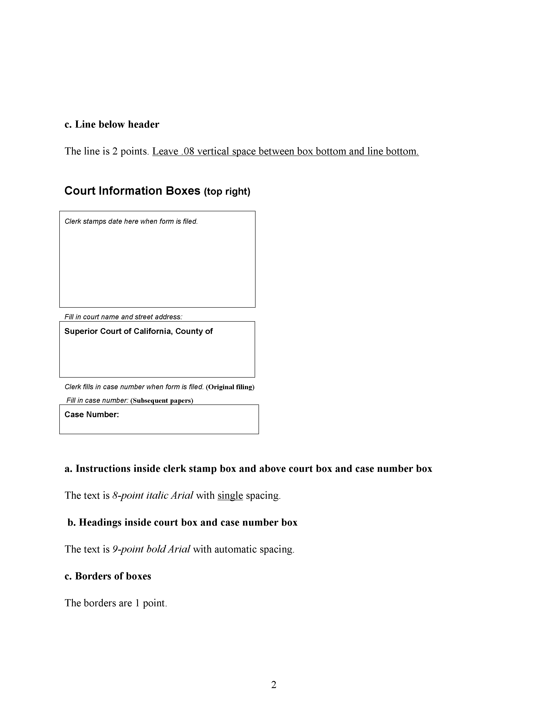

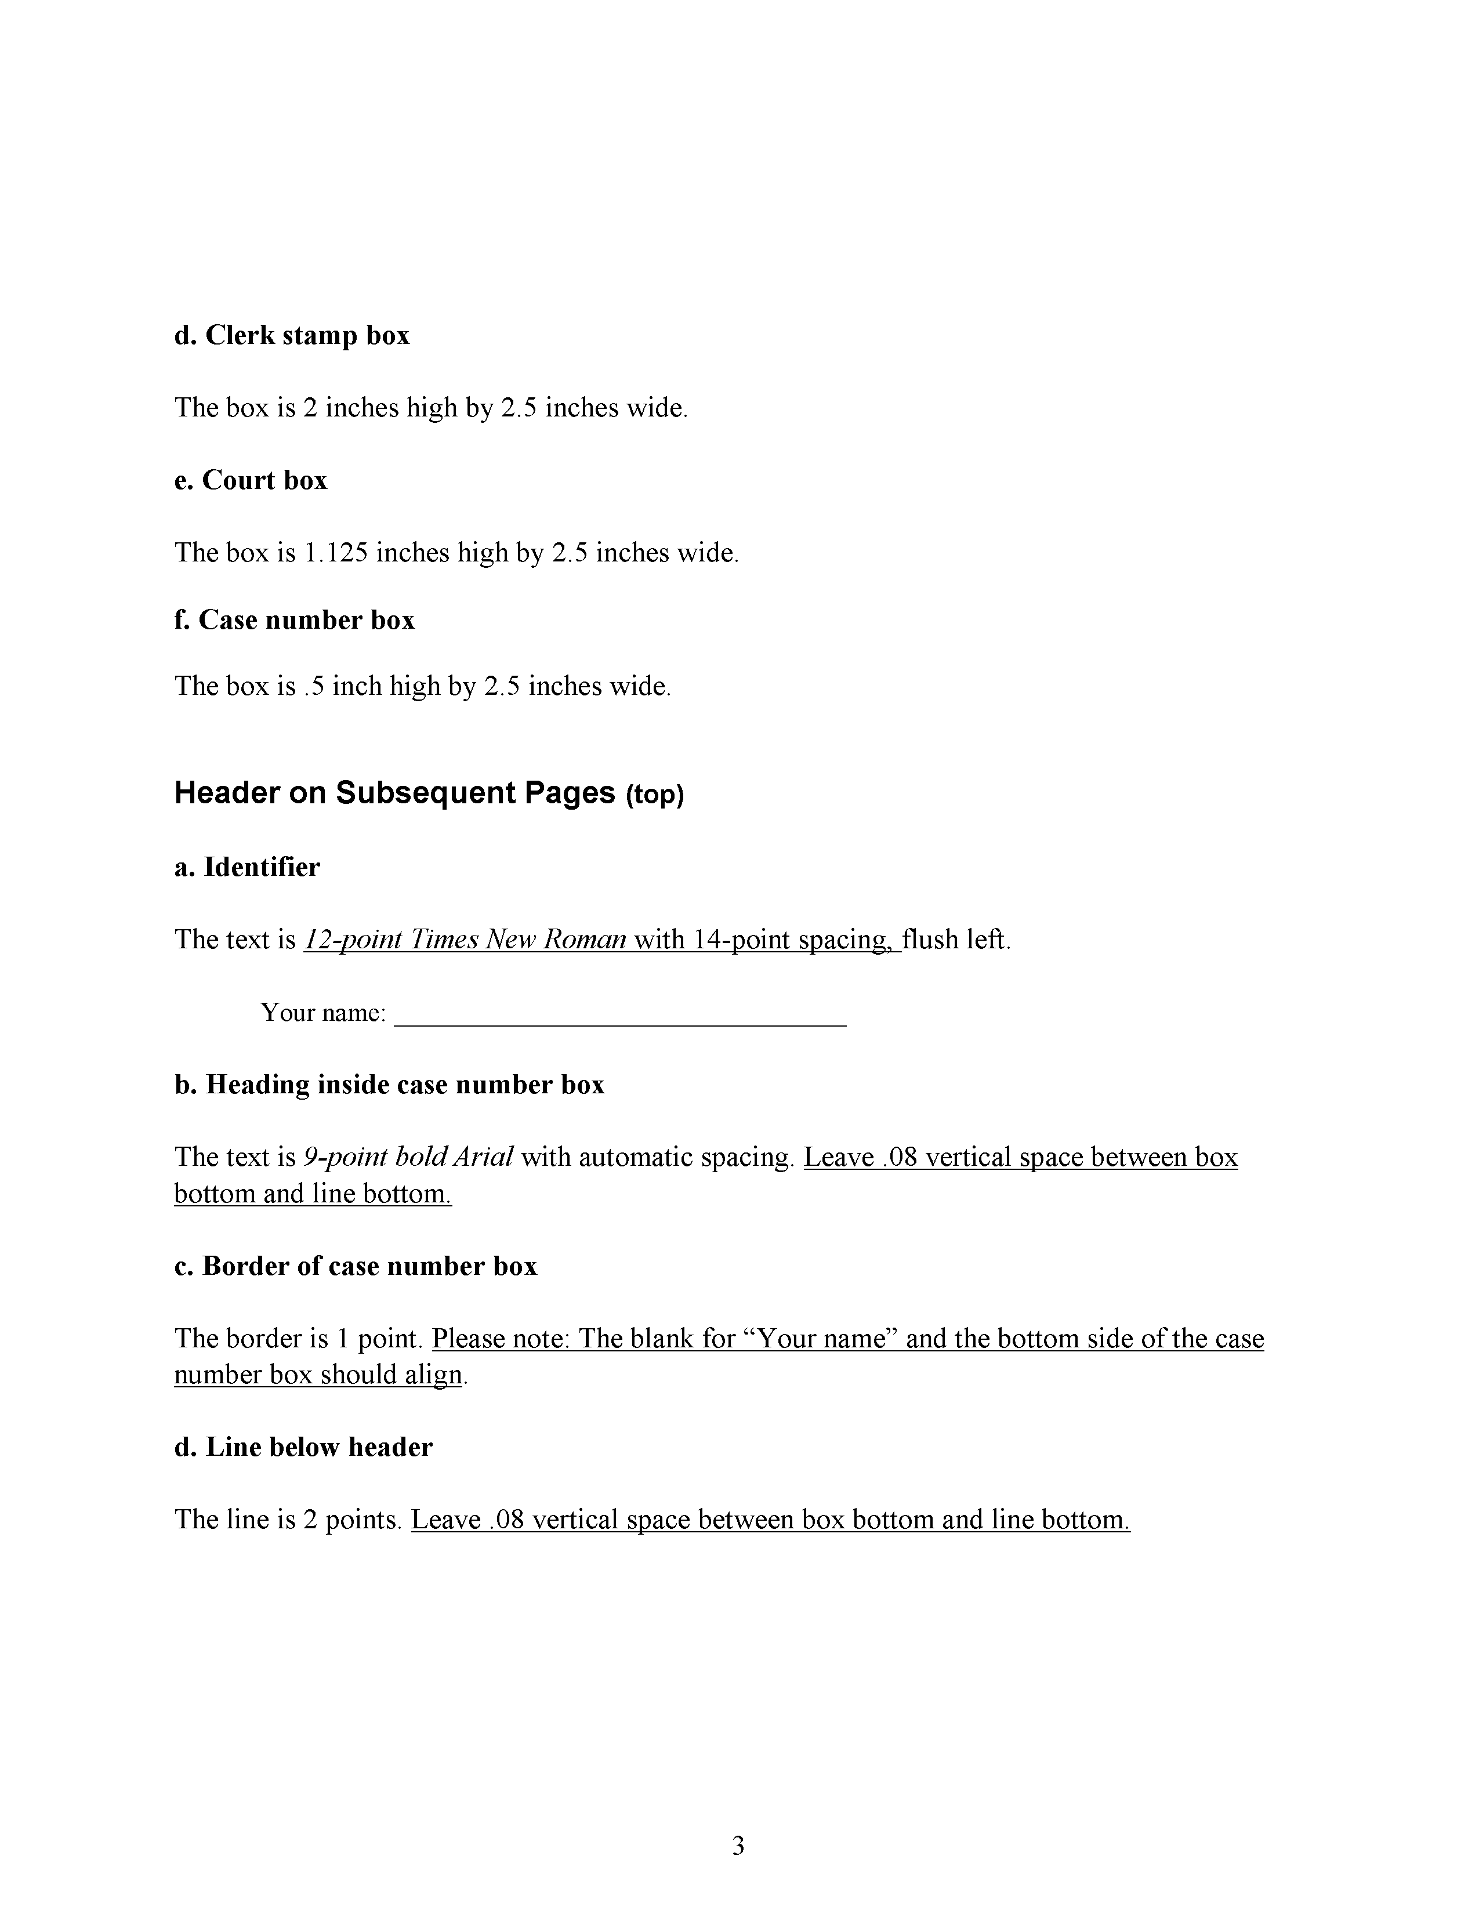

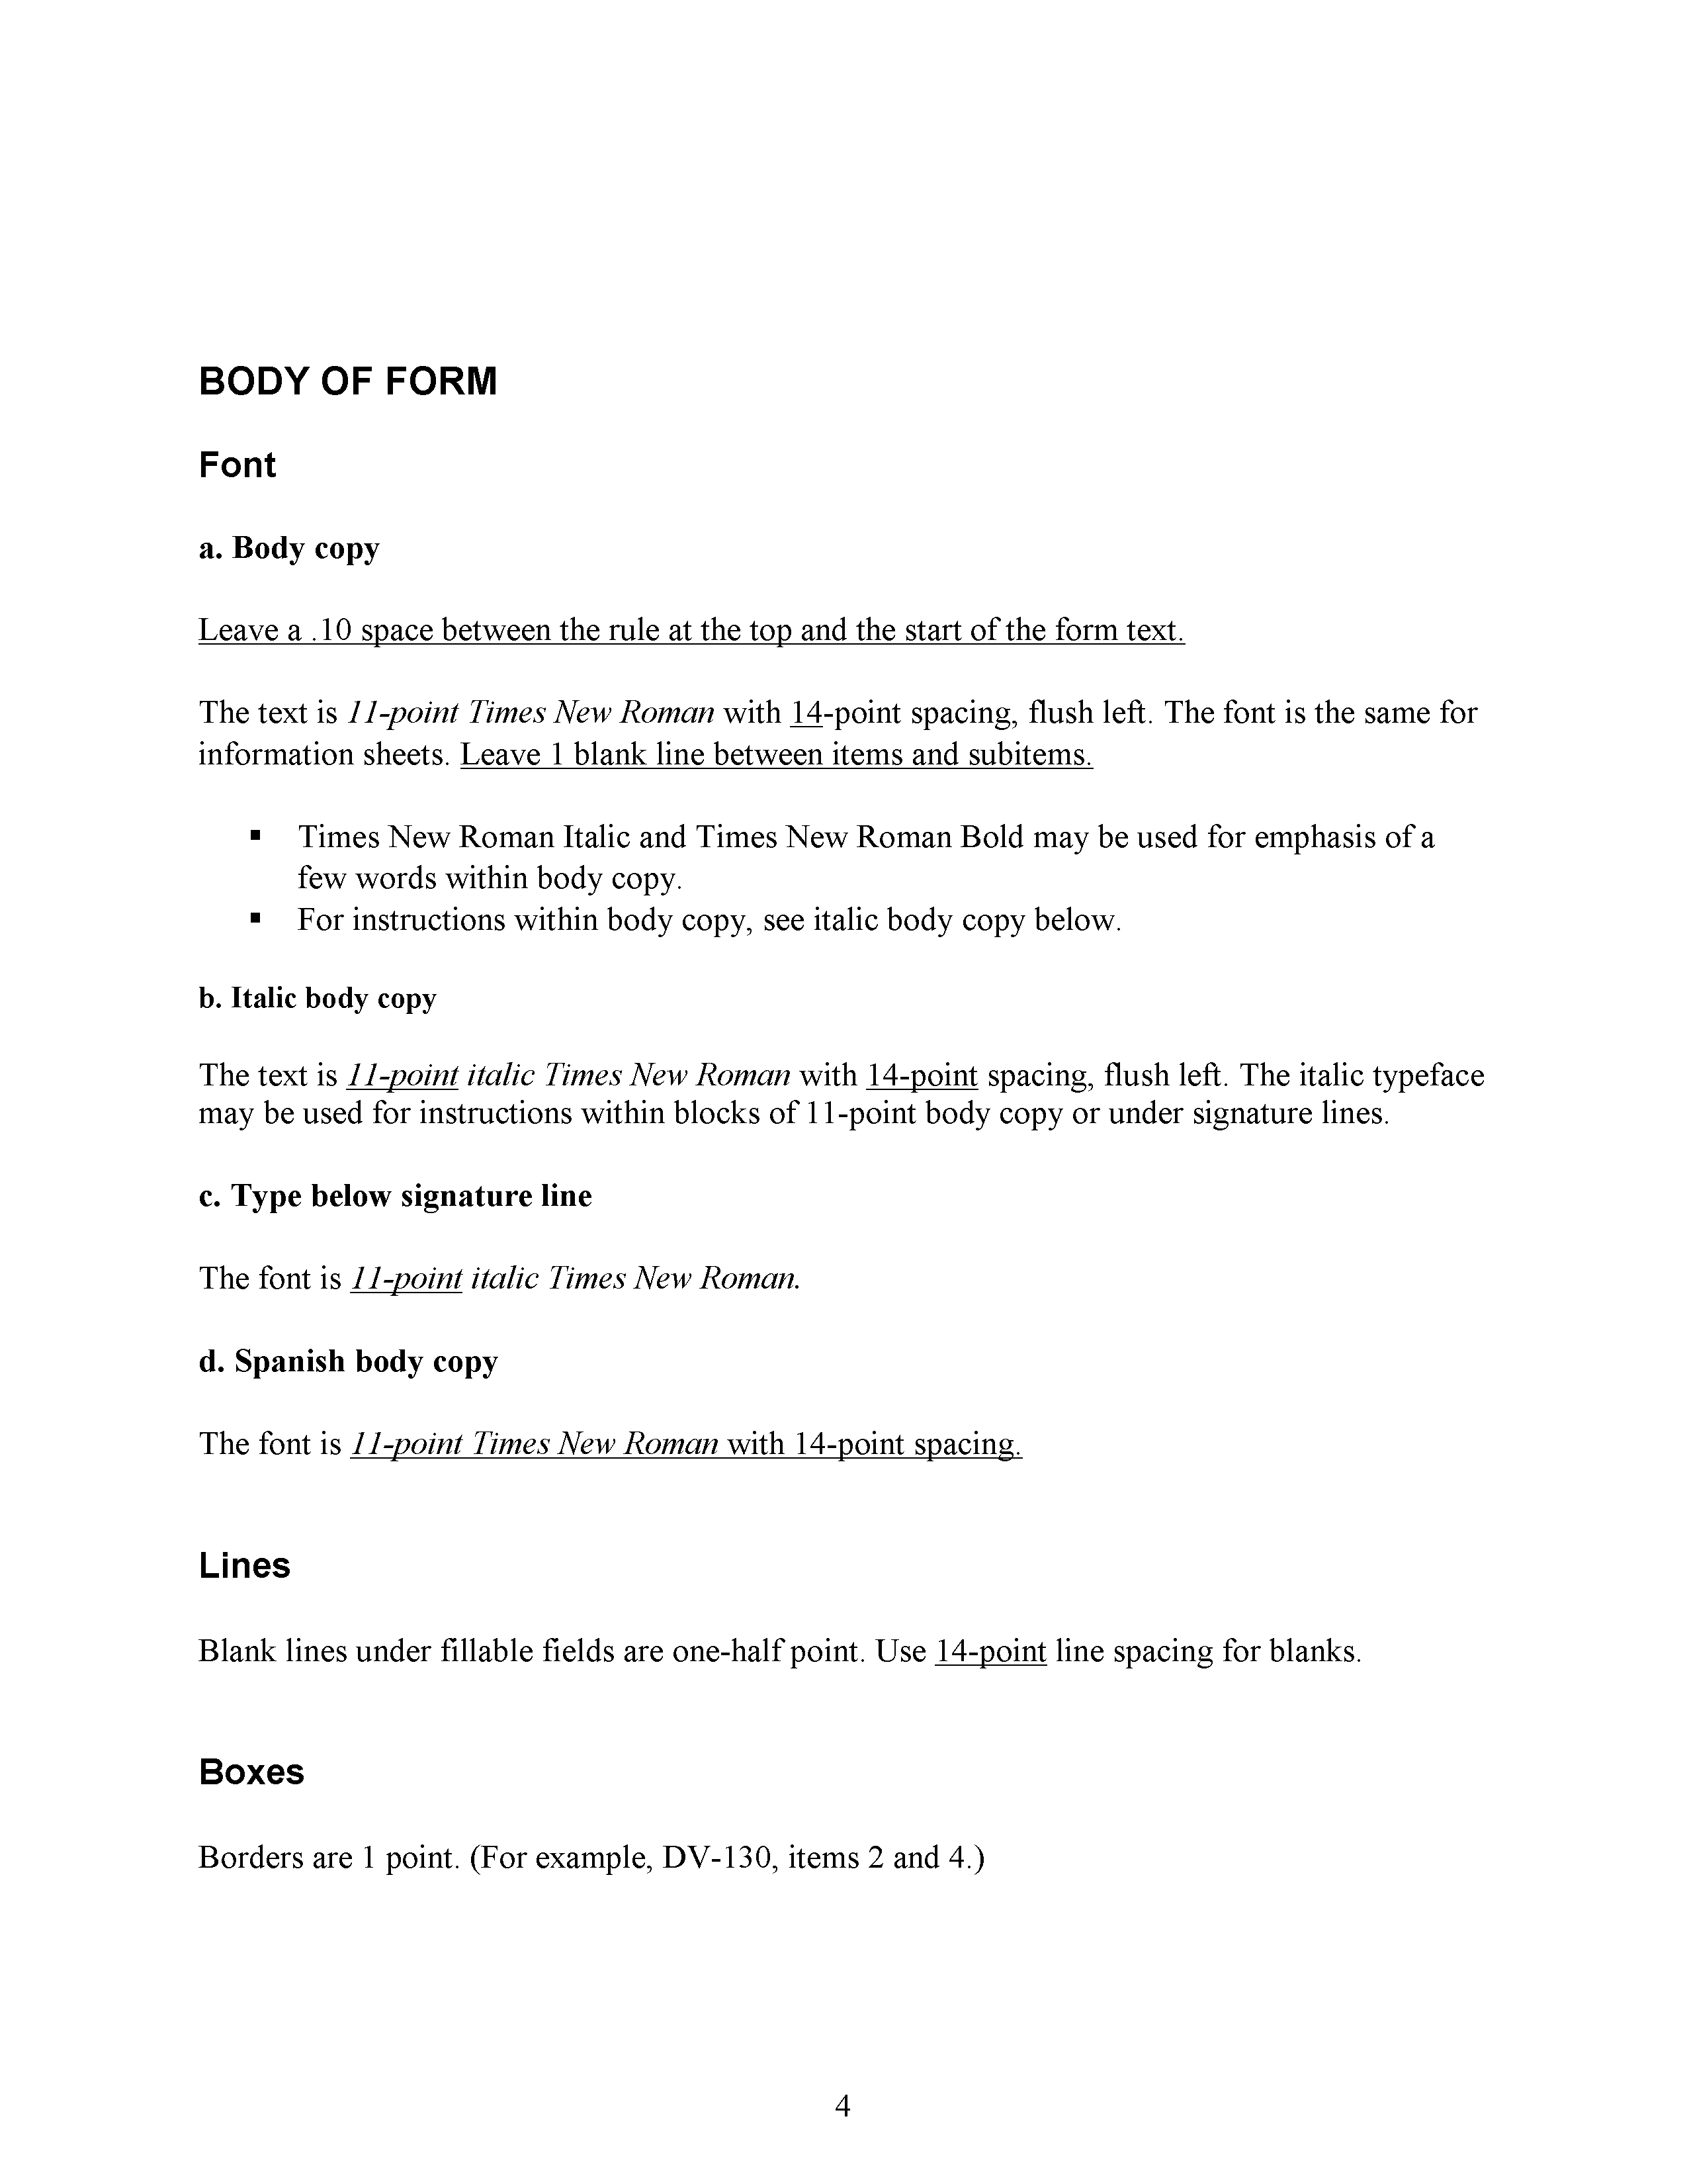

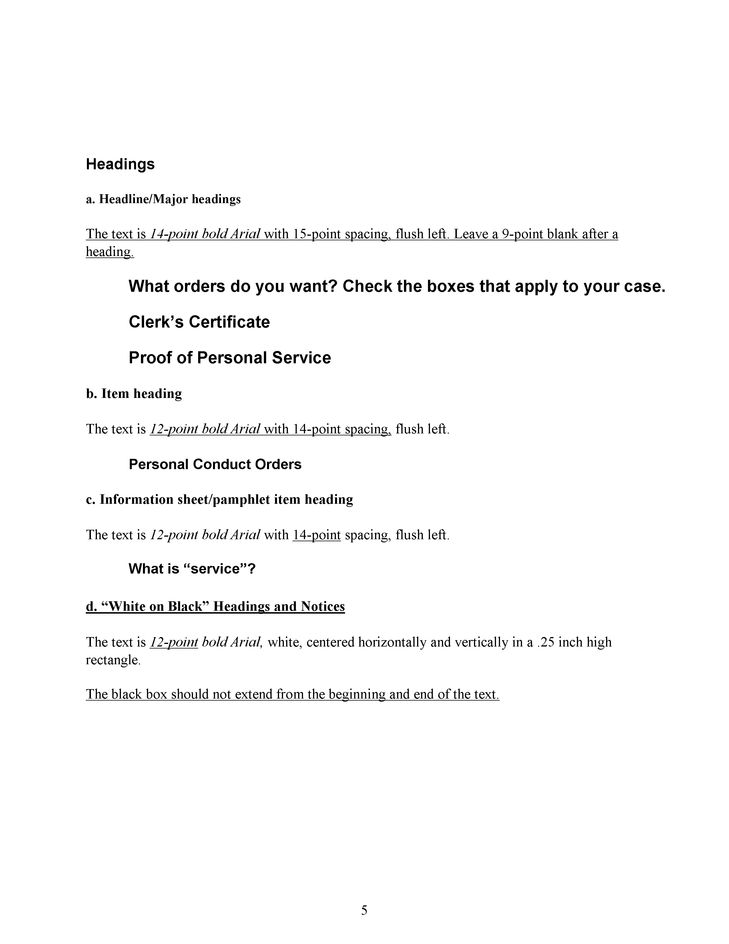

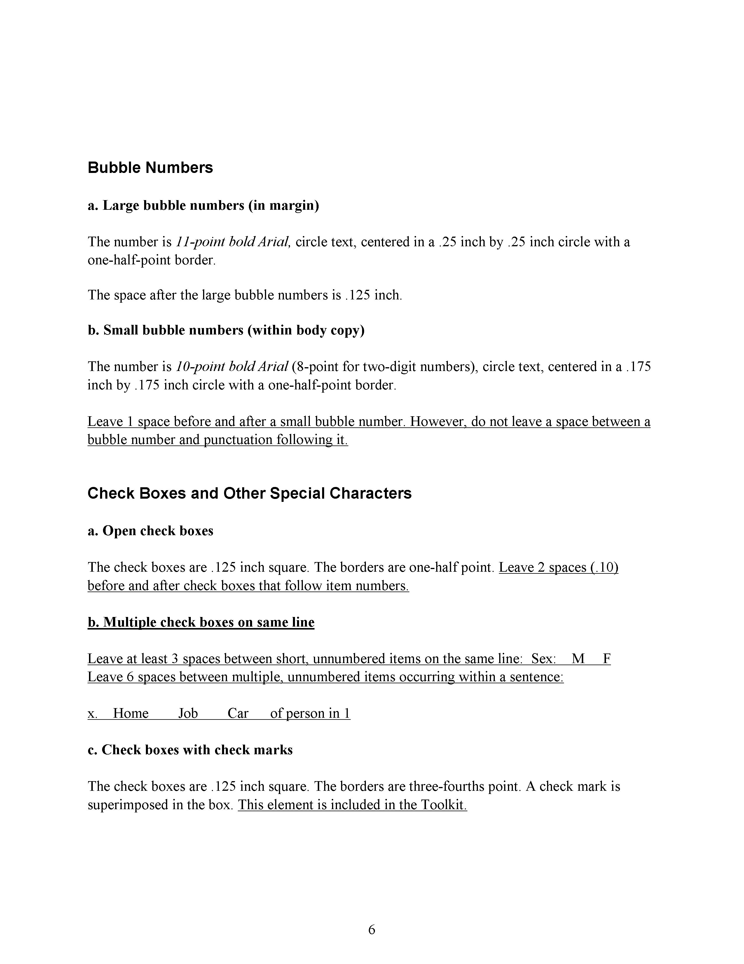

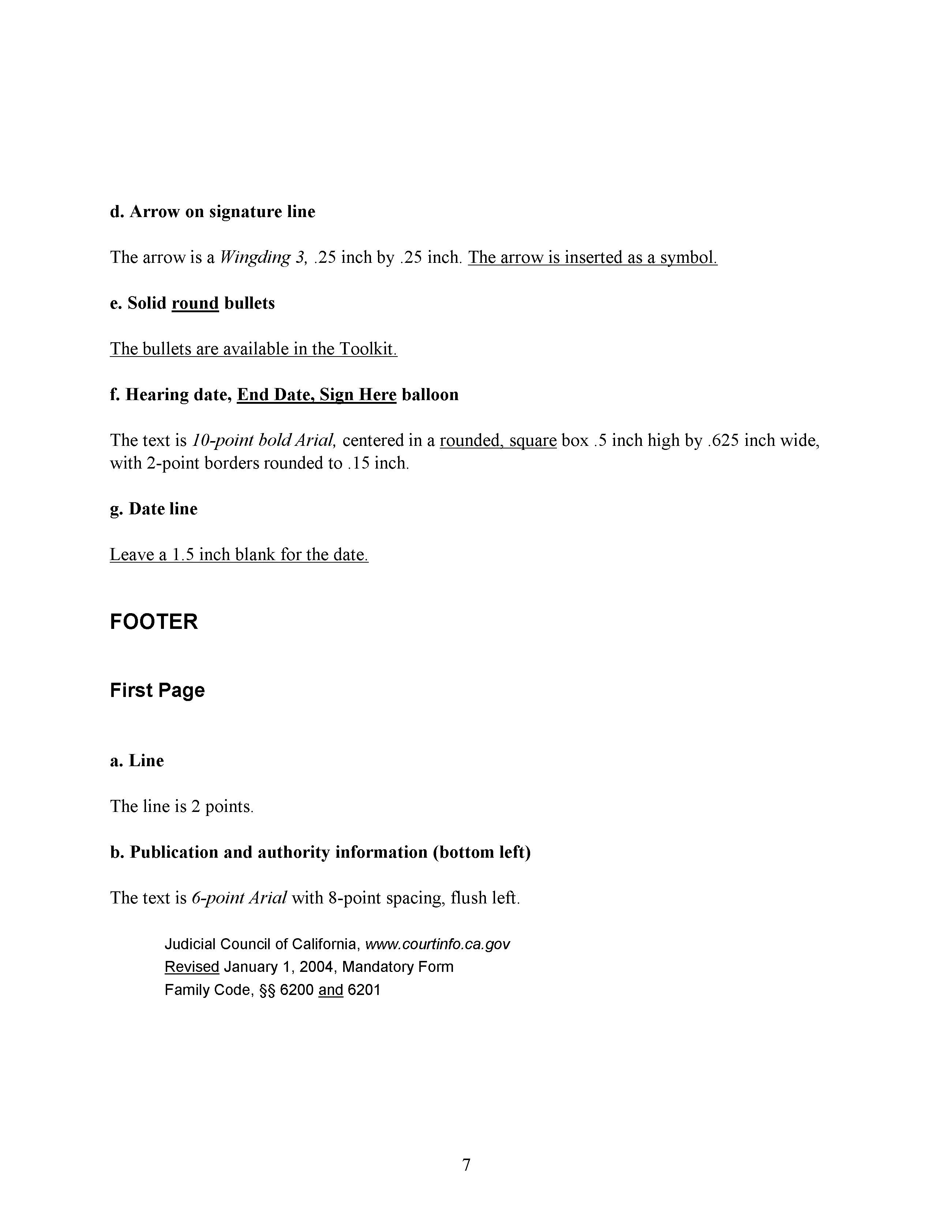

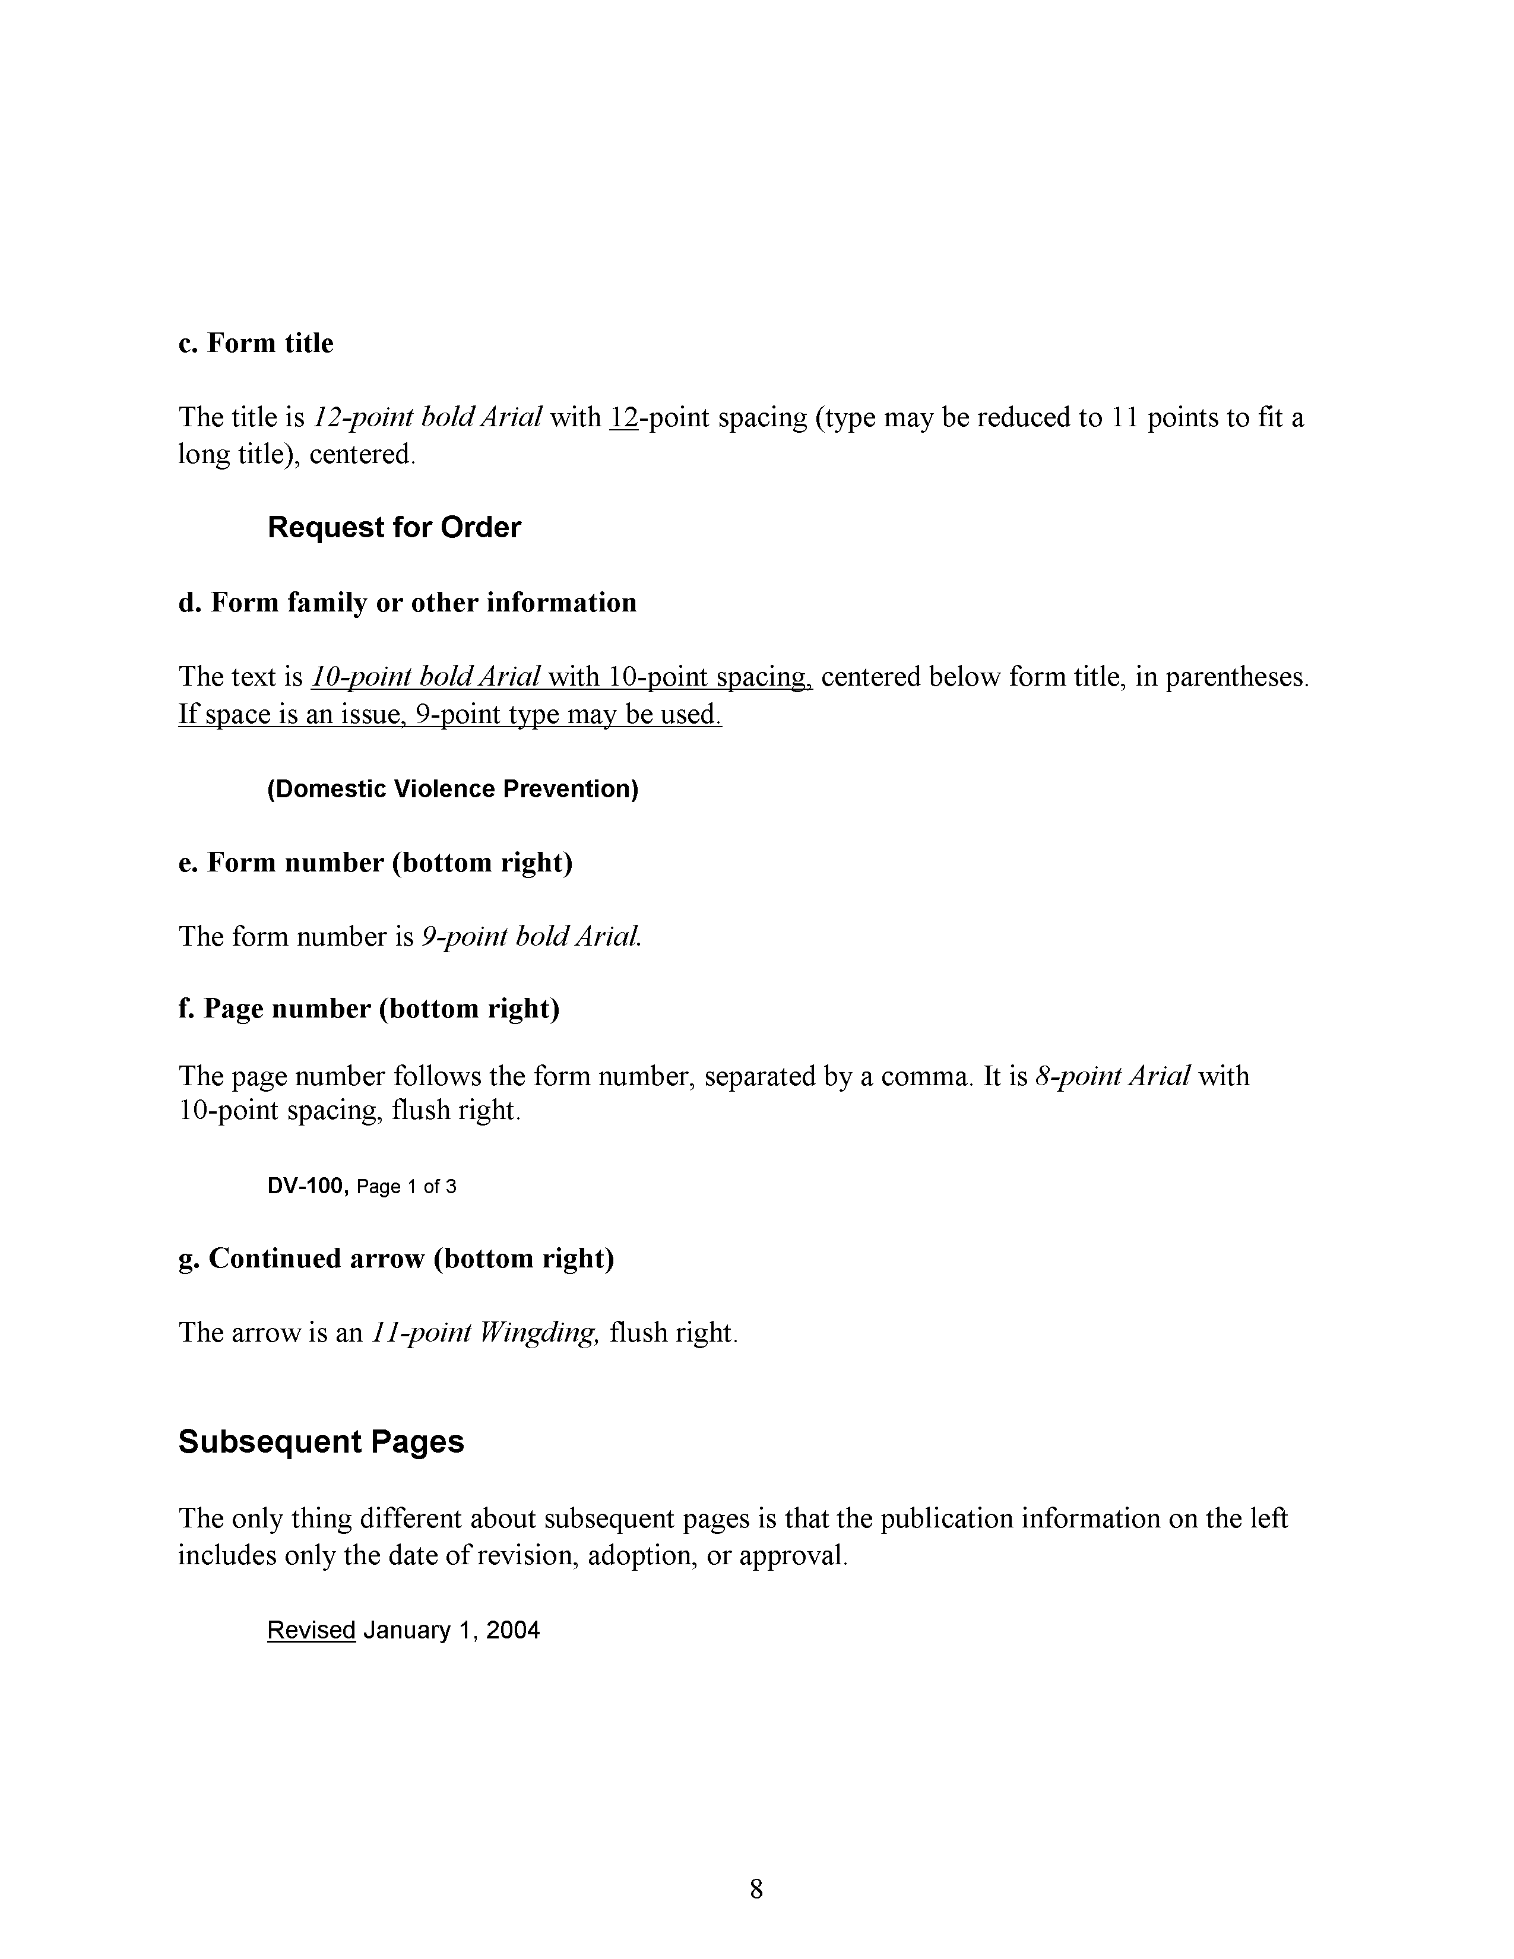

END OF ATTACHMENT 3

