Table of Contents

Superior Court
TC1 Document Flow ………………………………………………………………… 2
TC2 Courtesy Notice Processing …………………………………………………….. 4
TC3 Microfilmed Records …………………………………………………………... 5
TC4 Jury Summons Responses …………………………………………………….. 5
TC5 Legal Research/Judicial Review ………………………………………………. 5
TC6 Courtroom Use ………………………………………………………………… 5

E-Filing
EF1 E-Filing …………………………………………………………………………. 8

Administrative Office of the Courts
AOC1 Document Review and Approval Workflow ………………………………… 9
AOC2 Paper on Demand ………………………………………………………………. 9
AOC3 Digital Assets Management …………………………………………………….. 10
AOC4 Information Sharing Collaboration ……………………………………………… 10

Phoenix SAP Integration Accounts Payable
PH1 Direct Pay Invoice ………………………………………………………………...11

Appellate/Supreme Court
AP1 Appellate Courts ………………………………………………………………… 13

Use Case Scenario TC1 Document Flow
A person, business or government agency brings a document to the clerk’s office. The clerk records the document in the Case Management System (CMS) and receives a case number from the CMS (either for an existing case or as a newly filed case). A cover sheet is produced that contains the information that will be used as index values for this document. The cover sheet and document will be scanned into the Document Management System. A clerk will verify that the document was successfully scanned and the index values were correctly captured in the Document Management System. The document will be placed in a bin to be destroyed in the near future.

Alternatively, a document can be filed electronically via the internet, e-mail, or batch file (e-citations). A clerk or an automated process will record the document in the CMS. The Document Management System must be able to scan and store the electronic image(s) picking up the correct indexed values. Some documents will require a clerk to verify that the Court is in receipt of the filing fee payment. Other documents will proceed through the Court’s process without payment.

As court hearings are set, a Clerk and/or Judicial Officer will be able to tag the document as relating to the specific hearing (Register Action or Minute). When a Judicial Officer requests documents for a specific case from the DMS, they will have the option of seeing all documents related to that case or seeing only documents related to a specific hearing. Court hearings often result in court orders. There must be a way to import these orders, whether they originate on paper or in electronic format, into the system and be attached to the proper case.

Other parties may view documents related to a case via the internet. Not all documents are accessible to all parties at all locations. Access will be granted based upon the type of party requesting the document, the location of that party, and the type of document being requested. Fees may be assessed for internet access to specific types of documents and for specific types of parties.

Forms and/or notices that are generated from the CMS may require importing into the DMS. These forms/notices may be generated ad hoc or as the result of a specific process. Processes may generate multiple forms that should be treated as a single packet or may generate the same form repeatedly for varying cases. The forms/notices may be in different file formats including, but not limited to: PDF/A, DOC, DOCX and TXT.

Once the court has deemed the case “closed”, the files will be retained for a specific period of time based on the document type and pre-determined retention rules set by various government codes. After the retention period, the documents are then eligible to be purged.

Graphical Representation of Superior Court Document Flow

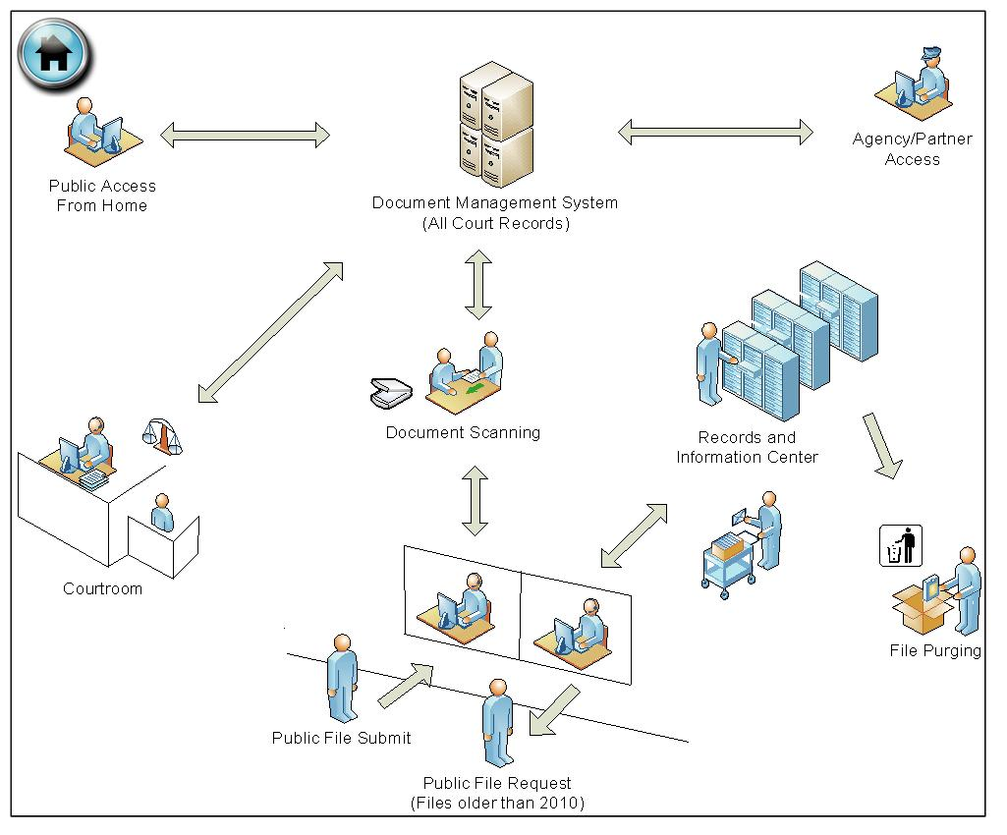

Use Case Scenario TC2 Courtesy Notice Processing
Currently, the court prints Courtesy Notices for Traffic Infraction cases and mails these out to the defendant. The court would like to digitize these Courtesy Notices by extracting the case data and merging it with a Courtesy Notice document template. The merged notice (client data + form data) will be sent to a process to convert it to PDF.
The notice will be printed and mailed to the defendant (some courts will enlist a vendor to print, fold, stuff and mail the notice). The PDF will be stored so that staff can view the Courtesy Notice to address any issues that arise. The PDF must be viewable to staff for at least 90 days.
The court may also choose to post the Courtesy Notices on the internet and make it available to the defendant to view and print.

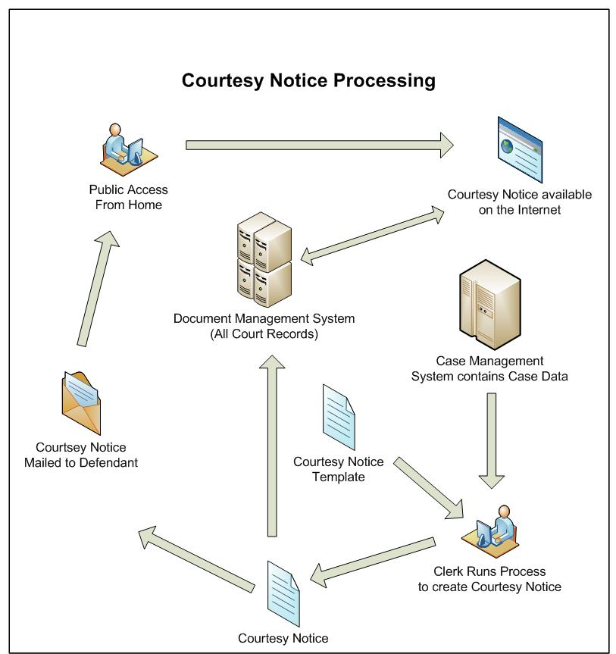

Use Case Scenario TC3 Microfilmed Records
Some of the court’s older case records are stored in Microfilm media. This media is deteriorating, hence, posing a risk to losing the data.
The Court would like to digitize these records in a file format such as PDF. In addition, key index data such as case number, file date and participant information should be captured using OCR and saved as associated metadata with the image.
These images and metadata will be stored in the DMS and a front end user interface (i.e; Web application) will be available so that a user can find the information.

Use Case Scenario TC4 Jury Summons Responses
The Court sends summons via first-class mail to eligible citizens to order their appearance at jury duty. Prospective jurors often respond in writing to the summons, requesting to postpone or be excused from their service, or informing the court of the ineligibility to serve. The written response could be in the form of a letter or by returning all or part of the summons document with answers written on the document itself. Copies of documents to support their request may also be enclosed with their response. Some responses and supporting documentation may be faxed to the court or dropped off in person.
The returned summons can contain data such as marked bubbles that indicate a reason why the juror should be excused. If the juror is excused, the excuse must be recorded in the jury application.
When a summons is returned as undeliverable by the post office, the returned envelope may be scanned showing the mailed-to address and the yellow sticker applied by the post office.
Responses are used to update the juror database and all documentation received is stored for three years.

Use Case Scenario TC5 Legal Research/Judicial Review
A researcher or Judicial Officer will pull relevant images/documents for an upcoming hearing, or for an entire case; making notes on the file for later use; including private notes to the judge and/or private notes by the judge. The researcher or Judicial Officer should have a way to highlight sections of text; and use ‘sticky notes’ to draw attention to specific pages. There should be an ability to copy text from the imaged document to use for other purposes such as orders or Probate notes.

Use Case Scenario TC6 Courtroom Use
As the courts move to paper-on-demand, there will be less paper routinely printed as part of calendar preparation. A calendar clerk would be able to access a list of cases on a specific calendar and, by clicking on a case, be able to see the related images/documents. After completing one case, the same calendar would still be available to allow the clerk to move to the next case. Note: there is no time available in the courtroom to do individual searches for a specific case. Speed of delivery of the image/document is the key to a successful implementation. Options for redundancy in case of network or power outage must be available.

Use Case Scenario EF1 E-Filing
An attorney or attorney firm (filer) accesses the e-filing website and enters case information along with uploading the case initiating document(s) (ex. Complaint, Civil Coversheet, Summons) in PDF format. The case information is translated into XML and then sent to the Court as an electronic filing, which may consist of one or more documents.

The E-filing, consisting of both data and documents will be received by the e-filing application/clerk review. The Court clerk has the ability to search, filter, and paginate through the submitted transactions and verify outstanding fees to be paid.

If the clerk determines that the E-Filing is ready to be filed into the Case Management System (CMS), the clerk will accept the documents. A Case Management System case number will be assigned to the case, and the documents will be file stamped (endorsed) by the clerk review application. The file stamp location will vary by document. The case data from the accepted E-Filing is saved to the CMS and the documents, and the metadata about the documents, are saved to the Document Management System (DMS). The documents are linked to the CMS case history. The clerk review application will communicate to/from the DMS through a DMS API, and should support the ability to subsequently extract the data and documents from the DMS.

Confirmation notice and endorsed documents (PDF) are sent to the filer.

Use Case Scenario AOC1 Document Review And Approval Workflow
A FedEx courier delivers a confidential 50 page document requiring action by a number of AOC officers. The document requires review and approval and return within 15 days.
A scanning unit clerk produces a bar coded cover page that contains the metadata that will be used as index values for this document. The cover sheet and document will be scanned into the Document Management System. The divisional office admin accesses the electronic inbox queue that was predefined by index values defined on the initial bar coded coversheet. The office administrator browses the electronic image of the document to verify that the quality of the image is acceptable and that the index values were correctly captured. The administrator assigns the document image to an electronic review and approval distribution queue. The original document will be placed in a bin to be destroyed at a specified date. The DMS distribution queue routes the designated along the specified workflow path, sending electronic notifications to the designated staff all along the chain of distribution. The workflow logic sends alerts and reminders as each review and approve timing threshold are reached. Reviewers are able to include comments and questions or attachments and are able to indicate their approval by use of digital signatures. The electronic document is stored into a centrally hosted records retention cycle determined by the appropriate document classification by the metadata classifications that were assigned at the time of capture.

Use Case Scenario AOC2 Paper on Demand
The office administrator is asked by an office executive to go to the DMS and find all correspondence sent from a specified court officer. The office executive needs to review them on his/her computer securely at home. All important historic paper documents sent to this AOC division formerly contained in bankers’ boxes in a basement office storage room have been back scanned and indexed. The office administrator goes to his/her desktop computer; logs in and is authenticated for secure access. The administrator chooses a search query allowing his/her to select multiple conditions of metadata including; Type of Court (Court Type); Name of Court (Court Name ); Document Type (Correspondence); Date Range (1996-present); Sent By Name (Specified Court Officer). The query yields a search result containing all of the correspondence received from specified court officer between 1996 to current date. The office administrator is able to copy the URL link to the documents into an email message to the office executive. The office executive receives the email and clicks on the URL link. The officer’s access is authenticated by the single sign-on security system which navigates through the DMS security and is able to bring up each multi-page correspondence in PDF/A file format.

Use Case Scenario AOC 3 Digital Assets Management
A media specialist is asked to create a video using the divisions’ video recording studio equipment. The presentation must also contain video content created 5 years ago and stored in a digital Assets content repository. The specialist uses an electronic search query at his/her desktop using multiple metadata variables. The query search through the indexed digital repository yields multiple related content, of different file formats including; video recordings, web pages, MS word documentation files and scanned paper document images in PDF format. The specialist selects the content needed to complete the project including tracks from various video recordings and pulls them into workspace for use. The specialist edits the content using video authoring software tools including and assembles the rendered video file in both raw recording format and also compressed NTSC format. The specialist stores the finished project in the digital repository using an established departmental taxonomy classification structure. Authenticated staff requestors are able to access the published video project for download. Each download is logged and tracked in the DMS system.

Use Case Scenario AOC4 Information Sharing Collaboration
A Senior staff from the a AOC Project team based in San Francisco is working with a team of technical and business staff located in the Sacramento and Burbank regional offices. They all must have access to complete a collaborative review, analysis of a functional requirements artifact for completeness and accuracy. The review was requested from the Teams Project Manager. The Project Manager at the San Francisco office creates an electronic folder, designates the level of access and specific users that may have access to the highly confidential 300 page legal MS Office word file. The PM uploads the document to the document management repository. The PM is able to include a URL link to the address of the document in an email to the other team members. When the Sacramento team member receives the email and clicks on the link, MS Word opens, his/her security is authenticated, and he/she is able to Check-Out the document for review and editing. While the Sacramento team member has the document checked out, other users can not check it out. At completion of his/her edit session the document can be checked-in. The DMS system logs all access transactions to the document in an audit file including details about the user, session and changes made.

Use Case Scenario PH1 Direct Pay Invoice
The Phoenix Financial System is a statewide system that enables courts to maintain control over expenditures, providing timely information about fiscal needs while complying with policies, procedures, regulations, and other standardized processes. Some of the implemented modules are General Ledger, Controlling, Funds Management, Materials Management, Accounts Payable, Accounts Receivable, Project System, and Grants Management. Statewide, 58 courts are using the Phoenix Financial System.
The demonstrated process flow below represents UC134: The Accounts Payable Direct Pay process used by court Accounts Payable users to record non-procurement invoice documents in DMS and link them to direct invoices in SAP.
Court accounting department employee opens mails and date stamps received invoices and related documentation. Then the employee sorts invoices and other documentation alphabetically by vendor name and forwards appropriate invoice folders to scanning staff.
Scanning staff logs into DMS and scans the images either individually or in batch into DMS. Then scanning staff selects an appropriate document type for the image and completes the required index properties for each scanned image. After that, scanning staff stamps the original document with the “Imaged” stamp and files the stamped document for retention purposes. Once the indexing is complete, a workflow is started routing the invoice to the appropriate senior accounting assistant based on the vendor name.
The senior accounting assistant logs into DMS and accesses scanned images in the in-box. Then the scanned image is routed to the defined cost center manager(s) for approval. Once the scanned image is approved, the user opens SAP session and DMS application concurrently, creates direct invoice in SAP and attaches related scanned image in DMS to the SAP invoice. The linked scanned image can be accessed in DMS as well as SAP.

Use Case Scenario AP1 Appellate Court
Any party who is not satisfied with a Trial Court decision can “appeal” their case, asking an Appellate Court to change what the Trial Court decided. This can take the form of an extraordinary writ or an appeal. An extraordinary writ is limited review and begins with the filing of a petition in the reviewing court. The filing party is responsible for providing the documents necessary for the appellate court. An appeal begins when the party (or their attorney) files a “Notice of Appeal” in the Trial Court that heard the original case. A fee is charged in civil cases. The trial court is responsible for collating the pertinent documents and transcripts (i.e. prepare the record on appeal) and then sending a copy to the parties and the court of appeal. In civil cases the parties may elect to prepare the record on appeal themselves... The documents and transcripts (record on appeal) will be sent (either physically or via e-filing) to the appropriate Appellate Court. (The Appellate Court may also order exhibits from the Trial Court. Such exhibits, which may be either physical objects or electronic documents, do not become part of the Record on Appeal and are returned to the Trial Court upon completion of appellate review.)

Upon receipt of the extraordinary writ or notice of appeal the Appellate Court Deputy Clerk (DC) will initiate a case in the Appellate Court Case Management System (ACCMS). The DC will select from the received documents a set which becomes the “Record on Appeal”.

All attorneys involved in the case will be notified that the case is being appealed. The attorneys will then submit briefing documents to the Appellate Court. The attorneys may also file various motions which will be reviewed by an individual in the court. Typically, this person will prepare a draft order granting or denying such a motion. The order will be reviewed by a justice. Additional drafts of the order may be required, When the justice agrees with the order, the order is filed and the decision is communicated to the case parties/attorneys. If a motion to dismiss is filed and granted, the appeal ends and the case is closed.

Once all the required documents and briefs have been filed a panel is assigned to the case. In the court of appeal this is a three judge panel, with one of the panel members being designated as the author, and an Oral Argument hearing may be scheduled.

If no argument occurs, or after argument and filing of any supplemental briefing, the DC will “submit” the case and an opinion is prepared by the assigned justice (author) for review by the entire justice panel. The opinion may agree with the decision of the Trial Court, agree in part and disagree in part, or disagree and reverse the Trial Court decision. The opinion must be signed by at least two of the justices on the panel; and any justice may prepare a separate opinion to express their own concerns or to dissent from the lead opinion decision. Once all of the justices on the panel have participated, the Clerk’s Office will stamp and file the opinion. Whether disposition of the case is by opinion or by dismissal, all parties to the case will be noticed. (An opinion is sent to the Reporter of Decision who makes the opinion available to the public via the internet.)

The parties in the case will have 30 days after the disposition date to request rehearing. If rehearing is granted, the justice panel may request further oral argument and will issue a replacement opinion. If there is no request for rehearing, or if such a request is denied, the case becomes “final” as to the Court of Appeal and if no petition for REVIEW is granted by the Supreme Court the Clerk’s Office will prepare a form called a remittitur and send the case back to the Trial Court. The Record on Appeal remains with the Appellate Court.

