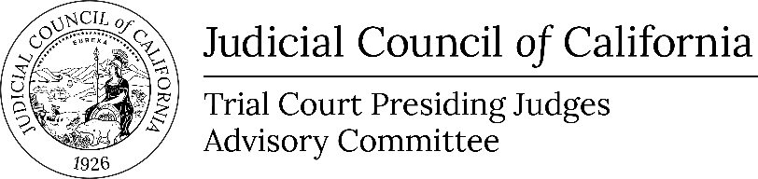
Request for ADA accommodations
should be made at least three business days before the meeting and directed to:
JCCAccessCoordinator@jud.ca.gov

www.courts.ca.gov/ceac.htm
tcpjac_ceac@jud.ca.gov

Executive Committee of the
Trial Court Presiding Judges Advisory Committee
Notice and Agenda of Open Meeting
Open to the Public Unless Indicated as Closed (Cal. Rules of Court, rule 10.75(c), (d), and (e)(1))
THIS MEETING IS BEING CONDUCTED BY ELECTRONIC MEANS
OPEN PORTION OF THIS MEETING IS BEING RECORDED
Date: | November 05, 2025
Time: | 12:15 p.m.
Public Call-In Number: | 1-669-254-5252, ID 1600413112 passcode 449161 (Listen Only)
Meeting materials for open portions of the meeting will be posted on the advisory body web page on the California Courts website at least three business days before the meeting.
Members of the public seeking to make an audio recording of the open meeting portion of the meeting must submit a written request at least two business days before the meeting. Requests can be e-mailed to tcpjac_ceac@jud.ca.gov.
Agenda items are numbered for identification purposes only and will not necessarily be considered in the indicated order.
- Open meeting (Cal. Rules of Court, Rule 10.75(c)(1))
Welcome and Call to Order
- Public Comment (Cal. Rules of Court, Rule 10.75(k)(1))
This meeting will be conducted by electronic means with a listen only conference line available for the public. As such, public may submit comments for this meeting only in writing. In accordance with California Rules of Court, rule 10.75(k)(1), written comments pertaining to any agenda item of a regularly noticed open meeting can be submitted up to one complete business day before the meeting. For this specific meeting, comments should be e-mailed to tcpjac_ceac@jud.ca.gov. Only written comments received by 12:15 p.m. on November 4, 2025 will be provided to advisory body members prior to the start of the meeting.

- Discussion and Possible Action Item (Item 1)
Item 1
2026 TCPJAC Annual Agenda (Action Required)
Presenter: Hon. Patricia L. Kelly, Chair, Trial Court Presiding Judges Advisory Committee, and Presiding Judge, Superior Court of Santa Barbara County
- Adjournment
Adjourn to Nonpublic Session

