Rules Committee Working Group on Family Violence Appellate Project v. Superior Court
Notice and Agenda of Closed Meeting
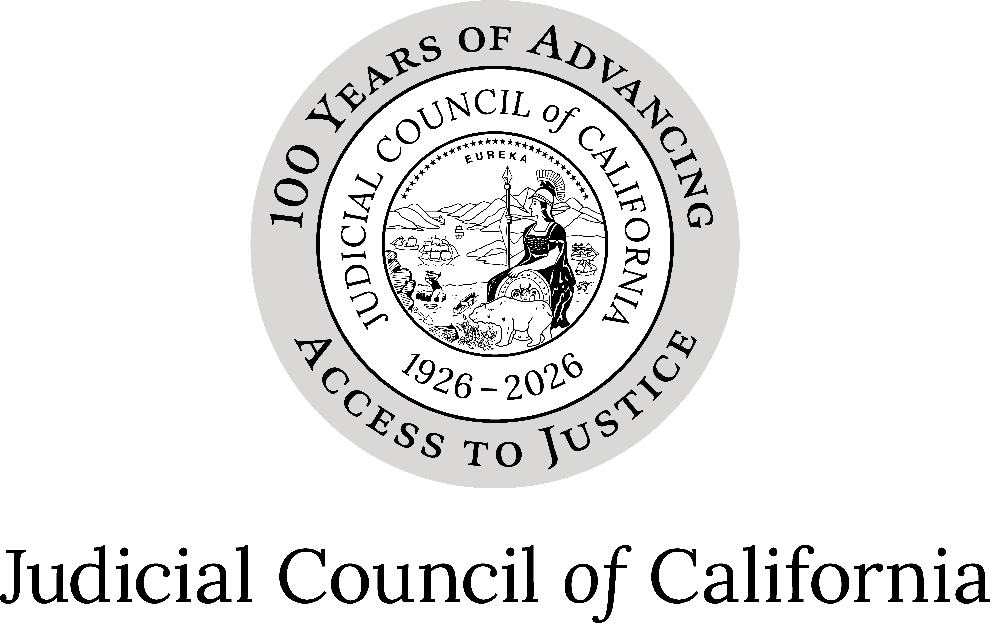
October 12, 2026
12:10 P.M. - 1:10 P.M.
Closed to the public (Cal. Rules of Court, rule 10.75(d) and (e)(1)).
Meeting materials will not be posted on the Rules Committee webpage on the California Courts website.
Materials are only posted for open meetings. (Cal. Rules of Court, rule 10.75(h).)

Closed Session (Cal. Rules of Court, Rule 10.75(d)(10))

Call to Order and Roll Call

Approval of Minutes
Approve minutes of the October 2, 2026, Family Violence Appellate Project v. Superior Court Working Group meeting.

Item 1
Pursuant to California Rules of Court, rule 10.75(d)(10) (No Action Required)
Discussion of rules and forms changes related to Family Violence Appellate Project v. Superior Court of Contra Costa County, (2026) 20 Cal.5th 564.

Adjournment
Adjourn.

