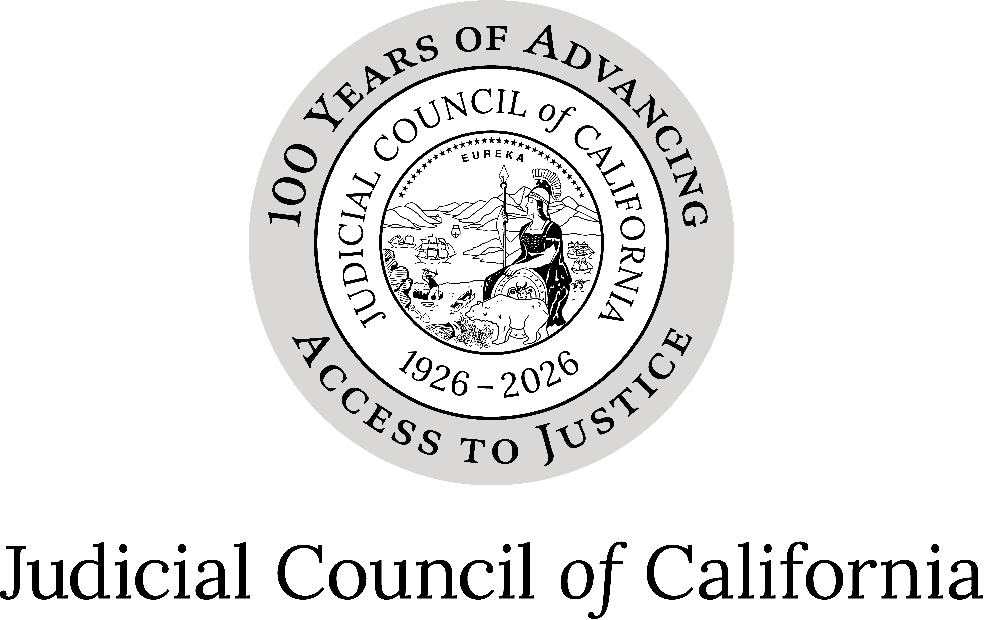
Trial Court Facility Modification Advisory Committee
Minutes of Open Meeting(DRAFT)
May 18, 2026
10:00 a.m. – 11:28 a.m.
Judicial Council of California – Videocast for Public Access
Members Present: Hon. Donald Cole Byrd, Chair
Hon. William F. Highberger, Vice-Chair
Hon. John B. Ellis
Mr. Jarrod Orr
Ms. Anabel Z. Romero
Ms. Nocona Soboleski
Mr. David H. Yamasaki
Members Absent: Hon. Brad R. Hill
Hon. Eric J. Wersching
Hon. Jennifer K. Rockwell
Hon. Vanessa W. Vallarta
Others Present: Mr. Tamer Ahmed, Director, Judicial Council Facilities Services
Mr. Jagan Singh, Deputy Director, Judicial Council Facilities Services
Ms. Maria Atayde-Scholz, Principal Manager, Judicial Council Facilities Services
Mr. Harry O’Hagin, Principal Manager, Judicial Council Facilities Services
Ms. Peggy Symons, Principal Manager, Judicial Council Facilities Services
Mr. Jeff Anderson, Manager, Judicial Council Facilities Services
Mr. Robert Carlson, Manager, Judicial Council Facilities Services
Mr. Andre Navarro, Manager, Judicial Council Facilities Services
Mr. Paul Fitzgerald, Supervisor, Judicial Council Facilities Services
Ms. Donna Jorgensen, Supervisor, Judicial Council Facilities Services
Mr. Chris Magnusson, Supervisor, Judicial Council Facilities Services
Ms. Jennifer Merrill, Supervisor, Judicial Council Facilities Services
Mr. Steve Shelley, Supervisor, Judicial Council Facilities Services
Mr. Robert Stetson, Supervisor, Judicial Council Facilities Services
Mr. Randy Swan, Supervisor, Judicial Council Facilities Services
Mr. Patrick Treanor, Supervisor, Judicial Council Facilities Services
Mr. Guillermo Urena, Supervisor, Judicial Council Facilities Services
Mr. Edward Gonzalez, Security Coordinator, Judicial Council Facilities Services
Ms. Erin Stagg, Attorney II, Judicial Council Legal Services
Ms. Morgan Lardizabal, Legislative Advocate, Government Affairs

Open meeting

Call to Order and Roll Call
The chair called the meeting to order at 10:00 a.m., roll was taken, and opening remarks were made.

Approval of Minutes
The advisory body reviewed and approved the open session minutes of the April 6, 2026, Trial Court Facility Modification Advisory Committee (TCFMAC) meeting. (Motion: Romero; Orr)

Public Written Comments
No public comments were received.

Director’s Report
The committee received the following update:
- Facility Modification (FM) Funding Update:
  - To date, the committee has approved approximately $74.9 million for FMs:
    - $26.1 million for Emergency FMs (List A);
    - $7.9 million for FMs Under $100K (List B);
    - $9.4 million for FM Cost Increases Over $50K (List C);
    - $28.4 million for FMs Over $100K (List D); and
    - $3.1 million for Planned FMs Over $100K (List G).
- Service Provider Analysis for Contract Recompete:
  - Judicial Council Facilities Services’ Facility Operations Unit currently delivers the maintenance program through three separate contracts across three regions:
    - The contracts were extended until December 2028, with an additional extension through 2031.
    - The Facility Operations Unit will conduct a comprehensive analysis to inform the decision of whether to issue a Request for Proposal (RFP) prior to the expiration of the contracts.
- May Revision Update:
  - The committee received an update on the May Revision to the Governor’s Budget:
    - No changes were made to previously proposed facilities funding included in the January Governor’s Budget for FY 2026–27.
    - Trailer bill language was added to extend the Assembly Bill 1576 implementation deadline—to make lactation space available to court users in courthouses that provide lactation rooms for court employees—for three years until July 1, 2029.
    - Staff will continue to monitor the budget process and provide updates on facilities funding and related legislative actions as information becomes available.

Discussion and Action Items (Items 1–6)

Item 1
Fiscal Year 2025–26 Facility Modification Program Budget Actions
Action: For fiscal year 2025–26, the committee approved reallocating $500,000 from Statewide FM Planning to Priority 2 FMs Over $100,000.
(Motion: Yamasaki; Second: Highberger)

Item 2
List A – Emergency Facility Modification Funding (Priority 1)
Action: The committee approved 102 projects for a total of $3,414,879 to be paid from FM program funds previously encumbered for Priority 1 projects.
(Motion: Yamasaki; Second: Orr)

Item 3
List B – Facility Modifications Under $100K (Priority 2)
Action: The committee approved 72 projects for a total of $1,014,202 to be paid from FM program funds previously encumbered for Priority 2 projects under $100K.
(Motion: Highberger; Second: Ellis)

Item 4
List C – Facility Modification Cost Increases Over $50K
Action: The committee approved cost increases over $50K for seven projects for a total of $4,054,463 to be paid from FM program funds. (Motion: Yamasaki; Second: Orr)

Item 5
List D – Facility Modifications Over $100K (Priority 2)
Action: The committee approved eight Priority 2 FMs over $100K for a total cost to the FM program budget of $4,619,958. (Motion: Highberger; Second: Romero)

Item 6
Trial Court Facility Modifications Report for Quarter 3 of Fiscal Year 2025–26
Action: The committee approved the draft Trial Court Facility Modifications Report for Quarter 3 of Fiscal Year 2025–26, for submission to the Judicial Council as an Information-Only item. The committee requested Attachment A line #391 to be amended to reflect FM Priority 2 and report page 2 revised accordingly.
(Motion: Highberger; Second: Soboleski)

Discussion Items (Items 1–3) (No Action Required)

Item 1
List E – Court-Funded Facilities Requests (CFRs)
The committee received an update on CFR projects approved by the Facilities Services Director since the last meeting and any CFR projects cancelled.

Item 2
Equipment Facility Condition Assessments
The committee received a report comparing results of 2019 Facility Condition Assessments (FCAs) to 2025 FCAs on 11 buildings with a high number of equipment replacements, to determine whether deferred maintenance projects have improved building operating life. In conclusion, replacing equipment in an older building doesn’t significantly improve its overall condition score because the assessment evaluates the entire facility, including all major systems. Updating only a few components doesn’t resolve broader aging issues—such as structural problems, outdated HVAC, plumbing, or life safety systems. Even when new equipment lowers repair costs, the building’s large overall replacement value means the improvement may barely affect the final condition rating.

Item 3
Facilities Maintenance Performance Report
The committee reviewed the report on facilities maintenance performance.

Information Items (Items 1–2) (No Action Required)

Item 1
Deferred Maintenance Funding - DMF-4 Projects Update
The committee received an update on the status of DMF-4 projects. DMF-4 projects are funded by a one-time general fund budget allocation in July 2021 of $180 million (reduced to $132.6 million) for trial court facilities. Funding is earmarked primarily for roof, elevator, electrical, fire protection, and heating, ventilation, and air conditioning (HVAC) projects.

Item 2
Architectural Revolving Fund Projects Update
The committee received an update on the status of FM projects in the Architectural Revolving Fund.

Adjournment
There being no further business, the meeting was adjourned at 11:28 a.m., and the advisory committee moved to the closed session of the meeting.
Approved by the advisory body on July 10, 2026.

