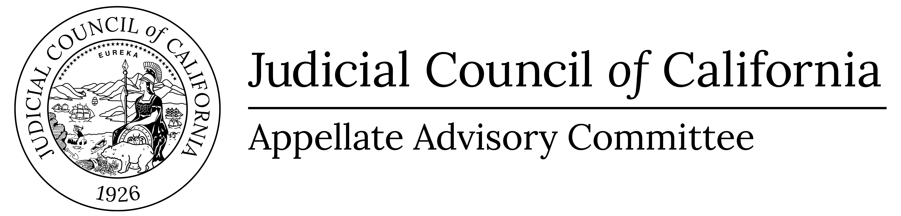 |  | www.courts.ca.gov/aac.htm  aac@jud.ca.gov

Appellate Advisory Committee

Appellate Efficiency Ad Hoc Subcommittee
Notice and Agenda of Closed Meeting
Closed to the Public (Cal. Rules of Court, rule 10.75(c)(3) and (e)(1))
Date: | January 15, 2026
Time: | 12:30 P.M.
In accordance with California Rules of Court, rule 10.75(e)(1), public notice is hereby given that the Appellate Efficiency Ad Hoc Subcommittee of the Appellate Advisory Committee will hold a closed session on Thursday, January 15, 2026 at 12:30 p.m. The meeting will be closed pursuant to California Rules of Court, rule 10.75(c)(3). Meeting materials will not be posted on the advisory body web page on the California Courts website. Materials are only posted for open meetings. (Cal. Rules of Court, rule 10.75(h).)
- Closed Session (Cal. Rules of Court, Rule 10.75(d))
Call to Order and Roll Call
Item 1
Appellate Procedure Rules and Forms. Closed under Rule 10.75(c)(3)(A) – Rule Committees.
Consider revised draft amendments to the rules on appendixes.
Item 2
Appellate Procedure Rules and Forms. Closed under Rule 10.75(c)(3)(A) – Rule Committees.
Consider draft amendments to the rules and forms on record designation and register of actions.
- Adjournment
Adjourn Closed Session

Posted on: January 12, 2026

