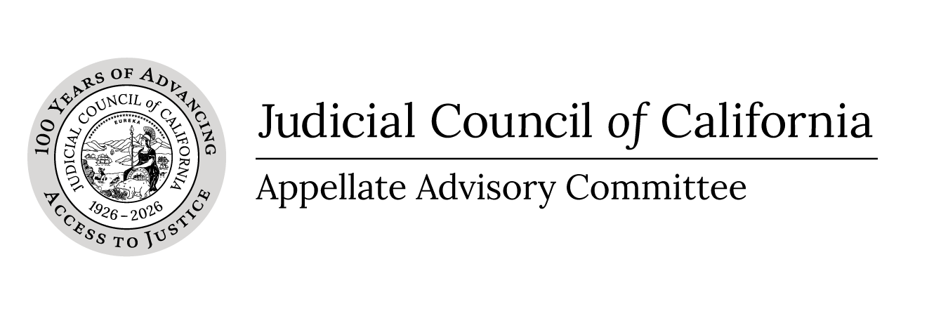 |  | courts.ca.gov/aac.htm  aac@jud.ca.gov

Appellate Advisory Committee
Notice and Agenda of Closed Meeting
Closed to the public (Cal. Rules of Court, rule 10.75(c)(3) and (e)(1))
Date: | February 26, 2026
Time: | 12:00 p.m.
In accordance with California Rules of Court, rule 10.75(e)(1), public notice is hereby given that the Appellate Advisory Committee will hold a closed session on Thursday, February 26, 2025 at noon. The meeting will be closed pursuant to California Rules of Court, rule 10.75(c)(3). Meeting materials will not be posted on the advisory body web page on the California Courts website. Materials are only posted for open meetings. (Cal. Rules of Court, rule 10.75(h).)
- Closed Session (Cal. Rules of Court, Rule 10.75(c)(3))
Call to Order and Roll Call
Approval of Minutes
Approve minutes of the February 2, 2026enter date(s), Appellate Advisory Committee meeting.
Item 1
Closed under rule 10.75(c)(3) – Rule Committees.
CEQA Actions: New Projects for Expedited Review
Item 2
Closed under rule 10.75(c)(3) – Rule Committees.
Appellate Procedure: Clarify Rule for Record Procurement Default Notice (rule 8.140)
Item 3
Closed under rule 10.75(c)(3) – Rule Committees.
Appellate Procedure: Appendixes
Item 4
Closed under rule 10.75(c)(3) – Rule Committees.
Appellate Procedure: Record Designation Rules and Forms
Item 5
Closed under rule 10.75(c)(3) – Rule Committees.
Fee Waiver Rules and Forms
- Adjournment
Adjourn Closed Session

Posted on: February 17, 2026

