Filed 6/5/23

**CERTIFIED FOR PUBLICATION**

IN THE COURT OF APPEAL OF THE STATE OF CALIFORNIA

SECOND APPELLATE DISTRICT

DIVISION EIGHT

|  |  |
| --- | --- |
| THE PEOPLE,  Plaintiff and Respondent,  v.  JERAMY LEE ODELL,  Defendant and Appellant. | B319448  Los Angeles County  Super. Ct. No. NA114654 |

APPEAL from a judgment of the Superior Court of Los Angeles County, James D. Otto, Judge. Affirmed with instructions.

Matthew Alger, under appointment by the Court of Appeal, for Defendant and Appellant.

Rob Bonta, Attorney General, Lance E. Winters, Chief Assistant Attorney General, Susan Sullivan Pithey, Senior Assistant Attorney General, Roberta L. Davis and Theresa A. Patterson, Deputy Attorneys General, for Plaintiff and Respondent.

____________________

We reject Jeramy Odell’s claim that the Second Amendment invalidates the statute barring felons from possessing guns. We affirm Odell’s conviction for murdering Myron Johnson, and we order corrections to the minute order and abstract of judgment.  Undesignated citations are to the Penal Code.

I

A motel’s outdoor video system recorded nearly all of the events surrounding Johnson’s death. Witness testimony supplemented the videos.

At 3 a.m., Odell and Shalisha White arrived at the two-story motel, arguing as they approached the exterior check-in window. Video showed Odell hitting White’s head.  They checked in, went to a second-floor room, and headed back to the parking lot.

On the way back to the parking lot, Odell and White kept arguing but paused on the way, lingering by Johnson’s second-floor room at the top of the stairwell above the check-in window.  Then they walked to their car and continued arguing. Annoyed by the noise, Johnson left his room, came to the second-floor railing, and yelled at the couple to be quiet.  Odell yelled back it was not Johnson’s business.

The night manager came out and told Johnson to return to his room.

Johnson was six feet two inches, about 235 pounds, and 41 years old. Odell’s driver’s license listed him as six feet tall, 175 pounds, and 29 years of age.

Johnson did not return to his room. Instead he descended the stairs and crossed the parking lot to where Odell was standing by White’s car.

Johnson swiftly moved toward Odell. A video showed this aggressive movement. At close range, Johnson quickly swung his left arm and leg towards Odell, who reacted by crouching and backing up a step. Both men remained on their feet.  In his closing argument, Odell’s counsel characterized the movement this way: Johnson ran over and took “a swing” at Odell. “It’s not clear whether he hit him or not. [Johnson is] standing there in an aggressive manner.”

After this thrust and parry, Johnson and Odell faced off for about 20 seconds, apparently exchanging words. Neither made additional violent or sudden movements.

The manager walked towards the two and again told Johnson to go to his room.

After about 10 seconds, Johnson obeyed the manager.  Hands in his pockets, he strolled back across the parking lot towards the stairs leading up to his room.

Very soon, this stairwell would become the killing scene. We describe the scene, for its layout is germane.

The top of the stairwell was across from the door to Johnson’s second-floor motel room. Between his door and the stairs and perpendicular to the stairs was a walkway. Other rooms had doors on this walkway.

The stairs did not descend from the second floor in one straight shot but made a 180 degree turn at a landing halfway down, and then continued to the ground.

Odell would gun down Johnson in this stairwell. How exactly this happened was a central focus of the trial. A fixed video camera recorded the scene, but the lens captured only a sliver of the view. The limits on the recorded perspective have significance for this appeal. In a moment, we will describe this view, second by second, as it was shown to the jury in Exhibit 20, which is a black-and-white video in our record.

As can be seen in the screenshot below, the dimensions of the view in this video are wider horizontally than vertically, and the format cuts off the view at the top and bottom of the screen. This screenshot from Exhibit 20 shows Johnson returning to his room after his confrontation with Odell. Johnson’s shirt is light across the shoulders and otherwise dark.

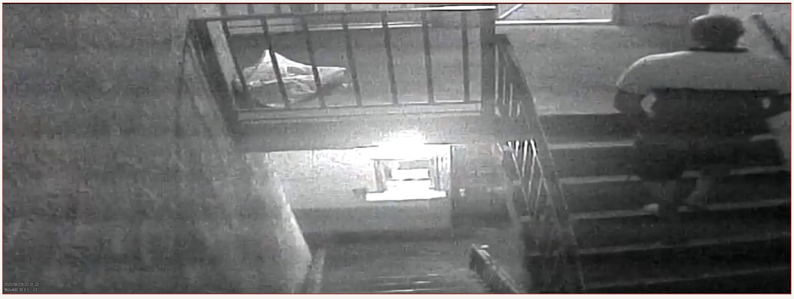

As we can see, the view from this camera looks down the exterior staircase; the camera is mounted opposite the stairwell entrance and exit, above the walkway on the second floor. The entrance and exit are open: no doors enclose the stairwell. On the left side of the image, stairs head up from the ground floor. The bottom three steps are visible, and then the bottom of the screen cuts off the view of the stairs to the landing. Immediately to the right, the staircase continues from the bottom of the screen to near the top. The stairs take a U-turn at the landing halfway up, but that landing is outside the frame. We can see only the top five steps on the right side of the staircase.

The video images do not show the landing. This lacuna will become consequential, because the landing is where Odell soon would shoot Johnson.

At the top of the frame, the walkway extends along the top edge of the screen. On the far side of this walkway is the bottom of the door to Johnson’s room. Johnson had left his door open.

The video in Exhibit 20 began with a static view. There was no motion and no one was in sight. Then the camera revealed the final 60 seconds of Johnson’s life.

At the two-second mark on the video, Johnson walked into the image’s frame at ground level. He was heading for his room after his parking lot confrontation with Odell.

Johnson sauntered up the stairs, taking about 15 seconds to reach the second floor. When Johnson got to the walkway at the top of the screen, the frame dimensions cut off most of his body. We see only his legs from the knees down.

Johnson went into his room, leaving the door open.

Meanwhile, Odell got a gun from the car. Odell told White, “Give me the clip.”  Odell put the clip in the pistol.

About one minute after the physical interaction with Johnson, Odell hid the gun under his arm and headed across the parking lot towards the stairwell.

As Odell approached the stairwell, a witness heard him say, “You want to act tough?  I got you.”  Then Odell charged up the stairs.

In Exhibit 20, Odell entered the frame at the 37-second mark. Pistol in hand, he ran up the first flight of stairs and towards the camera. At 42 seconds, he disappeared from view as he approached the stairwell landing.

At 43 seconds, Odell reappeared as he left the landing. Then he ascended the second flight of stairs, heading away from the camera. In the following seconds, he continued climbing, holding the pistol in front of him in his right hand, pointing it at Johnson’s open door and clutching the banister with his left hand. Odell wore a jacket with a stripe down the sleeves.

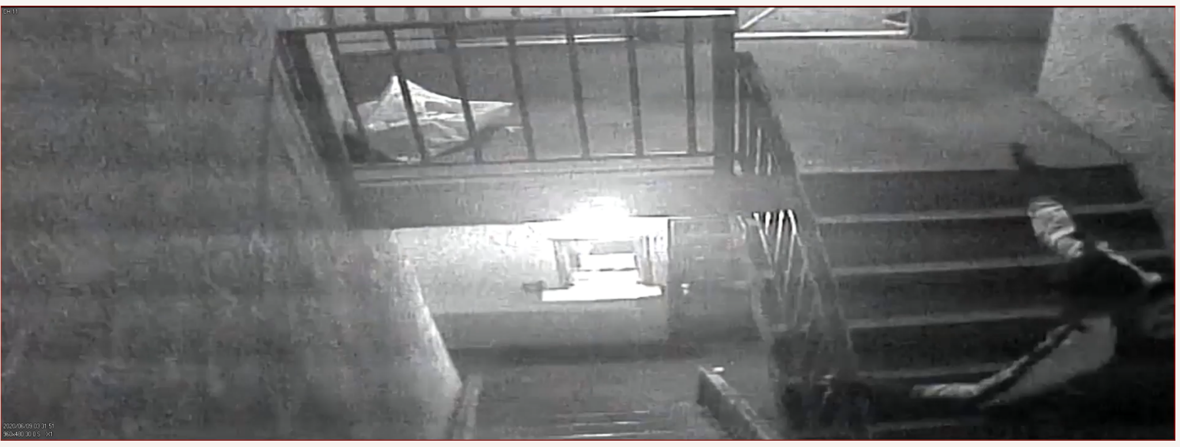

By the 47-second mark, Odell had completed his ascent and had crossed the walkway towards Johnson’s door. At that point the video showed him only from the knees down.

At the 48-second mark and over the next two seconds, the situation developed quickly. Johnson rapidly emerged from his motel room. He and Odell grappled. Odell kept the pistol in his right hand, while his left hand grabbed the front of Johnson’s shirt. Johnson, facing him and to his left, moved towards Odell. Both men headed in the direction of the stairs.

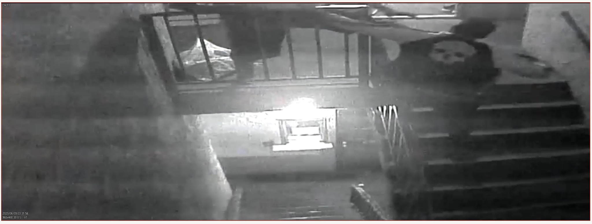

At the 50-second mark, the two men disappeared down the stairs and out of the frame.

For the next four seconds, there was a motionless image of the stairwell with no one in sight. Whatever was happening between Johnson and Odell was off camera on the landing.

Four seconds later, at the 54-second mark, Odell reappeared in the frame, alone, now running down the stairs to the ground floor, gun in hand. We see no more of Johnson.

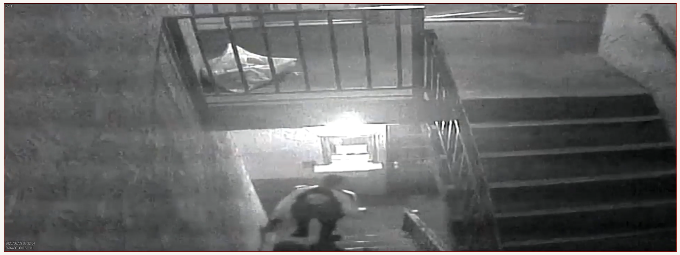

In these four seconds, Odell shot Johnson to death on the landing. But in these four seconds, what exactly was the situation, and what, inferentially, was Odell’s mental state? The video does not show the key seconds when the gun fires.

After Odell and White fled, police arrested them and put them in separate cells.  The empty cell between them concealed a microphone.  White told Odell the gun was “under the hood.”  Police found a gun under their car’s hood. Bullets from the scene matched it.

Prosecutors charged Odell with possession of a firearm by a felon in violation of section 29800(a)(1) and with the first-degree murder of Johnson.

At trial, Odell’s counsel requested CALCRIM No. 570 on heat of passion, No. 580 on voluntary manslaughter as a lesser included offense, and No. 505 on self-defense.

“Out of an abundance of caution,” the prosecutor said she did not object to No. 570 about heat of passion. The court replied, “Okay. That was easy, [defense counsel]. I’ll give it.”

As given, this instruction No. 570 included the following:

“*A killing that would otherwise be murder is reduced to voluntary manslaughter if the defendant killed someone because of a sudden quarrel or in the heat of passion. The defendant killed someone because of a sudden quarrel or in the heat of passion if:*

1. *the defendant was provoked;*
2. *as a result of the provocation, the defendant acted rashly and under the influence of intense emotion that obscured his reasoning or judgment; and*
3. *the provocation would have caused a person of average disposition to act rashly and without due deliberation, that is, from passion rather than from judgment. . . .*

*It is not enough that the defendant simply was provoked. The defendant is not allowed to set up his own standard of conduct. You must decide whether the defendant was provoked and whether the provocation was sufficient. In deciding whether the provocation was sufficient, consider whether a person of the average disposition, in the same situation and knowing the same facts, would have reacted from passion rather than from judgment. . . .*”

The court also gave CALCRIM No. 522, which stated that “[p]rovocation may reduce a murder from first degree to second degree and may reduce a murder to manslaughter. The weight and significance of the provocation, if any, are for you to decide. If you conclude that the defendant committed murder but was provoked, consider the provocation in deciding whether the crime was first or second degree murder. Also, consider the provocation in deciding whether the defendant committed murder or manslaughter.”

The prosecutor objected to CALCRIM No. 580, concerning involuntary manslaughter, because no evidence showed Odell actually believed he was in imminent danger of being killed or suffering great bodily injury. The court agreed.

CALCRIM No. 505 concerned self-defense. The prosecution objected to Odell’s self-defense theories because she said no evidence showed Odell believed he was in imminent danger. She also argued self-defense was inappropriate because Odell created the situation. The trial court agreed with both points.

Defense counsel claimed video showed Johnson attacking Odell at the top of the stairs, and argued this was circumstantial evidence Odell would have been in fear. The prosecutor argued Odell was the aggressor and had attacked the unarmed Johnson with a gun, which disqualified him from a self-defense theory.

The trial court did not instruct on self-defense or on involuntary manslaughter. It did not give CALCRIM Nos. 580 or 505.

The parties stipulated to Odell’s two past felony robbery convictions.

Odell’s defense, as presented in closing argument, was that the prosecution could not prove beyond a reasonable doubt that Odell shot Johnson intentionally.

In his closing, Odell’s attorney described the scene shown in Exhibit 20’s video: “They go down the stairs. You can see it happens fast. No shots were fired as they’re going down the stairs. You can see him holding the gun. The other guy is on top of him. They both end up down on that . . . landing, and that’s where the shots happen. And the video does not cover that part; so we don’t know at the end of the day whether he intentionally shot him or whether the gun went off accidentally during the struggle.” “You’ve got two men struggling. You don’t know. You can’t tell. It’s out . . . of the frame. . . . [And] that’s the fatal flaw in their murder case[:] . . . they cannot show that he intentionally shot the man.”

Defense counsel did not argue Odell, after provocation and in the heat of passion, *intentionally* shot Johnson. Odell’s attorney argued a contradictory theory: that Odell had “no motive for him to go and kill the guy.” Counsel rather suggested Odell sought “to confront him, to brandish the gun to try to scare” Johnson. “Why would he go up there to kill a man over something as trivial, knowing that his photo, his identification, description of the car is in the manager’s office?”

The jury convicted Odell of being a felon in possession of a gun.  The jury also convicted him of second-degree murder, finding he had personally and intentionally discharged a gun causing death.

II

We affirm the judgment but order sentencing corrections.

A

Odell incorrectly argues the felon-in-possession law violates the Second Amendment. This law makes it a felony for any person who has been convicted of a felony to possess any firearm. (§ 29800(a)(1).) Odell cites *New York State Rifle & Pistol Association Inc. v. Bruen* (2022) 142 S.Ct. 2111 (*Bruen*).

The Second Amendment states, “A well regulated Militia, being necessary to the security of a free State, the right of the people to keep and bear Arms, shall not be infringed.” (U.S. Const., 2d Amend.)

All constitutional rights have limits. Holmes explained, for instance, that the “most stringent protection of free speech would not protect a man in falsely shouting fire in a theatre and causing a panic.” (*Schenck v. United States* (1919) 249 U.S. 47, 52.)

Like the First Amendment, the Second Amendment has boundaries. (*Bruen*, *supra*, 142 S.Ct. at p. 2128.) The Second Amendment right is “not a right to keep and carry any weapon whatsoever in any manner whatsoever and for whatever purpose.” (*Ibid*; *id*. at p. 2138 [the right has traditionally been subject to well-defined restrictions].)

This case illustrates one boundary on this right.

The decision in *District of Columbia v. Heller* (2008) 554 U.S. 570, 592 defined the Second Amendment right and described limits on it.  The court stated nothing in its opinion cast doubt on longstanding prohibitions on the possession of firearms by felons. (*Id*. at pp. 626–627.)  These prohibitions were presumptively lawful.  (*Id*. at p. 627, fn. 26.)  Two years later, the Supreme Court repeated those assurances in *McDonald v. City of Chicago, Illinois* (2010) 561 U.S. 742, 786.  *Bruen*, *supra*, 142 S.Ct. at p. 2157, reiterated that Second Amendment rights are limited.

These statements foreclose Odell’s challenge.

These statements are dicta. But they are sensible and persuasive dicta. People convicted of a felony have demonstrated a capacity for poor judgment that endangers others. Odell’s impulsive desire to get back at Johnson, for instance, led to a swift, deadly, and irrational outcome. Guns are designed to kill or injure. Modern guns are accomplished pieces of engineering: they effectively perform their design function. They are easy to use and can cause damage quickly. People who are not thinking clearly or who are not in control of their emotions can use them to potent effect. In a flash, a gun can turn a noise complaint into an event of death.

It was no accident the *Bruen* majority repeated the qualifier “law-abiding” some 13 times. (*Bruen*, *supra*, 142 S.Ct. at pp. 2122, 2125, 2131, 2133, 2134, 2135 n. 8, 2138 & n.9, 2150, 2156.) People who have been convicted of a felony are not “law-abiding.”

We agree with *People v. Alexander* (May 11, 2023, E078846) –––– Cal.App.5th –––– [2023 Cal.App. Lexis 366]). This statute is constitutional.

B

Odell’s murder conviction is valid because his claims of instructional error lack merit. His three claims relate to provocation, self-defense, and involuntary manslaughter.

1

Odell complains the provocation instruction did not instruct the jury that provocation need not be sufficient to cause an average person to kill. In particular, he argues that, although the provocation required for the heat-of-passion form of voluntary manslaughter must be sufficient to cause a person of average disposition to *react rashly*, it need not be sufficient to cause such a person *to kill*. That is, he claims the trial court set the bar on provocation too high. This argument fails, however, because the trial court set the bar just right.

We begin with some basic law.

The doctrine of homicide reduces the offense when a killer acts in the “heat of passion.” (§ 192, subd. (a).) But what kind of “passion” suffices, and how much is necessary?

General rules regulate these questions. First, heat of passion does not require anger or rage. It can be any violent or intense emotion. (*People v. Breverman* (1998) 19 Cal.4th 142, 163.) Second, provocation is measured by an objective standard: the reaction of the *average* person is the benchmark. Defendants are not allowed to set up their own standards of conduct. (*People v. Beltran* (2013) 56 Cal.4th 935, 938, 942, 950, 954, 957 (*Beltran*).) Third, the provocation must be enough to induce an average person to *react from passion and not from judgment*, but the provocation need not be so extreme as to prompt an average person to *kill*. (*Ibid.*) The emotional response required, however, goes far beyond the type of irritation that mundane annoyances would prompt an average person to feel. (*Id.* at p. 950.)

Case law has made these abstractions more concrete.

A voluntary manslaughter instruction is unwarranted where the alleged provocation was no more than taunting words, a technical battery, a slight touching, or simple assault. Engaging in a verbal argument with expletives, together with a “tussle” involving chest scratching and kicking, also does not rise to the level of provocation necessary to support a voluntary manslaughter instruction. Calling the defendant a motherfucker and repeatedly asserting that, if defendant had a weapon, he should take it out and use it, plainly is insufficient to cause an average person to become so inflamed as to lose reason and judgment. (*People v. Gutierrez* (2009) 45 Cal.4th 789, 826-827 (*Gutierrez*).)

The trial court instructed the jury on these issues using CALCRIM No. 570. Odell’s counsel requested this instruction. The Supreme Court approved an earlier version of this instruction. (*Beltran, supra*, 56 Cal.4th at pp. 954, fn. 14, 956, 957.) Odell does not claim later revisions of CALCRIM No. 570 departed from the law.

Odell, however, argues the *prosecutor* misstated this law in her closing argument. We inspect her relevant words, adding italics to this excerpt of her closing argument. The prosecutor told the jury:

“Now, the judge has also given you an instruction on manslaughter based on heat of passion, and I would like to think of manslaughter as murder but we’re going to reduce it because of certain circumstances. So in this case the theory of reducing it is called heat of passion. Now, I’m sure the defense will get up and argue a little bit more about this, but there are a few key things about heat of passion that I want you to think about when you are evaluating the evidence. *First of all, heat of passion, it’s not enough that the defendant simply [was] provoked. It’s whether a person of average disposition, our normal, average person in the same situation, and knowing the same facts, would have reacted the same way and killed, would have reacted from the heat of passion and killed.* So it’s not just what the defendant did, but would our person of average disposition respond in the same way in the same situation? The defendant is not allowed to set up his own standard of conduct. Well, I was provoked; therefore, it’s manslaughter. So keep those in mind when you are evaluating the heat of passion.”

The italicized portion of the prosecutor’s argument is ambiguous. One interpretation is that she was properly describing valid law: clarifying that provocation must be objective and not subjective in character. “*It’s whether a person of average disposition, our normal, average person in the same situation, and knowing the same facts, would have reacted the same way and killed, would have reacted from the heat of passion and killed.*”

This interpretation would understand the challenged words, in context, to be explaining the correct standard is the reaction of “our normal, average person” and that the “defendant is not allowed to set up his own standard of conduct.” (Accord, *Beltran*, *supra*, 56 Cal.4th at p. 950 [“no defendant may set up his own standard of conduct and justify or excuse himself because in fact his passions were aroused, unless further the jury believe that the facts and circumstances were sufficient to arouse the passions of the ordinarily reasonable man.”] [omitting quotation marks and citation].)

So interpreted, this explanation has been the law in California for over a century. (See *People v. Logan* (1917) 175 Cal.45, 49 [“no defendant may set up his own standard of conduct”].)

Odell argues for a contrary interpretation. He maintains the prosecutor was insisting provocation had to be so great as to prompt an average person to *kill.* According to this interpretation, Odell argues, the prosecutor misstated the law and misled the jury, because *Beltran* held that provocation need only induce an average person to *react from passion and not from judgment*. *Beltran* held that provocation need not be so extreme as to prompt an average person to *kill*. (*Beltran*, *supra*, 56 Cal.4th at pp. 938–939.)

To the extent the prosecutor’s one sentence was undesirably ambiguous, these few words could not have affected the trial’s outcome. This is true under any standard of review. (See *Chapman v. California* (1967) 386 U.S. 18, 24 [reverse unless the error is harmless beyond a reasonable doubt]; *People v. Watson* (1956) 46 Cal.2d 818, 836 [reverse only when it is reasonably probable a result more favorable would have been reached absent the error].) We thus elide the debate between Courts of Appeal on this standard-of-review issue. (See *People v. Schuller* (2021) 72 Cal.App.5th 221, 237–238 [recounting debate], rev. granted, S272237, January 19, 2022.)

The prosecutor’s sentence about provocation had minimal impact on the trial result because provocation was mostly irrelevant in this trial. Provocation was not Odell’s defense in closing. Provocation is a theory about an *intentional* killing. That theory would be that Odell intended to kill Johnson when passion overwhelmed Odell’s reason. Odell’s attorney, however, argued a contradictory theory: that Odell *unintentionally* fired the gun at Johnson as the result of a violent tussle. The shooting was a mistake, according to defense counsel, and not an intentional and passionate act.

Odell’s defense of an *unintentional* killing was Odell’s best trial theory. This theory exploited the only weak link in the prosecution’s video case: the four-second video gap in Exhibit 20. The motel’s many cameras recorded the other interactions between Johnson and Odell. Significantly, down in the parking lot, before the shooting, a different camera captured Johnson’s brief and unsuccessful lunge at Odell, from which Odell emerged standing and unharmed. That camera also recorded the time passing after this confrontation, and it showed Johnson walking away. By showing the minor character of this episode, this video evidence thus undercut the plausibility of a potential heat-of-passion defense. By contrast, the missing evidence during the four seconds of the shooting—when Johnson and Odell moved down the stairwell and out of the camera frame—created an opportunity to argue there was no proof beyond a reasonable doubt that Odell had intended to kill Johnson at all. Odell’s attorney used this four-second gap as best he could, given the circumstances of the case. This defense was tactically sound; it was the most plausible avenue available to the defense. This defense, however, made the issue of provocation irrelevant.

The evidentiary foundation for the provocation instruction was marginal at best. Earlier we quoted the *Gutierrez* case, which explained that a “tussle” involving chest scratching and kicking did not rise to the level of provocation necessary to support a voluntary manslaughter instruction. (*Gutierrez* , *supra*, 45 Cal.4th at p. 827.) The court agreed to give this instruction because the prosecutor decided, “out of an abundance of caution,” not to object to this defense request.

In sum, assuming, for the sake of argument, there was error by the prosecutor, that error was harmless beyond a reasonable doubt.

Our resolution of this issue means we need not and do not reach Odell’s arguments about ineffective assistance of counsel.

2

Odell faults the trial court for failing to instruct the jury on self-defense. The trial court’s refusal to give this instruction was, however, proper.

A killing in perfect self-defense is justifiable homicide. Perfect self-defense requires that one must actually and reasonably believe in the necessity of defending oneself from imminent danger of death or great bodily injury. Imperfect self-defense reduces an intentional and unlawful killing to voluntary manslaughter. Imperfect self-defense occurs when defendants act in the actual but unreasonable belief they are in imminent danger of great bodily injury or death. (*People v. Thomas* (2023) 14 Cal.5th 327, 385–386.) Thus, both theories of self-defense require your actual belief that you must defend against an imminent danger.

The trial court rightly declined to instruct on self-defense because no evidence suggested Odell actually believed he was in danger. Odell did not testify and so gave no evidence he actually believed he was in danger of death or injury. The evidence showed Johnson walked away from Odell in the parking lot confrontation. Odell then pursued the unarmed man with a loaded pistol. From the 37-second mark to the 47-second mark of the video in Exhibit 20, Odell, gun in hand, charged up the stairs towards Johnson’s room. Johnson is nowhere to be seen until the point when, for two seconds, the video shows Johnson and Odell grappling and heading down the staircase. Odell continued to hold the loaded gun in his right hand while Johnson remained unarmed. There was no evidence Odell actually believed he was in danger.

Because substantial evidence did not support self-defense instructions, the trial court properly refused to give them.

3

Odell argues the court should have given an instruction about involuntary manslaughter. The difference between other homicide offenses and involuntary manslaughter depends on whether Odell was aware of the risk to life that his actions created and consciously disregarded that risk. (See *People v. Thomas* (2012) 53 Cal.4th 771, 813–815.) The trial court properly rejected this instruction because Odell deliberately procured a gun, loaded it, and sought to confront a large man at close quarters, pointing the gun at the man as he rushed towards him. “Such conduct is highly dangerous and exhibits a conscious disregard for life.” (*Id.* at p. 815.) No evidence suggested Odell was unaware of this risk, which proved fatal to Johnson. The court rightly rejected this instruction because it lacked evidentiary support.

C

At the March 29, 2022 sentencing hearing, the trial court awarded Odell 658 days of presentence credit and sentenced him to 16 months on his felon in possession conviction to run concurrently with his sentence on the murder count.  The minute order from the hearing states the 16-month sentence is to be consecutive, and the abstract of judgment fails to state whether it is concurrent or consecutive.  We order the trial court to correct the minute order and abstract of judgment to reflect that the 16-month sentence is to run concurrently with the murder charge, consistent with the trial court’s oral pronouncement at the hearing.  We further order the trial court to correct the abstract of judgment to reflect that Odell is entitled to 659 days of presentence credit.

1. **DISPOSITION**

We order the trial court to correct the minute order and abstract of judgment to reflect that the 16-month sentence on the felon in possession charge is to run concurrently with the murder charge. We further order the trial court to correct the abstract of judgment to reflect that Odell is entitled to 659 days of presentence credit. We otherwise affirm the judgment.

WILEY, J.

We concur:

STRATTON, P. J.

VIRAMONTES, J.