TO: | Potential Proposers
FROM: | Administrative Office of the Courts  Executive Office Programs Division
DATE: | April 15, 2009
SUBJECT/PURPOSE OF MEMO: | Request for proposals  INteraction design FOR AOC knowledge centers
ACTION REQUIRED: | You are invited to review and respond to the attached Request for Proposals (“RFP”):  Project Title: Interaction Design for AOC Knowledge Centers,  RFP Number: EOP-200903-RB
PROPOSAL DUE DATE: | Proposals must be received by end of business day on May 4, 2009
SUBMISSION OF PROPOSAL: | Proposals must be sent to:  Judicial Council of California  Administrative Office of the Courts  Attn: Nadine McFadden, RFP# EOP-200903-RB  455 Golden Gate Avenue  San Francisco, CA 94102
FOR FURTHER INFORMATION: | E-MAIL:  Solicitations@jud.ca.gov

Table of contents

Section Title Page

1.0 GENERAL INFORMATION 3
2.0 PURPOSE OF THIS RFP 5
2.0 WEB SITE REQUIREMENTS 6
4.0 RFP SCHEDULE AND GENERAL INSTRUCTIONS 10
5.0 RFP ATTACHMENTS 12
6.0 SCOPE OF SERVICES 12
7.0 SPECIFICS OF A RESPONSIVE PROPOSAL 13
8.0 EVALUATION OF PROPOSALS 14
9.0 SUBMISSION OF PROPOSALS 15
10.0 RIGHTS 16
11.0 ADDITIONAL REQUIREMENTS 16
12.0 CONFIDENTIAL OR PROPRIETARY INFORMATION 16

- GENERAL INFORMATION

  - Background

The Judicial Council of California, chaired by the Chief Justice of California, is the chief policy making agency of the California judicial system. The California Constitution directs the Council to improve the administration of justice by surveying judicial business, recommending improvements to the courts, and making recommendations annually to the Governor and the Legislature. The Council also adopts rules for court administration, practice, and procedure, and performs other functions prescribed by law. The Administrative Office of the Courts (AOC) is the staff agency for the Council and assists both the Council and its chair in performing their duties.

The Executive Office Programs (EOP) Division of the AOC serves the judicial branch, its leaders, and the courts in advancing programs and innovations that support excellence in the administration of justice. To support the work of the Judicial Council, EOP works collaboratively with internal and external stakeholders to develop and implement policies and procedures to assist judicial branch leaders to enhance the administration of justice in the state.

  - Procedural Fairness in the California Courts

Building on the momentum generated by the Judicial Council’s 2005–2006 public trust and confidence assessment (which was executed by EOP staff and outside consultants), the current branch initiative on procedural fairness in the California courts is focusing on strategies for the courts to ensure that the public perceives the highest standards of fairness and quality treatment in court procedures. The council is committed to enhancing public trust and confidence in the California courts by supporting and promoting the branch policy of achieving procedural fairness in all types of cases.

EOP is currently working with the Center for Court Innovation (a New York nonprofit that helps courts and criminal justice agencies to evaluate programs and improve public trust and confidence) to develop a print and Web resource guide for the courts on procedural fairness, for release in September 2009. Guided by the strategic and operational goals of the branch, the resource guide will include effective strategies and techniques, tools for judges and court staff, and programs and best practices readily adaptable to court environments. Within EOP, the procedural fairness project is led and staffed by the Promising and Effective Programs Unit.

  - AOC Web Redesign

The AOC is also committed to enhancing the user-experience on both our public- and court-facing Web sites and aspires to become a leader in delivering e-government services related to the judicial system. Concurrent with development of the resource guide on procedural fairness, EOP is working with a Bay Area interactive consultancy agency focused on Web strategy to help us unify many of our court Web sites under a cohesive identity/branding system and to help optimize our existing information design and navigation systems.

For the internally-facing Web sites, our goals are to improve ease of use, implement a single, coherent visual identity system, and significantly improve the user experience by aligning user tasks with improved information architecture. Today, court professionals are inundated with information. Our Web sites need to present relevant information, when it is needed, in an efficient and streamlined fashion. Within EOP, the AOC Web Redesign project is led and staffed by the Office of Communications.

  - AOC Knowledge Centers

In conjunction with the AOC Web Redesign, the AOC desires to create model and innovative Web-based Knowledge Centers as a gateway where court professionals will be able to access an extensive array of information to address important issues facing the California courts (for example, resources to help the courts achieve procedural fairness). The Knowledge Centers will be designed to (1) keep court professionals up-to-date on key issues and new developments; (2) present trends in court practices; (3) help the courts to implement branch goals and operational objectives; and (4) provide strategies and tools that increase court effectiveness and enhance the experience of court users. The centers will present targeted Web resources in a dynamic format to assist members of the California judicial branch in the day-to-day provision of court services for the public.

  - Relevant Web Resources

Proposers for the RFP should be familiar with the following Web pages and documents:

California Courts Web site: www.courtinfo.ca.gov.

The California Courts Web site also includes:

a) The California Online Self Help Center: An award-winning online legal resource providing self-help resources in both English and Spanish: www.courtinfo.ca.gov/selfhelp

b) Programs Page: this section features Judicial Council programs and activities designed to enhance the quality of justice in California's courts:
http://www.courtinfo.ca.gov/programs/

Trust and Confidence in the California Courts, 2005–2006 (Phase I and Phase II reports):
http://www.courtinfo.ca.gov/reference/4_37pubtrust.htm
Justice in Focus, the Strategic Plan for California’s Judicial Branch, 2006–2012
http://www.courtinfo.ca.gov/reference/2_annual.htm

Procedural Fairness in the California Courts (2007)
http://www.courtinfo.ca.gov/programs/profair/documents/profair_brochure_092507.pdf

The Operational Plan for California’s Judicial Branch, 2008–2011 (2008)
http://www.courtinfo.ca.gov/reference/documents/2008_operational_plan.pdf

----------------------------------------------------------------------------------------------------

More information about the California Courts Web Site can be found at:
http://www.courtinfo.ca.gov/reference/documents/factsheets/CaliforniaCourtswebsite.pdf

More information about California Courts Online Self-Help Center can be found at:
http://www.courtinfo.ca.gov/reference/documents/factsheets/selfhelpqa.pdf

For a complete list of Fact Sheets, visit:
http://www.courtinfo.ca.gov/reference/factsheets.htm

- PURPOSE OF THIS RFP

  - The AOC seeks proposals from all qualified interactive, instructional design firms to help create and launch a series of Web-based AOC Knowledge Centers that will debut in fall 2009 and will be based on template pages resulting from the AOC Web redesign that is currently in progress. These templates will be provided to the contracted consultant for this Knowledge Center project (see design mockups below). The contracted consultant(s) for this project will work with AOC staff in Promising and Effective Programs and the AOC Office of Communications, and with the Center for Court Innovation, to help adapt the print version of the procedural fairness resource guide for Web use by members of the branch. Thus, we are primarily seeking a proposer who can demonstrate strength and expertise in interactive, instructional design.

  - Because the Knowledge Center on Procedural Fairness will be based in large part on a print resource guide currently being formed and developed for release in fall 2009, content development is not included in this RFP.

  - Ideally, the online version of the resource guide will make its content (i.e., procedural fairness tools or identification of programs that assist judicial officers, court administrators, and court users) more easily accessible to AOC, court, and other program staff via a model Web-based Knowledge Center. The contracted consultant will (1) assist the AOC with recommendations for presentation of content for the Web; (2) create an interactive and instructional design for the Knowledge Center; and (3) supply functional modules necessary to build a high quality, reliable custom Web site.

  - The creation of the first Knowledge Center on Procedural Fairness will serve as a blueprint for other, future Web Knowledge Centers. Thus, the contract will also include design of a Web template that other AOC program teams can use to create additional Knowledge Centers relevant to other areas of work (for example, to create additional Web-based Knowledge Centers on Alternative Dispute Resolution, Court Security, Equal Access, Probate, and Family/Juvenile Law).

  - The Knowledge Center for Procedural Fairness may serve as a prototype, but the template for additional Knowledge Centers should be an easily transferable Web design and content structure that is flexible enough to feature a variety of programs.

  - The Knowledge Centers will be housed on Serranus, the AOC’s password-protected Extranet, which provides a wealth of information and resources pertaining to court administration. The site is used by a target audience of Judges, Court Executive Officers, Court Professionals, and AOC staff to share information regarding policies, programs, news, and other court-related initiatives. As noted above, existing AOC Web templates in conjunction with the overall AOC Web Redesign for the external- and internal-facing sites will be available to the consultant to insure that formation of the Knowledge Centers integrates with and complements newly designed AOC-Web components.

  - The contracted consultant will also have a strong grounding in customer experience and delivering user-centric design, including effective adaptation of print materials for interactive Web use. Finally, the contracted consultant will have a strong track-record in providing outstanding project management services to ensure that both end-user and AOC stakeholder goals are achieved and implemented in a timely manner.

- WEB SITE REQUIREMENTS

  - The Knowledge Centers will debut in conjunction with the launch of the redesigned California Judicial Branch Web page, currently planned for September 2009. Mockups for the new branch Web pages are included in Figure 1 and Figure 2, below. Proposers may reference these mockups to see where the Knowledge Centers will be placed in the new site.

Figure 1

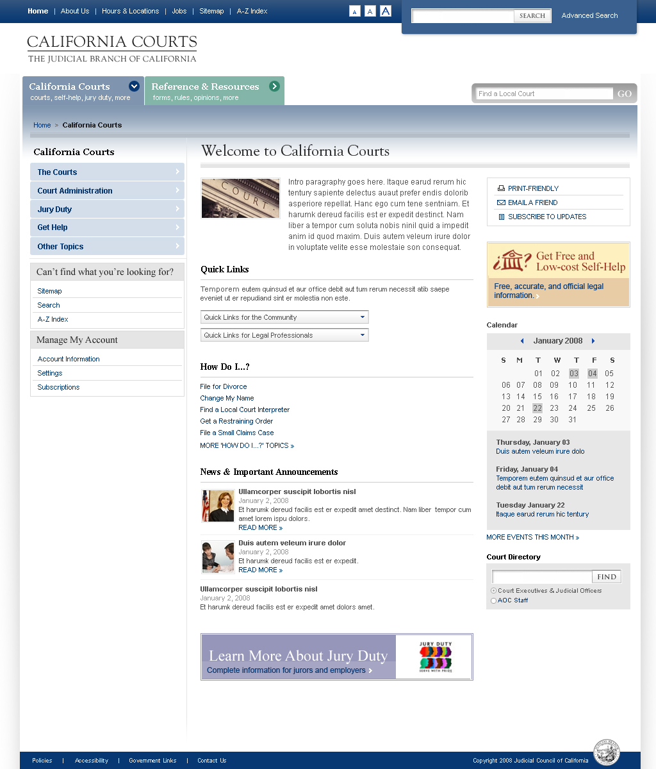
Figure 2

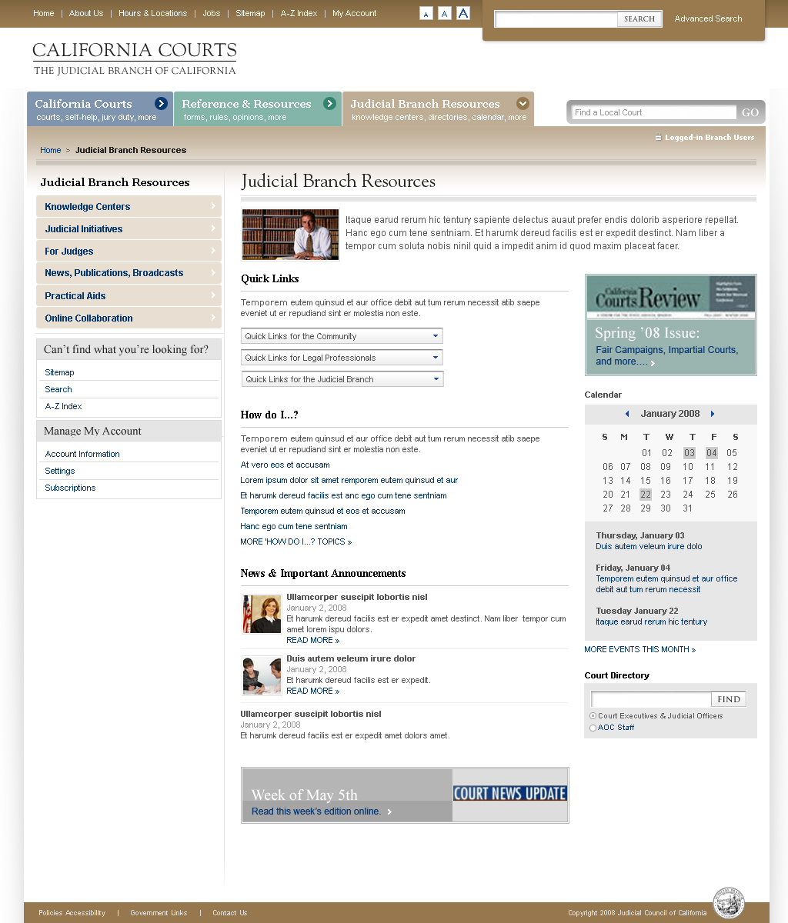

  - Design Requirements

Overall, the AOC Knowledge Centers should:

    - Be engaging and easy and intuitive to navigate;

    - Demonstrate a sophisticated understanding of target audience(s)—appeal visually to the primary audience (e.g., with color and interactive elements);
    - Be easy to maintain – using textual/non-interactive components developed in a tagged-based language; repeatable elements can be changed in a single place and changes populated throughout the site (e.g., using Server Side Includes (SSI) directives that are placed in HTML pages);

    - Be scalable – including design that can accommodate projected growth of the site;

    - Integrate with AOC Web Redesign Style Guide and formats.

Note: Design and delivery of graphic elements also implies providing the AOC with all design assets, such as gifs and original PSD files for future maintenance by AOC staff.

  - Design Methodology

    - The contracted consultant will provide the AOC with interactive design, graphic elements, and HTML to enable the AOC to build template variants within RedDot software.

    - The contracted consultant will coordinate development, and hand-off of the Knowledge Centers to the AOC’s Content Management System (CMS) Implementation team for site implementation and final development.

  - Accessibility Requirements

All graphic design must adhere to federal Section 508 (§1194.22) standards. (Visit http://www.section508.gov/ for a list of the 16 applicable provisions.)

  - Performance Requirements

The Web site is expected to contain both multimedia and interactive elements.

Note: (Usability best practice information regarding government sites can be found at: http://www.usability.gov/)

  - Technical Specifications

The Web site of which the Knowledge Centers will be part will be housed on a separate server; as such, the selected Web graphic design consultant must have a working knowledge of the principles of design, color theory, and graphics file creation optimized for the Web.

- RFP SCHEDULE AND GENERAL INSTRUCTIONS

  - The AOC has developed the following list of key events from RFP issuance through notice of contract award. All key dates are subject to change at the AOC’s discretion.
Event | Date
Issue RFP | 4/15/09
Deadline for Proposer Requests for Clarifications or Modifications | 4/20/09
AOC Posts Clarification/Modification Response (estimated) | 4/23/09
Proposal Due and Time | 5/04/09 end of business day
Posting of Short Listed Proposers on CourtInfo Website (estimated) | 5/18/09
Interviews/demonstrations of short listed Proposers on site at AOC Offices in San Francisco, CA (estimated) | 5/29/09
Posting of Intent to Award on CourtInfo Website (estimated) | 6/05/09
Commencement of contracted service(estimated) | 6/15/09

The RFP and any addenda that may be issued will be available on the following Website:
http://www.courtinfo.ca.gov/reference/rfp/ (“Courtinfo Website”)

  - Proposal Submittal Address:
Nadine McFadden
RFP# EOP-200903-RB
Judicial Council of California
Administrative Office of the Courts
455 Golden Gate Avenue, 7th Floor
San Francisco, CA 94102-3688
  - Request for Clarifications or Modifications

    - Proposers interested in responding to the solicitation may submit questions by e-mail only on procedural matters related to the RFP or requests for clarification or modification of this solicitation document, including questions regarding the Terms and Conditions in Attachment B, to the Solicitations mailbox referenced below. If the proposer is requesting a change, the request must set forth the recommended change and the proposer’s reasons for proposing the change.

    - Solicitations mailbox: solicitations@jud.ca.gov

    - All questions and requests for clarification or modification must be submitted by email to the Solicitations mailbox by no later than the date and time specified in the RFP Schedule in Section 4.1, above. Questions or requests submitted after the due date will not be answered.

    - All email submissions sent to the Solicitations mailbox MUST contain the RFP number and other appropriate identifying information in the email subject line. In the body of the e-mail, always include paragraph numbers whenever references are made to content of this RFP. Failure to include the RFP number as well as other sufficient identifying information in the email subject line may result in the AOC taking no action on a proposer’s email submission.

    - Without disclosing the source of the question or request, the AOC Contracting Officer will post a copy of the questions and the AOC’s responses on the Courtinfo Website.

    - If a proposer’s question relates to a proprietary aspect of its proposal and the question would expose proprietary information if disclosed to competitors, the proposer may submit the question in writing, conspicuously marking it as "CONFIDENTIAL." With the question, the proposer must submit a statement explaining why the question is sensitive. If the AOC concurs that the disclosure of the question or answer would expose proprietary information, the question will be answered, and both the question and answer will be kept in confidence. If the AOC does not concur regarding the proprietary nature of the question, the question will not be answered in this manner and the proposer will be notified.

- RFP ATTACHMENTS

  - The following documents are incorporated into this Request For Proposals (RFP) by reference:

Attachment 1 - Administrative Rules Governing Request For Proposals
Attachment 2 - Contract Terms
Attachment 3 - Proposer’s Acceptance of the RFP’s Contract Terms
Attachment 4 - Payee Data Record

  - Attachment 1, Administrative Rules Governing Request for Proposals. Proposers shall follow the rules, set forth in Attachment 1, in preparation of their proposals.

  - Attachment 2, Terms and Conditions. Contracts with successful proposer(s) will be signed by the parties on a State of California Standard Agreement form and will include terms appropriate for this project. Terms and conditions typical for the requested services are attached as Attachment 2 and include the following provisions:

Exhibit A, Standard Provisions.
Exhibit B, Special Provisions.
Exhibit C, Payment Provisions.
Exhibit D, Work To Be Performed.
Exhibit E, Contractor’s Key Staff. (To Be Determined)
Exhibit F, Attachments, including Attachment 1, Acceptance and Signoff Form

  - Attachment 3, Proposer’s Acceptance of the RFP’s Contract Terms. Proposers must either indicate acceptance of the Agreement Terms, as set forth in Attachment 2, or clearly identify exceptions with a written summary of relevance and rationale to substantiate each proposed change.

  - Attachment 4, Payee Data Record Form. The AOC is required to obtain and keep on file, a completed Payee Data Record for each proposer prior to entering into a contract with that proposer. Therefore, proposer’s proposal must include a completed and signed Payee Data Record Form, set forth as Attachment 5.

- SCOPE OF SERVICES

  - It is expected that the total cost for consultant services will be in the range of $40,000 to $50,000 inclusive of personnel, materials, computer support, travel, lodging, per diem, and overhead rates.

  - Services are expected to be performed by the consultant from June 2009 - February 2010.

  - See Attachment 2, Contract Terms, Exhibit D, Work To Be Performed, for the Work Requirements and Scope of Work specifications

- SPECIFICS OF A RESPONSIVE PROPOSAL

  - Responsive proposals should provide straightforward, concise information that satisfies the requirements noted above. Expensive bindings, color displays, and the like are not necessary or desired. Emphasis should be placed on conformity to the state’s instructions, requirements of this RFP, and completeness and clarity of content.

  - The following information shall be included as the technical portion of the proposal:

    - Company information, including: company name, address, telephone, fax numbers; name, address, telephone, and e-mail address of proposer’s point of contact; and federal Tax identification number. Note that if a sole proprietorship using its social security number is awarded a contract, the social security number will be required prior to finalizing a contract.

    - The number of years your firm has been in the business of providing the services specified in this RFP.

    - The number of full time employees.

    - Disclose any judgments, pending litigation, or other real or potential financial reversals that might materially affect the viability of the proposer’s firm.

    - Annual gross revenue from your most recent audited or reviewed profit and loss statement and balance sheet. State the audit/review year and the annual gross revenue. The AOC may request a copy of your most recent audited or reviewed profit and loss statement and balance sheet.

    - Resumes describing the background and experience of key staff, as well as each individual’s ability and experience in performing the proposed activities.

    - Description of key staff’s knowledge of the requirements necessary to complete this project.

    - Names, addresses, and telephone numbers of a minimum of five (5) clients for whom the consultant has conducted similar services. The AOC may check references listed by the consultant.

    - Method to complete the Project:

      - Proposed process necessary to address the project objectives.

      - Proposed Deliverables

      - Proposed implementation methodology.

      - Proposed project and team organization.

    - Samples of work similar to the work required in this RFP. Proposers must not submit examples that are proprietary or confidential to any third party, unless the proposer has a right to do so.

    - A statement of availability to complete the work within the timeframes specified in this RFP.

  - The following information shall be included as the Fee Proposal portion of the proposal:

    - Proposed firm fixed prices per proposed Deliverable. For evaluation purposes, include the following pricing elements for each deliverable: Key Personnel, their hourly rates, estimated hours, total labor costs, anticipated travel costs and other expenses.

- EVALUATION OF PROPOSALS

  - The evaluation team will first evaluate all parts of submitted proposals and score them as described below. The final scores will be used to create a short list of proposers to be interviewed. Proposers not on the short list will not be eligible for further consideration for this Project. Those proposers selected on the short list will be interviewed on site at the AOC in San Francisco, or via a video conference call, and will also be asked to provide a demonstration of its examples. The interview/demonstration will be evaluated on the same criteria as the proposals. After interviews/demonstrations are conducted, each evaluation team member will review his/her own points previously assigned to each proposer on the short list and make adjustments if necessary, and the final scores will be re-calculated.

  - The AOC will evaluate proposals using the criteria below, in descending order of importance:

    - Demonstrated past experience delivering engaging Web-based instructional design, including communicating complex subject matter into comprehensible and learnable modules.

    - Strength of work plan, including proposed plan for research and solicitation of information from branch stakeholders, implementation methodology, and review of samples provided.

    - Reasonableness of Fee proposal

    - Credentials of staff to be assigned to the project

    - Ability to meet timing requirements to complete the project.

    - References

    - Compliance with RFP requirements including acceptance of Contract Terms and Conditions, submission of the completed Payee Data Record (Attachment 4), and submitted responses to all parts of Section 7, Specifics of a Responsive Proposal, and its subparagraphs. Consideration will be given to the extent of any proposed contract exceptions in Attachment C, Contract Exceptions.

    - For those selected on the short list, any information revealed or demonstrated during the proposer’s interview/demonstration, will be used in the AOC’s final evaluation of the proposers proposal.

- SUBMISSION OF PROPOSALS

  - The proposer must prepare a cover letter on the prime proposer’s business letterhead to accompany the proposal. The purpose of this letter is to transmit the proposal; therefore, it should be brief. The letter must be signed by an individual who is authorized to bind his or her company to all statements, including services and prices, contained in the proposal. The cover letter must state who the proposed prime contractor is, name the proposed subcontractors, and provide proposer’s point of contact, including name, physical and electronic addresses, and telephone and facsimile numbers.

  - Responsive proposals should provide straight-forward, concise information that satisfies the requirements noted in section 7.0, Specifics of a Responsive Proposal. Expensive bindings, color displays, and the like are not necessary or desired. Emphasis should be placed on conformity to the state’s instructions, requirements of this RFP, and completeness and clarity of content.

  - Proposals must be delivered by the Proposal Due Date to the individual listed in the Submission of Proposals section of the coversheet to this RFP and must include the following:

- One (1) original hard copy of the entire proposal.
- Four (4) duplicate hard copies of the entire proposal.
- One (1) electronic copy of the entire proposal in MS Word compatible format on a CD-ROM.

  - Only written proposals, accompanied by the CD-ROM submittal, will be accepted.

- RIGHTS

  - The AOC reserves the right to reject any and all proposals, in whole or in part, as well as the right to issue similar RFPs in the future. This RFP is in no way an agreement, obligation, or contract and in no way is the AOC or the State of California responsible for the cost of preparing the proposal. One copy of a submitted proposal will be retained for official files and becomes a public record.

  - The AOC reserves the right to award more than one contract pursuant to this RFP.

- ADDITIONAL REQUIREMENTS

After proposal submission, it may be necessary to interview prospective service providers to clarify aspects of their submittal. If this is the case, interviews will likely be conducted by telephone conference call. If needed, the AOC will notify prospective providers to set up an interview.

- CONFIDENTIAL OR PROPRIETARY INFORMATION

The Administrative Office of the Courts’ policy is to follow the intent of the California Public Records Act (PRA). If a proposal contains material noted or marked as confidential and/or proprietary that, in the AOC’s sole opinion, meets the disclosure exemption requirements of the PRA, then that information will not be disclosed pursuant to a request for public documents. If the AOC does not consider such material to be exempt from disclosure under the PRA, the material will be made available to the public, regardless of the notation or markings. If a proposer is unsure if its confidential and/or proprietary material meets the disclosure exemption requirements of the PRA, then the proposer should not include such information in its proposal.

[END OF RFP]

