Request for Information

JUDICIAL COUNCIL OF CALIFORNIA

Title: INTELLIGENT FORMS
RFI No: IT-2019-06-LB
responses due:
June 23, 2020, no later than 2:00 p.m. pacific time

JUDICIAL COUNCIL OF CALIFORNIA

Contents
1 Background information 2
2 RFI GOALS & PURPOSE 2
High-Level Existing Business Process 2
Forms Desired StateI 5
3 RFI description of GOODS AND/or services 5
3.1 Intelligent Forms Requirements: 5
3.2 Proposer Response to RFI 6
4 TIMELINE for THIS RFI 6
5 RFI RESPONSE ATTACHMENTS 7
6 Confidential or proprietary information 7
7 INformation exchange 8
8 disclaimer 8

Background information

The Judicial Council of California (“Judicial Council”), chaired by the Chief Justice of California, is the chief policy making agency of the California judicial system. The California Constitution directs the Judicial Council to improve the administration of justice by surveying judicial business, recommending improvements to the courts, and making recommendations annually to the Governor and the Legislature. The Judicial Council also adopts rules for court administration, practice, and procedure, and performs other functions prescribed by law. The Judicial Council has sole authority to develop and maintain all statewide forms in use in California.
The Judicial Council has over 1,400 legal forms in PDF format available on https://www.courts.ca.gov/forms.htm. Most forms can be downloaded to a local computer and filled out. You can also print any form and fill it out by hand. The Judicial Council has sole authority to build, change and publish all the mandatory court forms to local courts and 3rd party form publishers.
Many forms are fillable PDFs, and some have improved formatting to provide better access and understanding for the filers. Currently, the council form developer team is using Adobe Experience Manager (AEM) Forms Designer (stand-alone) to build the published PDF forms.

RFI GOALS & PURPOSE
The objective of this Request for Information (“RFI”) is to make these online forms more intelligent, adaptive and user friendly. We are looking for new tools and technology to help us meet the business needs and features described in Appendix 1, Business/Technical Requirements. The Judicial Council is open to receiving information for both install-based and cloud-based products, which, at a minimum, provide the capabilities to publish forms in PDF and Webforms format, and have built-in capabilities to build webforms (presentation layer) that can be hosted on the judicial branch website, www.courts.ca.gov. Responses should follow the compliance requirements and guidelines provided in Appendix 1, Business/Technical Requirements.
The vision for Judicial Council intelligent forms is to allow staff to develop legally accurate judicial branch forms that can be certified and delivered in a multitude of ways in response to user demand. Forms are accessibility compliant and can be accessed via all types of devices (laptops, smartphones, tablets). Intelligent forms can be merged with appropriately formed data, returned to the requester and filed with a court, electronically, as e-filing, or in hard copy, or issued by the court to any party in electronic or hard copy format. Data gathered on the forms can be consumed by standard case management systems, e-filing systems and document management systems. As a long-term goal, forms will contract and expand depending on data entered, eliminating the need for attachments.

High-Level Existing Business Process
This section provides a high-level overview of the Judicial Council’s existing business process of forms creation.

Form Request and Approval Process
- On behalf of Judicial Council, Advisory Bodies and the council itself, staff attorneys/subject matter experts initiate requests for new forms or a change to existing forms, usually based on legislation or business need. Form developer team members develop the new or revised forms in collaboration with advisory committee staff.
- Advisory committees review and approve forms (often with additional changes) and recommend that the Rules and Projects Committee (RUPRO) circulate the proposed changes for public comment.
- Following public comment, additional revisions of forms are performed by the form developer team as directed by advisory committee staff. Advisory committees review forms and recommend them to RUPRO.
- RUPRO considers forms and recommends them to the Judicial Council.
- When reviewing forms, the staff attorneys/subject matter experts provide input either as annotations in PDF or manually on a print copy (scanned, if over email)
- New and revised forms are generally reviewed by the Judicial Council in May and September, with effective dates of September 1 and January 1, respectively.
- Final approved forms are emailed to courts and publishers.
- English to other language translation is usually provided by an external third-party agency. Not all forms are translated. Translations can be procured in step with or separate from the form’s approval process.

Form Building in AEM Forms Designer
- The Forms Manager receives a request from advisory committee staff to either create new forms or make changes to existing forms.
- For new forms, the form developer team uses prebuilt templates to start with. Currently, there are five (5) form templates.
- Form developers build or update forms and upload them to a QA/stage folder on an internal shared drive.
- Form developer team receives feedback from advisory committee staff either over email or annotated PDFs, and a working copy is saved in the in-progress folder.
- Final approved forms are kept in a secure restricted repository on an internal shared drive.
- For selected forms only, a third-party translation agency will translate approved English forms into Spanish, and some also into Chinese, Korean and Vietnamese. Additional languages are sometimes added on an ad hoc basis.
- Security: Currently all forms published to www.courts.ca.gov are extended for Adobe Reader and locked with password to discourage any edits.
- Publication to external agency: Final forms are converted to flat files (non-fillable) and sent to form publishers/providers via email.
- Publication to courts: Final forms are extended for Adobe Reader and posted on the Judicial Resource Network (JRN), an internal branch portal, and notice of availability is distributed by email.
- Frequency: Final forms are published for the public on September 1 and January 1.
- Tool: The form developer team is currently using AEM Forms 6.3 (desktop, stand-alone).

Form Publication
- All forms are published on www.courts.ca.gov, this site is the single source of truth for all statewide forms for the California judicial branch.
- Local courts direct users to www.courts.ca.gov for statewide forms.
- All courts and third-party form providers/publishers are notified of new and revised forms via email.

Form Consumption
- Users either electronically fill out the forms in their local systems and takes the printout to a court for filing, or they fill out printed forms by hand.
- User-filled forms are either consumed by the clerk at the local court or by law enforcement officers.
- The court clerk manually updates the court’s case management system with required details and keeps a scanned copy of the form in a local document management system.
- Third-party form providers use the published forms for their own proprietary form solutions.

Forms Desired State
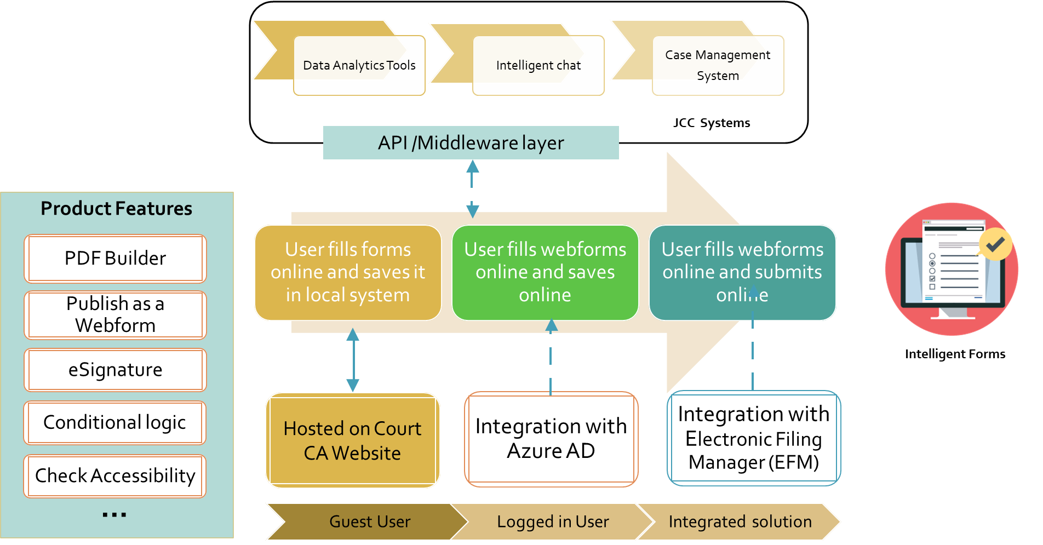
Judicial Council intends to move along an evolutionary path of modernization forms in progressive manner.
- Stage 1 of the project: User can fill the webform online and save it as a PDF in their local system or start working on PDF forms offline. There won’t be any user account for this stage.
- Stage 2: User can fill the form online as a guest user or create account on JCC site. Logged in users can save the form online to work on the forms over the time. User will be authenticated via JCC Azure AD.
- Stage 3: In this stage we will integrate forms with Electronic Filing Manager. Logged-in user can fill and submit the forms online. User-provided data will be managed by JCC.

RFI description of GOODS AND/or services

Intelligent Forms Requirements:
Intelligent forms requirements cover multiple business and technical requirements, including but not limited to:
- Webform builder
- Adaptive forms
- E-signature
- Document management
- API Integration
- Security compliance
The business, functional, and non-functional requirements can be found in Appendix 1, Business/Technical Requirements.

Submission of Response to RFI
The Judicial Council requests that Proposers use the Proposer Response Template and Appendix 1, Business/Technical Requirements to submit their current technical solution and cost information.
You can submit your enterprise pricing model as a separate attachment. Please include information on one-time and ongoing costs, by category such as licensing, hosting etc.
The Judicial Council will accept responses in soft copy and the responses must be submitted using the Attachments. Responses should be received no later than the due date and time below in Section 4 Timeline for this RFI.
Responses must be transmitted by email to solicitations@jud.ca.gov. The email subject line MUST include RFI Number IT-2019-06-LB.

TIMELINE for THIS RFI
The JCC has developed the following list of key events related to this RFI. All dates are subject to change at the discretion of the JCC. An addendum will be issued should any changes become necessary.
Event | Date
RFI issued | May 12, 2020
Deadline for questions. (Submit to Solicitations@jud.ca.gov) | May 26, 2020 due by 12:00 P.M. (PT)
Questions and answers posted (estimate only)(posted to the Courts website https://www.courts.ca.gov/rfps.htm) | June 9, 2020
Last date and time information response package may be submitted (Submit to Solicitations@jud.ca.gov) | June 23, 2020 due by 2:00 P.M. (PT)

RFI RESPONSE ATTACHMENTS
The following attachments are included as part of this RFI for Proposer Response submissions:
# | Attachment Title | Description
1 | Proposer Response Template | Proposer’s Response
2 | Appendix 1: Business/Technical Requirements | Functional and Non-functional Requirements

Confidential or proprietary information
RESPONSES ARE SUBJECT TO DISCLOSURE PURSUANT TO APPLICABLE PROVISIONS OF THE CALIFORNIA PUBLIC CONTRACT CODE AND RULE 10.500 OF THE CALIFORNIA RULES OF COURT. The Judicial council will not disclose Social Security numbers. All other information in responses will be subject to disclosure in response to applicable public records requests. Such disclosure will be made regardless of whether the response (or portion thereof) is marked "Confidential", "Proprietary," or otherwise, and regardless of any statement in the response (a) purporting to limit the Judicial Council's right to disclose information in the response, or (b) requiring the judicial council to inform or obtain the consent of the Proposer prior to the disclosure of the response ( or portions thereof). Any response that is password protected, or contains portions that are password protected, may be rejected. Proposers are accordingly cautioned not to include confidential, proprietary, or privileged information in responses.

INformation exchange
After the Judicial Council has reviewed the Proposers response, your firm may be contacted and invited to participate in an information exchange with council staff. The objective of the information exchange is to gain further understanding of your proposed approach or solution.
The information exchange can be in the form of a phone conversation/conference call, in-person meetings (subject to approval). The information exchange could also include a request for an application demonstration, completed in person (subject to approval) or via the web-ex. It is important to note the Judicial Council will not reimburse Proposers for any expenses, travel and/or time etc. incurred due to your participation in any information exchange activities.

disclaimer
This RFI is issued to gather information and is intended for planning purposes only. This RFI does not constitute a solicitation. A response to this RFI is not an offer and cannot be accepted by the Judicial Council to form a binding contract. The Judicial Council shall have no obligation to, and will not, reimburse respondents (or their agents, contractors or brokers) for any expenses associated with responding to this RFI. Responses to this RFI will not be returned. The Judicial Council shall have no obligation to respond in any manner to a submission.
Note: Nothing in this section limits the Judicial Council's ability to use an RFI. An RFI is used to gather information about goods or services available in the Marketplace, what goods or services generally cost, or similar topics. An RFI is not used to separate those prospective Proposers that intend to participate in an upcoming solicitation from those that have no interest in participating.
End of RFI

