|  |  |  |
| --- | --- | --- |
| RC purple 1 300 |  | Attachment A Project Description |
|  |  | New Sacramento Criminal Courthouse  Superior Court of California  County of Sacramento  S:\Logos\2014_JCC_Operations_CapitalProgram.emf |

**ATTACHMENT A—PROJECT DESCRIPTION**

|  |  |  |  |  |
| --- | --- | --- | --- | --- |
| ***Project Name*** | ***No. of Courts*** | ***Size***  ***(Sq Ft)*** | ***Construction Cost*** | ***Construction Start*** |
| Sacramento County: New Sacramento County Criminal Courthouse | 44 Courtrooms | 405,468 | $303.0 Million | Fall 2017 |
|  |  |  |  |  |

The project includes the design and construction of a new criminal courthouse building to be occupied by the Superior Court of California, County of Sacramento. The project replaces and consolidates five existing facilities and portions of the existing Gordon D. Schaber Courthouse. The new courthouse with a basement is estimated to be 405,468 building gross square feet (BGSF) in area with secure underground spaces for judicial officers. The project delivery method for construction is CM@Risk with LEED silver rating.

Notes:

1. Feasibility reports for the above projects are posted at

<http://www.courts.ca.gov/programs-facilities.htm>

1. Project construction scheduling assumptions include:
   * Site acquisition/Pre-design: Completed
   * Schematic Design/Design Development: 12 months
   * Working Drawings: 14 months
   * Construction: 38 months

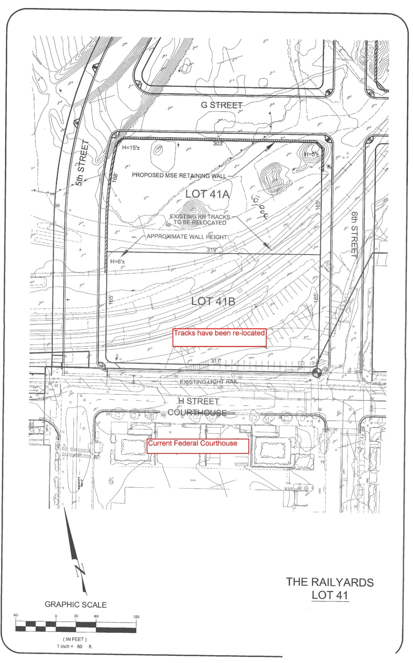

End of Attachment