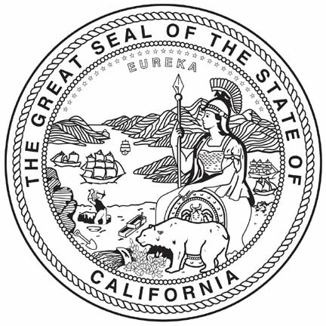

Civic Learning California Summit:

Making Democracy Work

Agenda

February 28, 2013
Secretary of State Auditorium
1500 11th Street, Sacramento

8:30– 9:30 Registration

9:30 - 9:55 Color Guard from McClatchy High School
Opening Remarks
Secretary of State Debra Bowen
Chief Justice Tani G. Cantil-Sakauye

9:55- 10:15 Civic Learning Awards
State Superintendent of Public Instruction Tom Torlakson
Student Speaker from Award winning school

10:15 – 11:05 Panel Discussion: Why Civics?
Hon. Stacy Boulware Eurie
Presiding Judge, Juvenile Court, Superior Court of Sacramento
Mr. Thomas A. Saenz
President and CEO, Mexican American Legal Defense and Educational Fund (MALDEF)
Ms. Yvonne Walker
President, Service Employees International Union (SEIU) Local 1000
Mr. Allan Zaremberg
President and Chief Executive Officer, California Chamber of Commerce

Moderator: Hon. Judith D. McConnell
Administrative Presiding Justice, Court of Appeal, Fourth Appellate District

11:05 – 11:15 Break

11:15 – 12:05 Justice Sandra Day O’Connor, United States Supreme Court (Ret.)
Introduction
Hon. Darrell Steinberg, California Senate President pro Tem

Justice Sandra Day O’Connor, United State Supreme Court (Ret.)
in conversation with
Hon. Deanell Reece Tacha (Ret.),
Duane and Kelly Roberts Dean and Professor of Law,
Pepperdine University School of Law

12:05 – 12:25 Call to Action
Hon. Joseph Dunn (Ret).
Chief Executive Officer, State Bar of California State Legislators

12:25 – 12:30 Closing
Chief Justice Tani G. Cantil-Sakauye
Hon. Judith D. McConnell

