REQUEST FOR PROPOSALS

Court of Appeal, Fourth Appellate District, Division Three

Regarding:
Court Security Modification

PROPOSALS DUE:
January 17, 2013, no later than 5:00 p.m. Pacific time

  - Description of Services and Deliverables

  - The Court of Appeal, Fourth Appellate District (Court), Division Three, located at 601 W. Santa Ana Boulevard, California 92701, is seeking proposals from individuals or entities for security modifications to its building to include:

    - The modification to existing or furnishing of and installation of new double doors to provide Level II bullet resistant glass with a one-way mirror effect from the outside. The finished product shall be consistent with the existing mechanical functionality and aesthetics; dark bronze anodized aluminum. All hardware and any materials used must match the existing door and hardware. The functionality of the doors, which include an ADA button, should not be affected by the changes. Each of the double doors has a 24”x 75 ½” center window.

    - The bid must include a 5 year parts and labor warranty.

    - Final measurements will be the responsibility of the vendor awarded the contract.

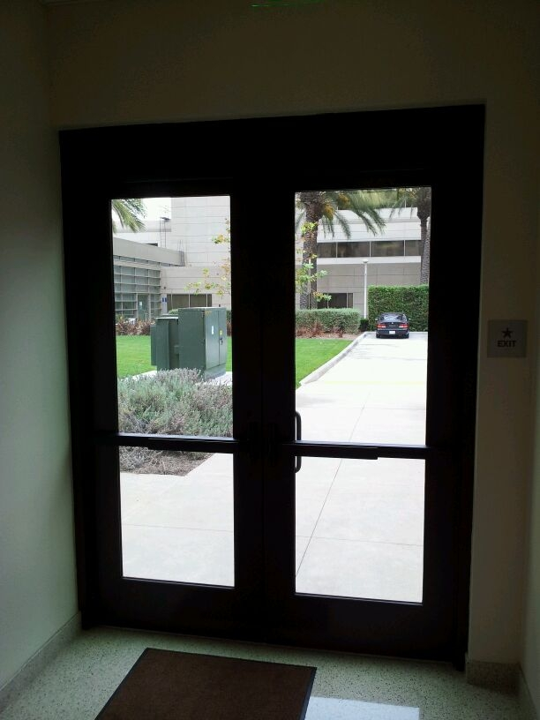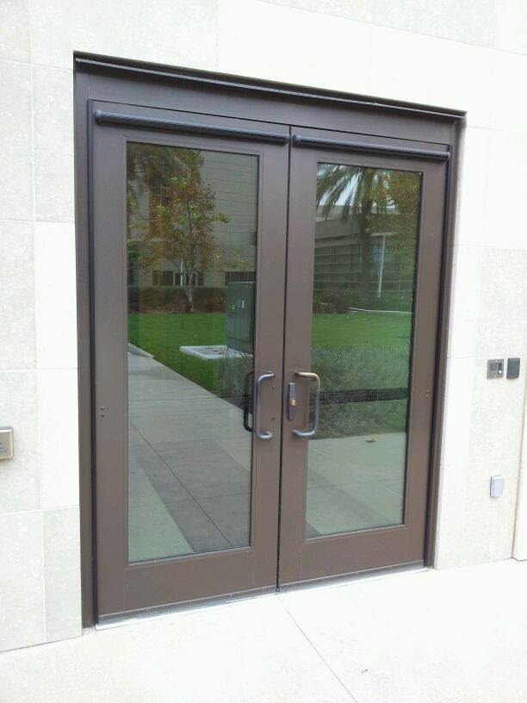

  - This Request for Proposals will cover all aspects of the security modification as described in Section 1.1. Proposals shall include all design fees, materials, and labor. The installation labor must not affect the courts operations. Proposed time scheduled is as follows:

    - The new double doors located in the north side of the building can be installed during court operational hours Monday-Friday 7:00am-6:00pm and should be reflected in the bid provided. The security of the court should not be compromised; the doors should be locked and sealed after 6:00 pm.

1.3 The service provider will be asked to provide:

a. appropriate security of technicians; government issued identification and resumes should be provided upon awarded the project.

b. certified technicians as may be required; and

c. resolution of any quality control or customer satisfaction issues.

2.0 Timeline for the RFP

The Court has developed the following list of key events related to this RFP. All dates are subject to change at the discretion of the Court.

EVENT | DATE
RFP issued | December 6, 2012
Mandatory Walk-Thru | December 13, 2012
Deadline for questions. Questions must be emailed and directed to solicitations@jud.ca.gov by December 7, 2012 no later than 1:00 p.m. PST | December 18, 2012
Questions and answers posted | January 3, 2013
Latest date and time proposal may be submitted, | January 17, 2013  5:00 p.m. P.T.
Evaluation of proposals (estimate only) | January 25, 2013
Notice of Intent to Award (estimate only) | January 30, 2013
Negotiations and execution of contract (estimate only) | February 1, 2013
Contract start date (estimate only) | February 1, 2013
Contract end date (estimate only) | January 31, 2015

3.0 RFP Attachments

The following attachments are included as part of this RFP:

ATTACHMENT | DESCRIPTION
Attachment 1: Administrative Rules Governing RFP (IT Services) | These rules govern this solicitation.
Attachment 2: Attachment 2: General Terms and Conditions | If selected, the person or entity submitting a proposal (the “Proposer”) must sign this Court Standard Form agreement containing these terms and conditions (the “Terms and Conditions”).
Attachment 3: Acceptance of Terms and Conditions | On this form the Proposer must indicate acceptance of the Terms and Conditions or identify exceptions to the Terms and Conditions.  Note: A material deviation from the Terms and Conditions may render a proposal non-responsive.
Attachment 4: Payee Data Record Form | This form contains information the Court requires in order to process payments
Attachment 5: Darfur Contracting Act Certificate | Proposer must fill this out and return with the RFP response.

4.0 Submission of Proposals

4.1 Proposals should provide straightforward, concise information that satisfies the requirements of the “Proposal Contents” section below. Expensive bindings, color displays, and the like are not necessary or desired. Emphasis should be placed on conformity to the RFP’s instructions and requirements, and completeness and clarity of content.

4.2 The Proposer must submit its proposal in two parts, the technical proposal and the cost proposal.

a. The Proposer must submit one (1) original and four (4) copies of the technical proposal. The original must be identified as the original on the cover and bear the original signatures of an authorized representative of the Proposer. The Proposer must write the RFP title and number on the outside of the sealed envelope.

b. The Proposer must submit one (1) original and four (4) copies of the cost proposal. The original must be identified as the original on the cover and bear the original signature of an authorized representative of the Proposer. The original cost proposal (and the copies thereof) must be submitted to the Court in a single sealed envelope, separate from the technical proposal. The Proposer must write the RFP title and number on the outside of the sealed envelope.

c. The Proposer must submit one electronic file version of the entire proposal on a CD-ROM. The files contained on the CD-ROM should be in PDF, Word, or Excel formats.

4.3 Proposals must be delivered by the date and time listed on the coversheet of this RFP to:

Debra Wise
Administrative Specialist II
RFP #4DCA RFP 12/13/01
Court of Appeal, Fourth Appellate District, Division One
750 B. Street, Suite 300
San Diego, CA 92019

4.4 Late proposals will not be accepted.

4.5 Only written proposals will be accepted. Proposals must be sent by registered or certified mail, courier service (e.g., FedEx), or delivered by hand. Proposals may not be transmitted by fax or email.

5.0 Proposal Contents

5.1 Technical Proposal. The following information must be included in the technical proposal. A proposal lacking any of the following information may be deemed non-responsive.

a. Proposer’s name, address, telephone and fax numbers, and federal tax identification number. Note that if Proposer is a sole proprietor using his or her social security number, the social security number will be required before finalizing a contract.

b. Name, title, address, telephone number, and email address of the individual who will act as Proposer’s designated representative for purposes of this RFP.

c Names, addresses, and telephone numbers of a minimum of three (3) clients for whom the Proposer has provided similar services. The Court may check references listed by Proposer.

d. A thorough technical proposal describing

i. the proposer’s background, expertise, and capacity to provide the required equipment, supplies, and services.

ii. information regarding the firm’s qualifications (e.g. licensed dealer status, number of service technicians and their training, past commendations, etc.).

iii. identification of any subcontractors, if used, to perform services or to provide equipment, parts, or other supplies and a description of the subcontractor’s expertise and ability to perform its respectivecomponent of the work described herein.

e. Acceptance of the Terms and Conditions.

i. On Attachment 3, the Proposer must either indicate acceptance of the Terms and Conditions or clearly identify exceptions to the Terms and Conditions. An “exception” includes any addition, deletion, qualification, limitation, or other change.

ii. If exceptions are identified, the Proposer must also submit a red-lined version of the Terms and Conditions that clearly tracks proposed changes, and a written explanation or rationale for each exception and/or proposed change.

iii. Note: A material exception to a Minimum Term may render a proposal non-responsive. Minimum terms include those items described in Section 3.0 above.

f. Certifications, Attachments, and Other Requirements.

i. Proposer must include the following certification in its proposal:

Proposer has no interest that would constitute a conflict of interest under California Public Contract Code sections 10365.5, 10410 or 10411; Government Code sections 1090 et seq. or 87100 et seq.; or rule 10.103 or rule 10.104 of the California Rules of Court, which restrict employees and former employees from contracting with judicial branch entities.

ii. If Proposer is a corporation, proof that Proposer is in good standing and qualified to conduct business in California.

iii. Copies of current business licenses, professional certifications, or other credentials.

iv. Proof of financial solvency or stability (e.g., balance sheets and income statements).

v. A statement or certification that Proposer can meet the insurance requirements of the U.S. Bank Tower, 621 Capitol Mall, Sacramento, CA 95814, which are attached as Attachment 4.

g. Proposals will be evaluated by the Court using the following criteria:

i. Experience and success on similar assignments;

ii. Reasonableness of cost; and

iii. Acceptance of the Terms and Conditions and provision of certifications.
5.2 Cost Proposal.

a. The Proposer may structure a cost proposal in any manner or form, but such form must provide sufficient detail and narrative explanation to be clear and understandable. The cost proposal must provide a cost for the Initial Term and all three (3) option years.

b. The cost proposal must provide a “not to exceed” total for all work, service, parts, and supplies payable under the contract, if awarded, for the Initial Term. The cost proposal must also provide a “not to exceed” total for all three (3) option years.

Note: It is unlawful for any person engaged in business within this state to sell or use any article or product as a “loss leader” as defined in Section 17030 of the Business and Professions Code.

6.0 Offer Period

A Proposer's proposal is an irrevocable offer for ninety (90) days following the proposal due date. In the event a final contract has not been awarded within this period, the Court reserves the right to negotiate extensions to this period.

7.0 Evaluation of Proposals

At the time proposals are opened, each proposal will be checked for the presence or absence of the required proposal contents.

The Court will evaluate the proposals on a 100 point scale using the criteria set forth in the table below. Award, if made, will be to the highest scored proposal.

CRITERION | maximum number of points
Ability to provide trained technicians and proven technical competency in the modification to existing or furnishing of and installation of new double doors to provide Level II bullet resistant glass with a one-way mirror effect from the outside. | 20
Experience and success on similar assignments | 20
Reasonableness of cost | 50
Acceptance of the Terms and Conditions and provisions of certifications | 10

8.0 Interviews

The Court may conduct interviews with Proposers to clarify aspects set forth in their proposals or to assist in finalizing the ranking of top-ranked proposals. The interviews may be conducted in person or by phone. If conducted in person, interviews will likely be held at the Court’s offices. The Court will not reimburse Proposers for any costs incurred in traveling to or from the interview location. The Court will notify eligible Proposers regarding interview arrangements.

9.0 Confidential or Proprietary Information

One copy of each proposal will be retained by the Court for official files and will become a public record. California judicial branch entities are subject to rule 10.500 of the California Rules of Court, which governs public access to judicial administrative records (see www.courtinfo.ca.gov/cms/rules/index.cfm?title=ten&linkid=rule10_500).
If information submitted in a proposal contains material noted or marked as confidential and/or proprietary that, in the Court’s sole opinion, meets the disclosure exemption requirements of Rule 10.500, then that information will not be disclosed upon a request for access to such records. If the Court finds or reasonably believes that the material so marked is not exempt from disclosure, the Court will disclose the information regardless of the marking or notation seeking confidential treatment.

10.0 Disabled Veterans Business Enterprise Participation Goals

The Court has waived the inclusion of DVBE participation in this solicitation.

11.0 Protests

Any protests will be handled in accordance with Chapter 7 of the Judicial Branch Contract Manual (see www.courts.ca.gov/documents/jbcl-manual.pdf). Failure of a Proposer to comply with the protest procedures set forth in that chapter will render a protest inadequate and non-responsive, and will result in rejection of the protest. The deadline for the Court to receive a solicitation specifications protest is January 19, 2013. Protests should be sent to:

Kevin Stinson, Assistant Clerk/Administrator
Court of Appeal, Fourth Appellate District, Division Three
601 W. Santa Ana Boulevard
Santa Ana, CA 92701

